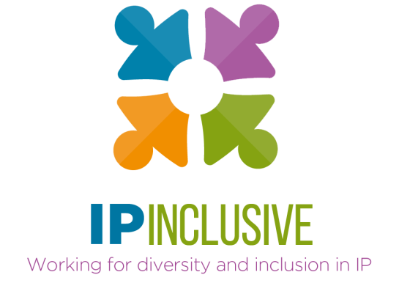

IP Inclusive Management
Meeting 21 June 2018
Minutes
Teleconference : 11.00 – 11.40 am
Attendees: Carol Arnold (Minutes); Andrea Brewster (Chair); Richard Goddard; Michael Silverleaf; & Lee Davies
Apologies: Keven Bader; Ben Buchanan; Liz Dawson
General re documentation & attendance
Carol asked if anyone had objection to making Julie Dunnett (IP Federation Council member) a direct copy recipient on distributions of the Agenda and Minutes of each meeting. All supported; it was noted that it would even be OK for both Carol and Julie to attend any future meeting since it is IP Federation that is the committee member.
Chair’s report (Agenda item 2)
A brief report was issued in advance of the meeting and was attached to the meeting Agenda.
The negative feedback from the LawCare webinar was queried. In the Webinar, the presenter had propounded that individuals needed to take their own responsibility; this caused the feedback that this was not a good message for those who felt they were in a vulnerable position. LawCare were pleased to receive feedback, understood the concern, and will respond.
Careers in Ideas jobs board (Agenda item 3)
Generally, all thought the draft TOR was good. Carol repeated her earlier viewpoint that she thinks there is a case for CinI to charge for entries; however, it was appreciated and understood that Andrea sees a no-charge jobs board to be a founding principle of the jobs board.
The TOR should now be referred to the founding organisations for review and comment, and particularly to CIPA and CITMA.
Action: Andrea to send to CIPA; Richard to CITMA; Carol to IP Federation; and Liz to FICPI.
IP Inclusive Week (Agenda item 4)
This is fixed as 12 to 18 November 2018.
The aim of the 2018 week (proposed as an annual event) is awareness raising throughout the IP community.
Andrea’s thoughts on the form that this could take, are:
- 1 or 2 events arranged by IP Inclusive, including something on ‘Allies’ (supporters from outside the Networks).
- Some form of event from the Charter Signatories. At some point during 2018 we aim to ‘launch’ regional networks or clusters of Charter Signatories, and this could be tied into the IP Inclusive Week.
- Toolkits would be nice to guide organisations on running events, e.g. a low-key event, internally.
Brainstorming of possible items/actions gave:
- A resource pack for people wishing to run an event in their organisation would be good.
- What about a game?
- Would the UK-IPO have some form of game, e.g. on unconscious bias?
(Action: Andrea to ask)
- Michael would be happy to propose such a game to the IP Bar.
- Daniel Alexander’s chambers has offered speakers to IP Inclusive. Currently Andrea is thinking of taking up the offer for the post-CIPA Congress drinks (see Chair’s Report) but if that does not pan out then something utilising such a speaker could be proposed for IP Inclusive Week.
- Carol has been approached for IP Inclusive to speak sometime at an AIPPI(UK) monthly meeting, and can ask if there would be any possibility for during this week in November. (Action: Carol).
- There should be the aim to talk about events being arranged (where events are internal events, these would not be invites) in blogs, on Twitter, on LinkedIn, to try to build some momentum. It would be good to create the impression ‘that everyone is doing something and if you are not then something is wrong’.
- It would be useful to spread the word through our different organisations to think about doing something.
- Is a special Webpage possible? Or something via IPKat? (Action: Andrea and Carol to coordinate actions to ask their contacts).
- Communication concerning the Week should be started over the summer, with publicity on specific open events started during September.
During the discussion, it was noted that Lesley Evans will be retiring in the autumn and is currently working 4 days a week. A new Charter Signatory focal point will be needed once Lesley retires, if not before – a topic for a future meeting.
Moderating social media communications & Key terms for supporter guidelines (Agenda items 5 & 6)
The two topics are linked in that guidelines for supporters in general, for social media communications, and for updates for GDPR could be a project for a few months’ hence IF a decision to have paid support for IP Inclusive is taken at the next meeting.
Currently moderating is done very much on an ad hoc level. The risk run from this is low since only a few people post entries from IP Inclusive/networks. However as/if IP Inclusive grows, the risk will also grow, if there are no policies in place as to who can ‘speak’ for IP Inclusive or how to communicate on behalf of IP Inclusive. There is limited knowledge on what is suitable to communicate in the EDI arena generally. Lee offered to review the CIPA communications policy and propose points for EDI communications in general. (Action: Lee).
As a separate but related issue, concern was expressed that Parminder is doing too much. As part of these topics, we need to think about liberalising access to the official IP Inclusive site to reduce the load on Parminder.
What if anything to do about benchmarking data (Agenda item 7)
Deferred.
Next Meeting: Face to Face (Agenda Item 9):
11 July 2018; 11:00 to 14:00 (face to face meeting, to include lunch).
Actions carried forward to the meeting:
Michael to investigate via contacts in WIPO & NOMINET regarding potential for funding a position in IP Inclusive.
Lee and Keven: to discuss what is the best sort of basis on which to operate a paid position: employment, contract, or consultancy.
CIPA has requested that a formal CIPA representative attends the meeting especially since there may be need for Andrea to be excused from the discussion where her current role and potential future role is discussed in detail. [PMN: Stephen Jones, CIPA President, will attend]
Next Normal Meeting: WebEx-telecon (Agenda Item 9):
19 July 2018; 11:00 to 11:30.

