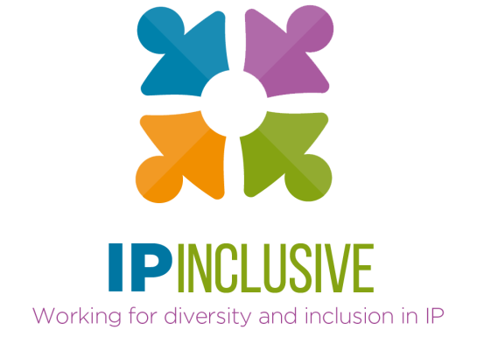

D&I data gathering:
making it count

Agenda

Date & time: 3 September 2020, 4-6 pm
Venue: Zoom
Chair: Andrea Brewster OBE, Lead Executive Officer, IP Inclusive

1600-1605 Introductions, welcome and housekeeping
1605-1655 Panel discussion
Advice, ideas and experiences from our four panellists:
- Pauline Beck, Head of Social Research and Statistics, UK IPO
- Jonathan Clarke, Director of Human Resources, Kilburn & Strode
- Matthew Clayton, Partner and Solicitor, Willans
- Stella Chandler, Director, Focal Point Training
Chaired by Andrea, with audience Q&A if time allows
1655-1700 Break
A chance to stretch your legs, fetch a drink, etc, while we set up the breakout rooms
1700-1730 Breakout sessions
Facilitated group discussions, in light of the panellists’ input, on improving D&I data gathering in the IP sector, both through IP Inclusive and among its individual Charter signatories
1730-1755 Plenary: collating outcomes
Breakout room facilitators share their groups’ ideas
1755-1800 Summing up and closing remarks

