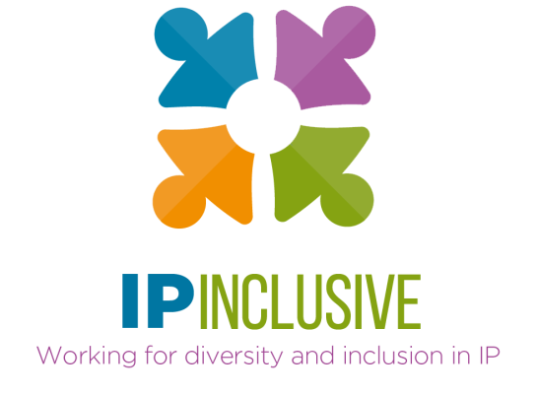

D&I data gathering:
making it count

Discussion outcomes

The questions
In the breakout sessions at our 3 September 2020 event on D&I data gathering, we explored two themes:
- What should we expect of IP Inclusive Charter signatories in terms of D&I data reporting? And how can we encourage and support that?

- What should IP Inclusive be doing at the sector-wide level? How can it do that better, and how can individual organisations help?

The answers

Theme 1:
Expectations of Charter signatories
There was broad agreement that we should expect – but not require – Charter signatories to gather their own D&I data. IP Inclusive’s role should be to encourage, inspire, educate and support their efforts to do this.
Specific suggestions included:
- Provide IP Inclusive resources such as:
  - Best practice guidelines (including for the gathering of data, its analysis and its subsequent use)
  - Template survey questions
  - A flow-chart of actions to take when embarking on a D&I data gathering exercise, with advice and links to useful resources
  - Further training and awareness-raising events like this one
- Encourage signatories to:
  - Implement an action plan in response to the data they gather
  - Renew their data regularly to chart and maintain progress
  - Share and celebrate their experiences of D&I data gathering, eg at events and in blog posts, to promulgate best practices
- Recognise that D&I data gathering can be a particular challenge for smaller organisations, and provide appropriate support
- Ask signatories that have more experience to “mentor” those with less
- Introduce a requirement (perhaps phased in over a few years) for Charter signatories to conduct internal D&I surveys and self-certify their compliance
- Consider different “tiers” of Charter accreditation, with different data gathering requirements for different types and sizes of signatory
  - Consider a minimum size threshold before data gathering expectations apply
  - A sector-wide “base level” expectation could be supplemented by optional higher standards for some signatories
- Encourage signatories to aim for external accreditation schemes such as the Advance HE Equality Charters (Athena Swan and Race Equality), as an incentive to gather and gain benefit from their own data
- Explore with larger signatories the possibility of supply chain schemes based on diversity metrics, to encourage the use of D&I data to incentivise change
Also discussed were suggestions for improving the value of the data gathered:
- Increase survey response rates, for example using “clickbait”-type tactics, or by linking the D&I survey to communications on essential issues such as CPD compliance
- Design survey questions to allow direct comparison with data available elsewhere (eg from the IP Inclusive surveys; membership body or regulator data; the legal sector as a whole; the wider UK workforce; or the organisations from which the IP professions recruit)
- Ensure data reveals how diversity varies with career level

Theme 2:
Actions for IP Inclusive
Most people felt that IP Inclusive should continue to gather sector-wide data. It provides a benchmark against which individual organisations can assess their own positions, and with which to compare data gathered in specific areas or contexts. Sector-wide data also offers a more comprehensive picture, since most organisations employ only a limited range of IP professionals (for example, mainly patent attorneys). It allows the sector’s progress to be monitored and if appropriate influenced over time, having particular value in efforts to improve representation of specific groups such as BAME professionals.
Some important suggestions were made regarding IP Inclusive’s future data gathering:
- We should be clear about why we are gathering the data and how we hope to use it.
- We should also collect information about the D&I-improving measures adopted by IP sector organisations, and their relative effectiveness.
Other suggestions for future IP Inclusive surveys included:
- Learn from approaches already adopted by bodies such as the SRA, Bar Council and Law Society
- Adopt measures (as discussed above) to optimise response rates, in particular among those who have less of an interest in diversity and/or think it “doesn’t apply to me”

Overall outcomes

- There are clearly benefits to IP Inclusive gathering sector-wide diversity data. We will therefore:
  - repeat our November 2019 benchmarking survey at the same time this year;
  - re-design it where feasible to take account of the above recommendations; and
  - ensure its results shape the work we do in 2021.
- For the time being we will not require our Charter signatories to gather their own D&I data, but we will strongly encourage them to do so.
- We will do what we can to support their data gathering efforts, and make the most of our positioning in the sector to inspire and promulgate best practices.
We believe that these outcomes complement those from our 29 July 2020 round table on BAME representation levels, which emphasised the importance of obtaining and monitoring appropriate diversity metrics.

Andrea Brewster OBE
IP Inclusive Lead Executive Officer
Event chair

