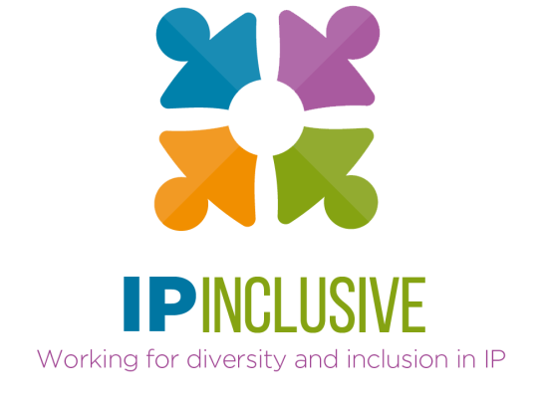

IP Inclusive/IP Federation

Social mobility think tank
23 September 2020

Venue: Zoom
Timing: 4-6 pm
Chair: Suzanne Oliver, Immediate Past President, IP Federation

Agenda

1600-1605 Introduction, welcome and housekeeping
Chair; IP Inclusive
1605-1610 A word from the IPO
Tim Moss CBE, Chief Executive Officer & Comptroller General
1610-1620 Introduction to the discussion themes and meeting objectives (see annex)
Chair
1620-1700 Breakout sessions
Facilitated group discussions on the 8 themes, to identify practical steps that the IP professions can take to improve social mobility and access
1700-1710 Break
A chance to stretch your legs, fetch a drink, etc, while the facilitators liaise.
1710-1750 Plenary: collating and agreeing outcomes
Breakout room facilitators share their groups’ recommendations
Collation of, and commitment to, key outcomes
1750-1800 Summing up and closing remarks
Chair

Please note: this meeting is intended as a frank and open discussion of potentially sensitive issues. Although the outcomes will be published, the discussions will not be recorded and we would ask you please not to tweet or take screenshots during the meeting and to keep its contents confidential.

Annex: Discussion themes and meeting objectives

Our 8 discussion themes

- Outreach
  - How can we make more people – in particular those from less privileged backgrounds – aware of IP sector careers?

- Access
  - How can we improve entry-level access for people from less privileged backgrounds?

- Career development
  - How can we help people from a wider range of backgrounds to switch careers, either into or within the IP professions?

- Unconscious and conscious bias
  - What role does bias play in restricting social mobility and access in the IP professions (both at entry level and during career development)?
  - How can we eliminate it?

- Particular issues for the STEM-related IP professions
  - What special challenges affect our ability to attract and recruit people from less privileged backgrounds into STEM-related IP professions (eg as patent attorneys, solicitors or barristers; as patent examiners; as patent searchers)?
  - How can we overcome those challenges?

- Patent attorney qualification requirements
  - What special challenges arise, in the context of improving social mobility, from the qualification requirements for UK and European patent attorneys?
  - How can we overcome those challenges?

- Evidence base
  - What data should we seek to gather, to monitor our progress and benchmark against social mobility metrics outside our sector?

- National policy
  - What can government – in particular through the IPO – do to help us improve social mobility and access to the IP professions?
  - Where, how and on what should we be lobbying for wider changes to support the IP sector’s own efforts?

Breakout session objectives
We’d like each breakout session to identify, in the context of its designated theme:
- One thing we can do now
- One thing we can commit to doing in the future
- How we can work with existing organisations (eg the charities represented at the meeting) to progress these plans
- How this fits into Careers in Ideas Week (16-22 November 2020)

Wider meeting objectives
More broadly, this think tank will focus on achieving:
- Practical outcomes that delegates’ organisations or departments (in particular IP Federation members and IP Inclusive Charter signatories) can commit to.
Some of these will be short-term measures, for example those relating to Careers in Ideas Week. Some will involve longer-term commitments. All must be specific, measurable and realistic, and ideally incorporate time goals.

