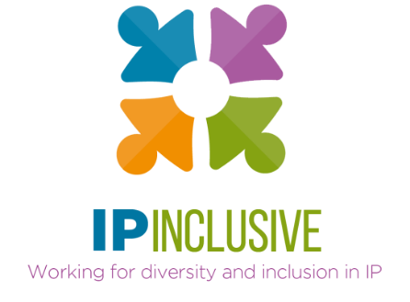

Social mobility & access to the IP professions
Outcomes for
Careers in Ideas Week

An IP Federation/IP Inclusive “think tank” convened on 23 September 2020 generated ideas for improving social mobility and access to the IP professions. A particular focus was projects to undertake – or at least initiate – to mark Careers in Ideas Week from 16 to 22 November 2020.
These are the Careers in Ideas Week suggestions:
- Individual organisations and departments (including the membership organisations) to confirm their senior-level commitment to improving social mobility and access; all to help IP Inclusive publicise those commitments.
- Each organisation or department to do at least one thing to help a relevant charity – perhaps a donation, or ideally by practical involvement with eg work experience opportunities, careers clinics and similar events.
- Individual IP professionals to help the charities as mentors, speakers, writers, coaches and/or facilitators, and generally as ambassadors for the IP professions. For example, each professional could pledge, say, half a day of their time to an appropriate project.
- Ensure these activities reach new potential recruits, in places not previously engaged by the IP sector.
- Showcase (eg on social media) true stories of IP professionals who have taken non-traditional routes into or through the IP sector, come from less privileged backgrounds, or overcome relevant challenges during their career.
- Begin a directory of IP professionals who are willing to speak or write about their IP sector careers to assist the charities.
- Use these opportunities to promote the Careers in Ideas campaign.
All of the above are best done in association with the charities represented at the meeting, who can help us target our efforts appropriately. They will, for instance, be able to advise on the provision of Covid-19-compliant outreach activities (see for example the Teach First guidance on virtual work experience).
Each of the charities has provided information about the work it does and the types of help it would appreciate from both individuals and organisations: see the Careers in Ideas charities directory, initially compiled in connection with the think tank meeting. We suggest these “wish-lists” be used to identify suitable joint projects.
There are further suggestions for getting involved with Careers in Ideas Week on the IP Inclusive website1. The more detailed outcomes from the think tank meeting also include ideas for suitable outreach activities.

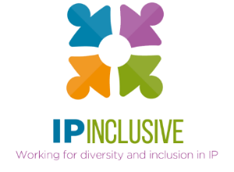
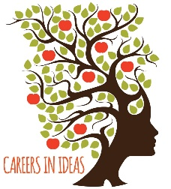

https://ipinclusive.org.uk/careers-in-ideas-week/
http://careersinideas.org.uk/
https://ipinclusive.org.uk/wp-content/uploads/2020/09/Teach-First-Virtual-Work-Experience-Employer-Brochure.pdf
https://ipinclusive.org.uk/wp-content/uploads/2020/10/201008-charity-directory.docx
https://ipinclusive.org.uk/wp-content/uploads/2020/10/201020-soc-mob-think-tank-outcomes.docx

