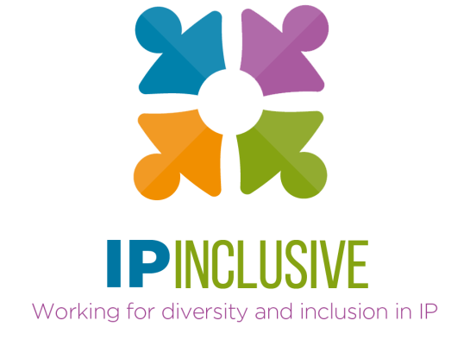
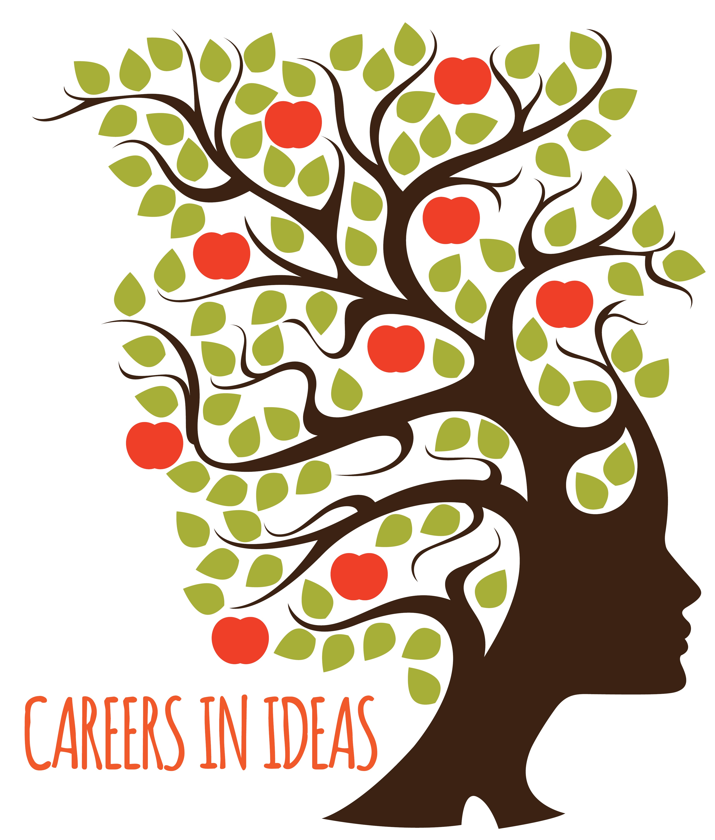

Careers in Ideas:

Directory of outreach organisations

The charities and community interest groups featured in this directory are:
 | Page
Generating Genius | 2
HUDL Youth Development Agency | 3
In2scienceUK | 5
National Careers Week | 6
Reach Society | 7
Stemette Futures | 8
Strive Consultants | 10
Teach First | 11
The Access Project | 13
The Sutton Trust | 14
WISE | 16

Many of these were represented at a 23 September 2020 “think tank” meeting organised by the IP Federation and IP Inclusive to discuss social mobility and access to the IP professions. They have an interest in promoting social mobility as well as, in many cases, other forms of diversity.
The information they’ve provided outlines the work each of them does and how the IP professions can get involved. Their suggestions will help you identify opportunities to give back to the community whilst also improving diversity within the IP sector. Perhaps more to the point, working with and through these organisations will help ensure that the support you provide reaches the right people in the right way.

https://careersinideas.org.uk
https://ipinclusive.org.uk/careers-in-ideas/
Generating Genius | 
www.generatinggenius.org.uk

Dr Tony Sewell
Director tony@generatinggenius.org.uk

What does your organisation do to improve social mobility and access to the professions? | We provide a pipeline for young people who are from Black Caribbean and Black African backgrounds to get into top Universities to study STEM subjects. This out of school programme uses mentoring, work experience , insight days, enhanced Science knowledge , University visits, soft skills training and scholarships.
What can IP sector organisations do to help? | We need more mentors, work experience opportunities and donations.
What can individual professionals do to help? | They should contact us to support our mentoring programme.
If applicable, what specific things could IP professionals do to help your organisation during Careers in Ideas Week (16-22 November 2020)? | In the past IP professionals have provided 2 kinds of input into Generating Genius:  1 They have volunteered as mentors for our 6th form programme called Uni-Genius or our Undergraduate programme called Alumni Genius  2 They have lobbied their firms to partner with Generating Genius usually taking on a student for a short work experience and supporting GG with its wider programme with a donation.

HUDL Youth Development Agency | 
www.hudl.org.uk

Keji Okeowo
kejiokeowo@gmail.com

What does your organisation do to improve social mobility and access to the professions? | HUDL is a youth development agency, dedicated to the professional and personal growth of young people from low socio-economic backgrounds. We work in  partnership with young people, organisations and networks to diversify opportunities and impact positive change.  We support young people to access opportunities by recognising their own talent and abilities and equipping them with the confidence, skills and knowledge to realise their aspirations. For instance we deliver development days, spotlighting key transferable skills; we support young people to overcome barriers and challenges through structured group coaching with their peers; we facilitate young people to make connections with other young people who they may not otherwise have met to learn and share different perspectives; and we help them make the most of mentorships, work experience and internship opportunities. We develop strong networks that bring together young people and professionals, creating spaces that are fun, engaging, informative and impactful. We also encourage young people to use their voice in shaping the services that impact them.  We recognise that young people from low socio-economic backgrounds and particularly those from BAME backgrounds need additional support in accessing opportunities. We encourage organisations to value the contributions that a diverse workforce brings. For example we work with organisations to provide pre-access programmes to better position young people from disadvantaged backgrounds when applying for graduate schemes or vacancies.
What can IP sector organisations do to help? | Encourage staff from across all roles and teams to volunteer within the HUDL network as mentors, facilitators and HUDL speakers  Provide annual access to buildings and resources for development days  Share opportunities for young people to experience work within your organisation  Join a HUDL collective - a partnership of organisations that provide a robust and insightful year-long programme of activities for 30 young people aged 16 - 21. Managed and Facilitated by HUDL.
What can individual professionals do to help? | Sign up to volunteer with HUDL  Share your careers journey (blog or vlog)  Encourage young people to join the HUDL network so that they can access future opportunities and support.
If applicable, what specific things could IP professionals do to help your organisation during Careers in Ideas Week (16-22 November 2020)? | Online skills clinic - working in small groups to assess existing and transferable skills  3- 5min talking heads for Instagram and website - what is IP?, How to get started in IP, your journey into IP, what skills are required for a successful career in IP, Impact of IP, top tips…

In2scienceUK | 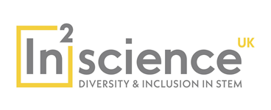
www.in2scienceuk.org

Luke McKelvey
Development Officer
luke@in2scienceuk.org

What does your organisation do to improve social mobility and access to the professions? | In2scienceUK gives young people from low income and BAME backgrounds the opportunity to achieve their potential and progress to degrees, apprenticeships and careers in the science, technology, engineering and maths (STEM) sector. With 20% higher salaries in STEM & IP careers, our vision is that In2scienceUK will provide a way out of economic inequality for young people from low income backgrounds and support greater social mobility. The young people supported by In2scienceUK are aged 17 year old studying A-levels and are recipients of free school meals, have parents with no history of higher education attendance and live in areas with limited careers development. Many of the young people have no positive role models in their lives and suffer from an acute lack of opportunities which serves to curtail their academic and career progression.
What can IP sector organisations do to help? | Organisations can support in2scienceUK by partnering with us and sponsoring young people through the In2scienceUK Programme. This is the only way we can increase the number of young people we help each year. Organisations can help us with business development by introducing us to their contacts and partners.
What can individual professionals do to help? | If IP firms support our In2scienceUK programme individual professionals can deliver a workshop to young people taking part in the programme and introduce them to careers in IP and provide mentoring.
If applicable, what specific things could IP professionals do to help your organisation during Careers in Ideas Week (16-22 November 2020)? | IP professionals can spread word of our contribution to supporting social mobility and diversity by writing a blog, social media post or article. If a professional would like to organise a fundraiser In2scienceUK can support them.

National Careers Week |  | 
www.nationalcareersweek.com

info@nationalcareersweek.com

What does your organisation do to improve social mobility and access to the professions? |  | National Careers Week celebrates careers education. The At  At NCW we recognise that the opportunities for organisations to promote their training or careers opportunities to future generations are limited; schools and colleges have little time for extended careers activities. This is why NCW is so important – we create the time and provide the opportunity for organisations to engage and inspire.  Free resources are available for careers events in schools.  Social media is flooded with posts about careers and education opportunities that young people may never have previously considered.
What can IP sector organisations do to help? |  | Organisations can use the national interest generated by NCW to promote career opportunities in their field by effective use of social media and press releases. Organisations can partner with National Careers Week to promote their websites and work with National Careers Week to produce resources which are emailed to schools and promoted through the National Careers Week website https://ncw2020.co.uk/  and video channel https://ncwtv.co.uk/
What can individual professionals do to help? |  | Professionals can download and make use of NCW resources when preparing for careers events in schools. Professionals can highlight and celebrate their own activity in schools by posting about it during National Careers Week and using #NCW2021 and tagging @CareersWeek.
If applicable, what specific things could IP professionals do to help your organisation during Careers in Ideas Week (16-22 November 2020)? |  | Consider and plan different ways in which you or your firm could highlight opportunities in your field during National Careers Week (1st -6th March 2021) either in person, virtually or on social media.
Reach Society | 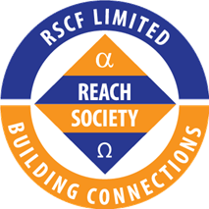
www.reachsociety.com

Dr Dwain Neil OBE
Chairman info@reachsociety.com

What does your organisation do to improve social mobility and access to the professions? | Reach Society is a QAVS award winning social enterprise. Its core purpose is to encourage, motivate and inspire young Black men to own the development of their potential and make viable transitions into adult life.
What can IP sector organisations do to help? | IP organisations can help the Society to deliver this purpose by taking part in the annual Careers Conferences as exhibitors, workshop facilitators and role models. They can also take part in any of the 6 regional Employability Days which are rolled out in Manchester, Birmingham, Leicester, Bedfordshire, Southampton and Cardiff.
What can individual professionals do to help? | Individual professionals can either facilitate one of the Perfect 10 Workshops or become a volunteer role model.
If applicable, what specific things could IP professionals do to help your organisation during Careers in Ideas Week (16-22 November 2020)? | IP professionals can spread word of the work that Reach Society is doing to inspire young Black men in the age range 13 to 24 by telling young people to visit the Society’s website – www.reachsociety.com – to obtain more information about our work; or contact the Society via info@reachsociety.com

Stemette Futures | 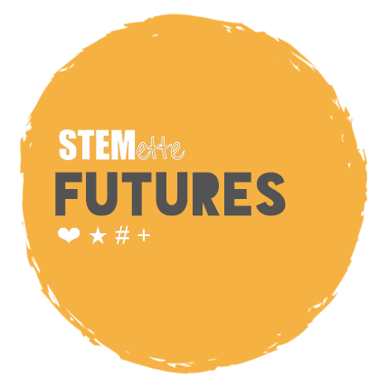
www.stemettefutures.org

Charlotte Pascual charlotte@stemettes.org

What does your organisation do to improve social mobility and access to the professions? | Stemette Futures  Our mission is to inspire the next generation of females into Science, Technology, Engineering and Maths (STEM) fields by showing them the amazing women already in STEM through a series of intersectional programmes, impactful events and inspirational content platforms.  Certification - We are providing professional STEM certifications for young people across the country who don’t have proper STEM education provision.  Experiences - We have impacted 45,000 girls with our interventions so far. We aim to reach 500,000 by 2025 across the globe.  Influence - Our ambition is to be the number one influencer in this space, influencing teachers, parents, media and wider society with quality advice, role model stories and actions for change.
What can IP sector organisations do to help? | Partner with us to host events or volunteer staff as panellists.  Learn more at www.stemettes.org/company.
What can individual professionals do to help? | If you work in STEM consider volunteering your time and skills with us:  - on our Programmes – including our mentoring programmes, leading sessions on STEM topics during our Certification programmes and hosting work experience  - At our events – Virtual events until 2021, then at physical events. Serve as a panellist, judge, ‘lightning’ speaker or speed mentor  - On our Content platforms – write a letter to your teenage self, write a profile of a female role model or share some career advice for the Stemettes Zine. Also promote our content and work on social platforms to your network.  - Donate to our work – run a fundraiser or encourage use of your company giving platform to our charity number 1188774 for Ada Lovelace Day (Oct 13), International Women’s Day (Mar 8), International Day of Women and Girls in Science (Feb 11) or International Women in Engineering Day (Jun 23)  Visit www.stemettes.org/company/volunteer for opportunities to give back and join our volunteers list – www.bit.ly/stemettesvolunteer
If applicable, what specific things could IP professionals do to help your organisation during Careers in Ideas Week (16-22 November 2020)? | Contribute your STEM passion and time to help us inspire. (And as above).

Strive Consultants | 
www.striveconsultants.co.uk

Sana Shafi
sana@striveconsultants.co.uk

What does your organisation do to improve social mobility and access to the professions? | Strive focuses solely on the potential of candidates from unconventional backgrounds to address the imbalance of diversity in City Law. Strive nurtures the potential of these candidates, regardless of their grades, ethnicities, and social standing, in order to enable them to access training contracts with City law firms. We provide training supplemented with one to one mentoring, application and assessment centre support all within one supportive community.
Do you focus on any particular under-represented groups (eg by gender or ethnicity)? If so, please tell us which. | We target students from social mobility backgrounds. All of our students are socially mobile and must meet at least one other diversity criteria. This way we ensure that we are focusing on representative diversity and assist those who need it.
Do you focus on any particular types of career (eg STEM-based or legal)? If so, please tell us which. | Legal
What can IP sector organisations do to help? | Host educational Events / Skills Clinics  Mentoring  Sponsorship  Assist with growth and scale
What can individual professionals do to help? | Sign up to become a mentor, join the team and help us grow

Teach First | 
www.teachfirst.org.uk/

workexperience@teachfirst.org.uk

What does your organisation do to improve social mobility and access to the professions? | The UK is failing to unlock the potential in all our children. It leaves their future at risk – and our society’s. At Teach First, we’re working to change this. It begins with getting great teachers and brilliant leaders into the schools that need them most. But it doesn’t stop there. We’re growing a powerful network of talented people committed to change – in education and beyond. Together we’re creating the results we all want to see: every child reaching their potential. In the classroom, in work, and in life.  We work to create partnerships that will provide students with a range of career insights and skills development opportunities. For example, we support our corporate partner Ashurst LLP to recruit for their summer work experience programme Access Ashurst, which gives the most disadvantaged pupils an insight into the global law firm whilst developing their transferable skills and boosting their career aspirations.
What can IP sector organisations do to help? | Teach First has over 50 corporate partners who, between them, contribute £5m+ to our work every year. It’s vital that we continue to build new partnerships with companies that have the capacity to donate at a significant level as well as engage directly with our network of schools to provide opportunities for pupils- e.g. by providing enriching engagement opportunities such as work experience opportunities and Virtual Career Talks to the pupils most in need of mobility.
What can individual professionals do to help? | Our virtual engagement actives have been designed to inspire and motivate bright young pupils from schools in low-income communities.  Professionals can help by:  - By hosting a one-week work experience placement, you can provide young people with the building blocks towards a successful career and increase awareness and understanding of the world of IP work and the different career options available.  - Individuals can also collaborate with us by creating short virtual career talks to give teachers flexible resources that they can use to embed IP careers into students’ learning.
If applicable, what specific things could IP professionals do to help your organisation during Careers in Ideas Week (16-22 November 2020)? | Our Partnerships go beyond just financial support. You can work with us in many ways to bring out the talents and potential of young people who are being let down by society. IP professionals can help our charity by inspiring pupils through our virtual career talks.

The Access Project | 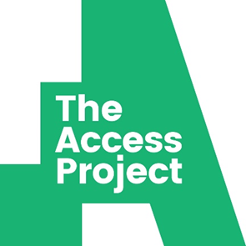
www.theaccessproject.org.uk

Alisa Zhiteneva
Volunteering@theaccessproject.org.uk

What does your organisation do to improve social mobility and access to the professions? | The Access Project works with talented GCSE and A-level students from disadvantaged backgrounds to help them access top universities. We match students with volunteer tutors to develop their academic skills, confidence, and self-efficacy.
What can IP sector organisations do to help? | - Promote The Access Project volunteering opportunity to their employees.  - Sponsor the project’s work in one of our partner schools.
What can individual professionals do to help? | - Volunteer – they will need to be able to tutor for 1 hour/week during an academic year. They will tutor one student online at a time that is convenient for them in a subject of their choice.  Promote The Access Project’s work to their networks.
If applicable, what specific things could IP professionals do to help your organisation during Careers in Ideas Week (16-22 November 2020)? | Take part in an online workshop for our students. We would host an online panel Q/A session where you would talk about your experiences of working in IP and your route into this profession to inspire our students.

The Sutton Trust | 
www.suttontrust.com

Laura Solomons
Head of Donor Relations
Laura.Solomons@suttontrust.com
Charity number: 1146244
What does your organisation do to improve social mobility and access to the professions? | The Sutton Trust champions social mobility from birth to the workplace so that every young person – no matter who their parents are, what school they go to, or where they live – has the chance to succeed in life. Using our distinctive ‘do-tank’ model, we support beneficiaries directly through our programmes whilst simultaneously publishing research and policy recommendations that keep Britain’s social mobility challenge high on the agenda for government and the media.  “Joining the pathways programme has been the best thing I have ever done for myself. I send the biggest thank you to all of the team, you truly have changed my future for the better and have given me an amazing experience and I could not be more grateful.” Pathways participant  The goal of Pathways to the Professions is to provide students with the knowledge and skills that will put them in the best possible place to secure work in their chosen profession. Founded in 2006 with the launch of Pathways to Law, the programmes have expanded significantly over the past five years, as part of our strategy to improve access to the workplace and now also covers banking and finance, engineering and medicine.  Pathways programmes run over two years, starting when students are just heading into Sixth Form. Each strand follows a similar format with the key component being a substantial piece of work experience enabling students to gain a real insight into working in their respective fields. This is supported by a programme of after-school and weekend events, e-mentoring throughout the course of the programme, networking events and a summer residential.
Do you focus on any particular under-represented groups (eg by gender or ethnicity)? If so, please tell us which. | We recruit students on our programmes based on social mobility markers (e.g., being first in their family to go to university or attending a school with low rates of progression to higher education) however we track gender and ethnicity as part of our independent evaluation.
Do you focus on any particular types of career (eg STEM-based or legal)? If so, please tell us which. | Pathways to the Professions covers law, banking and finance, medicine and engineering.
What can IP sector organisations do to help you? | You can become a Pathways supporter, providing work placements, insight sessions, joining networking sessions or hosting a spotlight session during our annual conference. You can also share relevant jobs and opportunities with our alumni community.  You can become a strategic employability partner by investing in our work championing social mobility alongside volunteering, and can read more about why Boult Wade Tenant has decided to work together with the Trust: https://www.suttontrust.com/news-opinion/all-news-opinion/challenging-the-status-quo-a-new-corporate-partnership-with-boult-wade-tennant/  For more information: https://www.suttontrust.com/support-us/corporate-partnerships/
What can individual professionals do to help? | Become a social mobility advocate in your organisation by reading and sharing our employer guide: https://www.suttontrust.com/our-research/social-mobility-in-the-workplace-  You can also donate to support our work: https://www.suttontrust.com/support-us/

WISE | 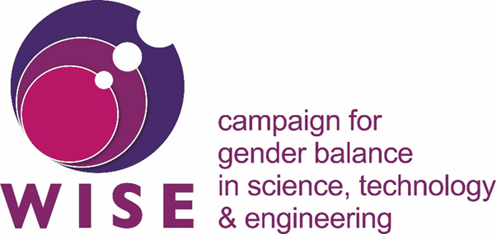
www.wisecampaign.org.uk

Ruth Frost
Partnership Manager
r.frost@wisecampaign.org.uk

What does your organisation do to improve social mobility and access to the professions? | WISE enables and energises people in business, industry and education to increase the participation, contribution and success of women in science, technology, engineering and mathematics (STEM).
What can IP sector organisations do to help? | Organisations can help by joining WISE and signing up as Ten Steps signatories to commit to improving cultural change in their organisation and further improving the recruitment, retention and career progression of women in STEM careers.
What can individual professionals do to help? | Individuals can help by signing up on our role model site (https://myskillsmylife.org.uk/) to showcase their career choices to young girls and help broaden outreach in schools and promote the WISE campaign this year through our 1 of the Million campaign (https://www.wisecampaign.org.uk/1ofthemillion) – sharing the link and uploading a photo of yourself to promote women in STEM.
If applicable, what specific things could IP professionals do to help your organisation during Careers in Ideas Week (16-22 November 2020)? | The more role models WISE have, the more we can promote the amazing technical careers available to women everywhere – if nothing else, please sign up as a role model on the My Skills My Life site and the 1 of a Million campaign (details above)!

