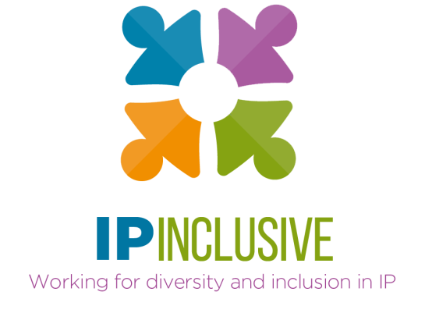
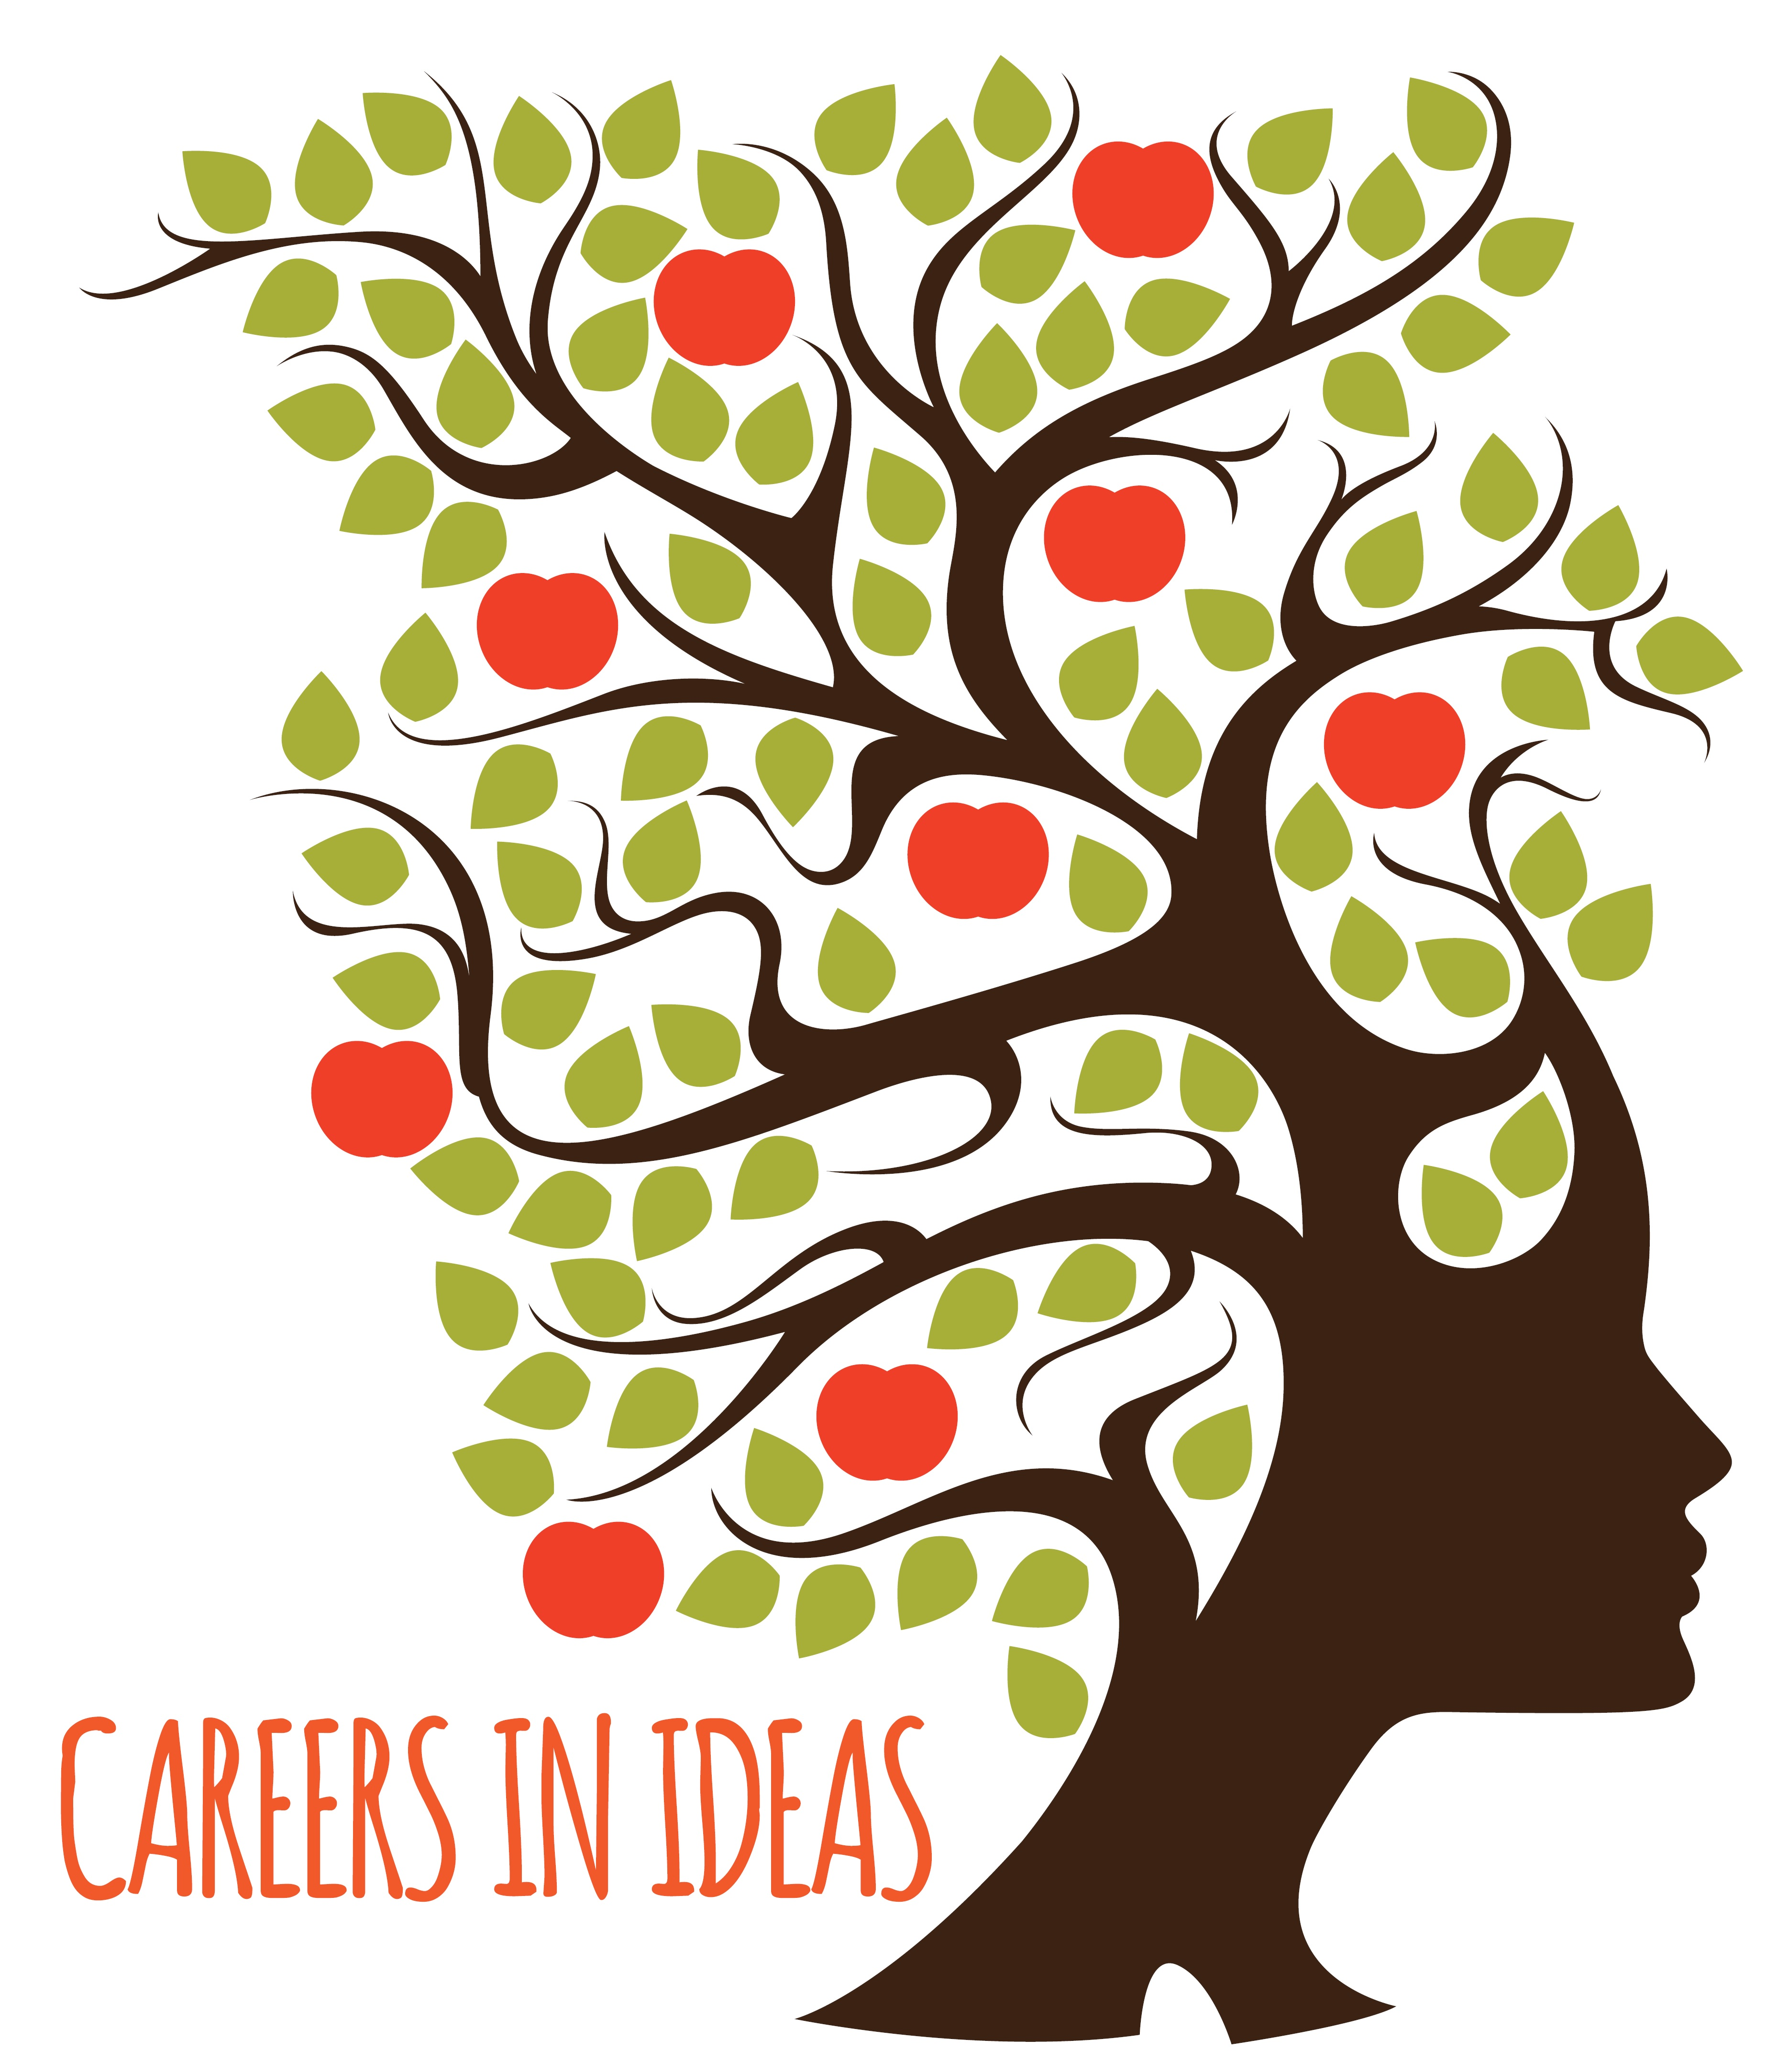

Careers in Ideas event 27.11.20

“Applying to train as a patent or trade mark attorney”

Some additional notes about accessibility
Please read these notes when you watch the recording of our 27 November 2020 event on “Applying to train as a patent or trade mark attorney”. They relate to an important aspect of the discussion which was covered in the final plenary session, after recording had stopped.

The context
As will be clear from the panellists’ comments, there is a great deal of competition for patent and trade mark trainee positions. This is likely to increase during the economic turmoil caused by the Covid-19 pandemic, and also as awareness of IP sector careers grows among university students.
What will also be clear is that, in both professions, accuracy and attention to detail are crucial qualities in a would-be recruit. Good communication skills, both written and spoken, are also important. These things are key to the work that patent and trade mark attorneys do, and employers will inevitably be looking to assess them in the people they hire.

So what if these things are an issue for you?
We are all of us, however – including patent and trade mark sector employers – becoming more sensitive to the challenges that traditional assessment methods can present for some people. These are people who might make very good patent or trade mark attorneys, but for whom some assessment techniques present an unfair barrier to entry.
For example, you might have dyslexia, dyspraxia, dyscalculia or some other specific learning difficulty that would make certain interview tasks or associated tests difficult for you. You might suffer from social or other forms of anxiety, or have another mental health condition that affects your performance in time-pressured or team tasks. You might currently be less fluent in written or spoken English, for example because you’ve been working abroad for a while, even though you know you’d be up to the job requirements given time. You might use a wheelchair or otherwise find travel challenging. You might have a health condition that makes a longer assessment session physically difficult.
Or you might have other things in your life that could make a conventional interview difficult: for example, you might have caring responsibilities you need to work around; or struggle to finance the travel and accommodation arrangements that an interview or assessment day necessitates.

How to deal with this
We understand that these things can be difficult to raise if you’re worried about reducing your chances of getting a job. But we strongly encourage you to mention them to prospective employers before they become an issue – in other words, before you attend an interview or complete any form of assessment, ideally in your first application letter.
Most IP sector employers are keen to recruit fairly. Most will try to make adjustments so that you can show them the best that you’re capable of. Most want to diversify the teams they employ. None of them want to miss out on potential talent because their selection procedures have inadvertently excluded somebody good.
But they need to know. If they don’t, they can’t accommodate. So please have the courage to ask if you have a difficulty or need support; usually only a small adjustment will be needed to level the playing field and make the system work for you, and most employers will be happy to help.

Be yourself!
As the panellists said, it’s important in any selection process to be honest about what you can and can’t do. Be up-front about what you need. Bring your “whole self” to the process.
If you do that:
- Your prospective employer can provide the adjustments you need
- If they don’t, you’ll learn a lot about whether you’d be happy with them, before it’s too late
- If you’re successful, they’ll know how to support you when you join, so that you can fulfil your potential as a patent or trade mark attorney
- You’ll help future applicants and employees to bring their whole selves to work too

Very best of luck!
The Careers in Ideas team

If you’d like more information or advice about the accessibility of the patent and trade mark professions, please visit the IP Ability page of the IP Inclusive website.
IP Ability is a networking and support community dedicated to disabled people, neurodiverse people and carers. It produces guidance to help both employees and employers in the IP sector become more disability-confident.

