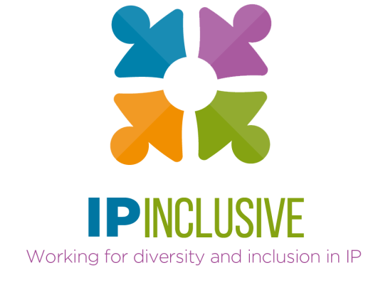

IP Inclusive
Diversity in IP global meeting

Venue: Zoom
Timing: 5 – 6.30 pm (UK time)
Chair: Andrea Brewster OBE, Lead Executive Officer, IP Inclusive

Agenda

1700-1705 Introduction
FICPI-UK
1705-1710 A word from the UK Intellectual Property Office
Tim Moss CBE, Chief Executive Officer and Comptroller General
1710-1730 An introduction to IP Inclusive and its work
Andrea Brewster
IP Inclusive’s “communities”
Darren Smyth, EIP
The Careers in Ideas outreach campaign
Chris Burnett, Birkett Long
1730-1750 Breakout sessions (i)
Join one of our breakout hosts for an informal chat on your first chosen theme (options below)
1750-1805 IP Inclusive and the membership bodies
Lee Davies, Chief Executive, CIPA
Richard Goddard, President, CITMA
IP Inclusive and industrial IP departments
IP Federation
1805-1825 Breakout sessions (ii)
A chance to discuss your second chosen theme with another breakout host
1825-1830 Summing up and closing remarks

Please note: the plenary parts of this meeting will be recorded and the recording made available via the IP Inclusive website. The breakout sessions will not be recorded.

Breakout session themes
The breakout sessions will explore the roles of the following in promoting diversity and inclusion in IP:
- IP Inclusive generally: strategy and management
- The IP Inclusive Charter: private practice perspectives
- The IP Inclusive Charter: in-house perspectives
- The IP Inclusive Charter: business support perspectives
- IP & ME (our community for BAME professionals and their allies)
- IP Ability (our community for disabled people, carers and their allies)
- IP Futures (our community for early career professionals)
- IP Out (our community for LGBT+ professionals and their allies)
- Women in IP (our community for female professionals and their allies)
- Careers in Ideas (our careers outreach campaign)
- Membership and representative bodies
- The national IP Office
- The IP regulator
- IP solicitors and barristers
- Mental health charities

