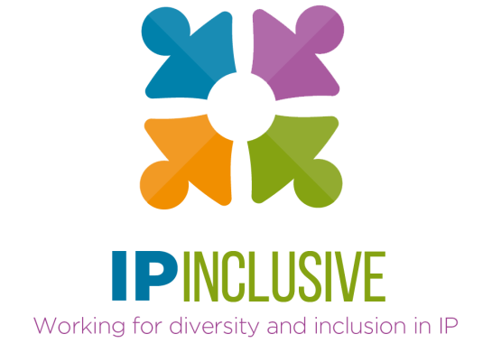


Careers in Ideas:

Meet the IP Crowd

To mark National Careers Week 2022, Careers in Ideas is creating a series of “bite-size” videos about different types of careers in the intellectual property (IP) professions. People who are already part of the IP Crowd have recorded some brief thoughts about their own Careers in Ideas, to give you a taste of what they do, why they enjoy it and how you can join them.
There are all sorts of jobs available here. Whatever you’re interested in, whatever you’re studying, there’ll be a role for you. Some are law-based, some science-based, some more business-focused. Some you need a degree for whilst others can be joined straight from school.
Please take a look at the first, general video about why IP is such a great sector to work in at the moment. Then pick and choose from the others depending on the types of Careers in Ideas you think you might want for yourself.

Who’s in The IP Crowd?
Here are the videos we’ve recorded so far. Just click on the thumbnails to access the ones you want to watch.

 | Why a career in IP? And why now?  Andrea Brewster OBE, who leads the IP Inclusive initiative behind Careers in Ideas, explains why now is such a great time to be thinking about joining the IP professions.  [You can also read the transcript here.]
 | Monifa (trainee patent attorney)  Monifa tells us what she enjoys about training to become a patent attorney after her physics degree.
 | Tom (trainee patent attorney)  Tom's short video about what you need to become a patent attorney is full of enthusiasm for the job he does.
 | Cherry (trade mark attorney)  Hear from Cherry about her work as a trade mark attorney, why she enjoys it, and how you can train to be one too. Cherry also talks about the other groups and campaigns she's involved with outside her day job.
 | Chris (patent attorney)  Hear from Chris, who’s also a patent attorney, about how he found the career he loves and what it involves.
 | Ellie (IP disputes solicitor)  Ellie tells us how wonderfully varied her work as an IP disputes solicitor is, and explains some of the routes into careers in IP law.
 | Ellie (diversity champion)  This Ellie's a diversity champion in an IP sector firm. She tells us what you need to go into that kind of work.
 | Julie (patent attorney – and more!)  Julie’s a patent attorney who’s had a range of IP-related roles, in different types of organisation, through her career. She tells us about the opportunities available and how much she’s enjoyed her work in the IP professions.
https://www.youtube.com/watch?v=bjvsRdz6vFI | IP Office examiners  …And here’s a link to a video created by the UK’s Intellectual Property Office (IPO), about a career as an IPO patent examiner. Meet different people who’ll tell you how they got into this role, what it’s like to work at the IPO and why they enjoy their job so much.

The IP Crowd collages
Why not download one of our FREE “The IP Crowd” collages to display in your classroom or common room?
We love the way the different people in these posters – all of them IP professionals – have allowed us to see a little of what makes them special: aspects of their identities and their hobbies outside of work. This is an inclusive, and increasingly diverse, sector. Perhaps you can make it more so?
Everyone’s welcome!

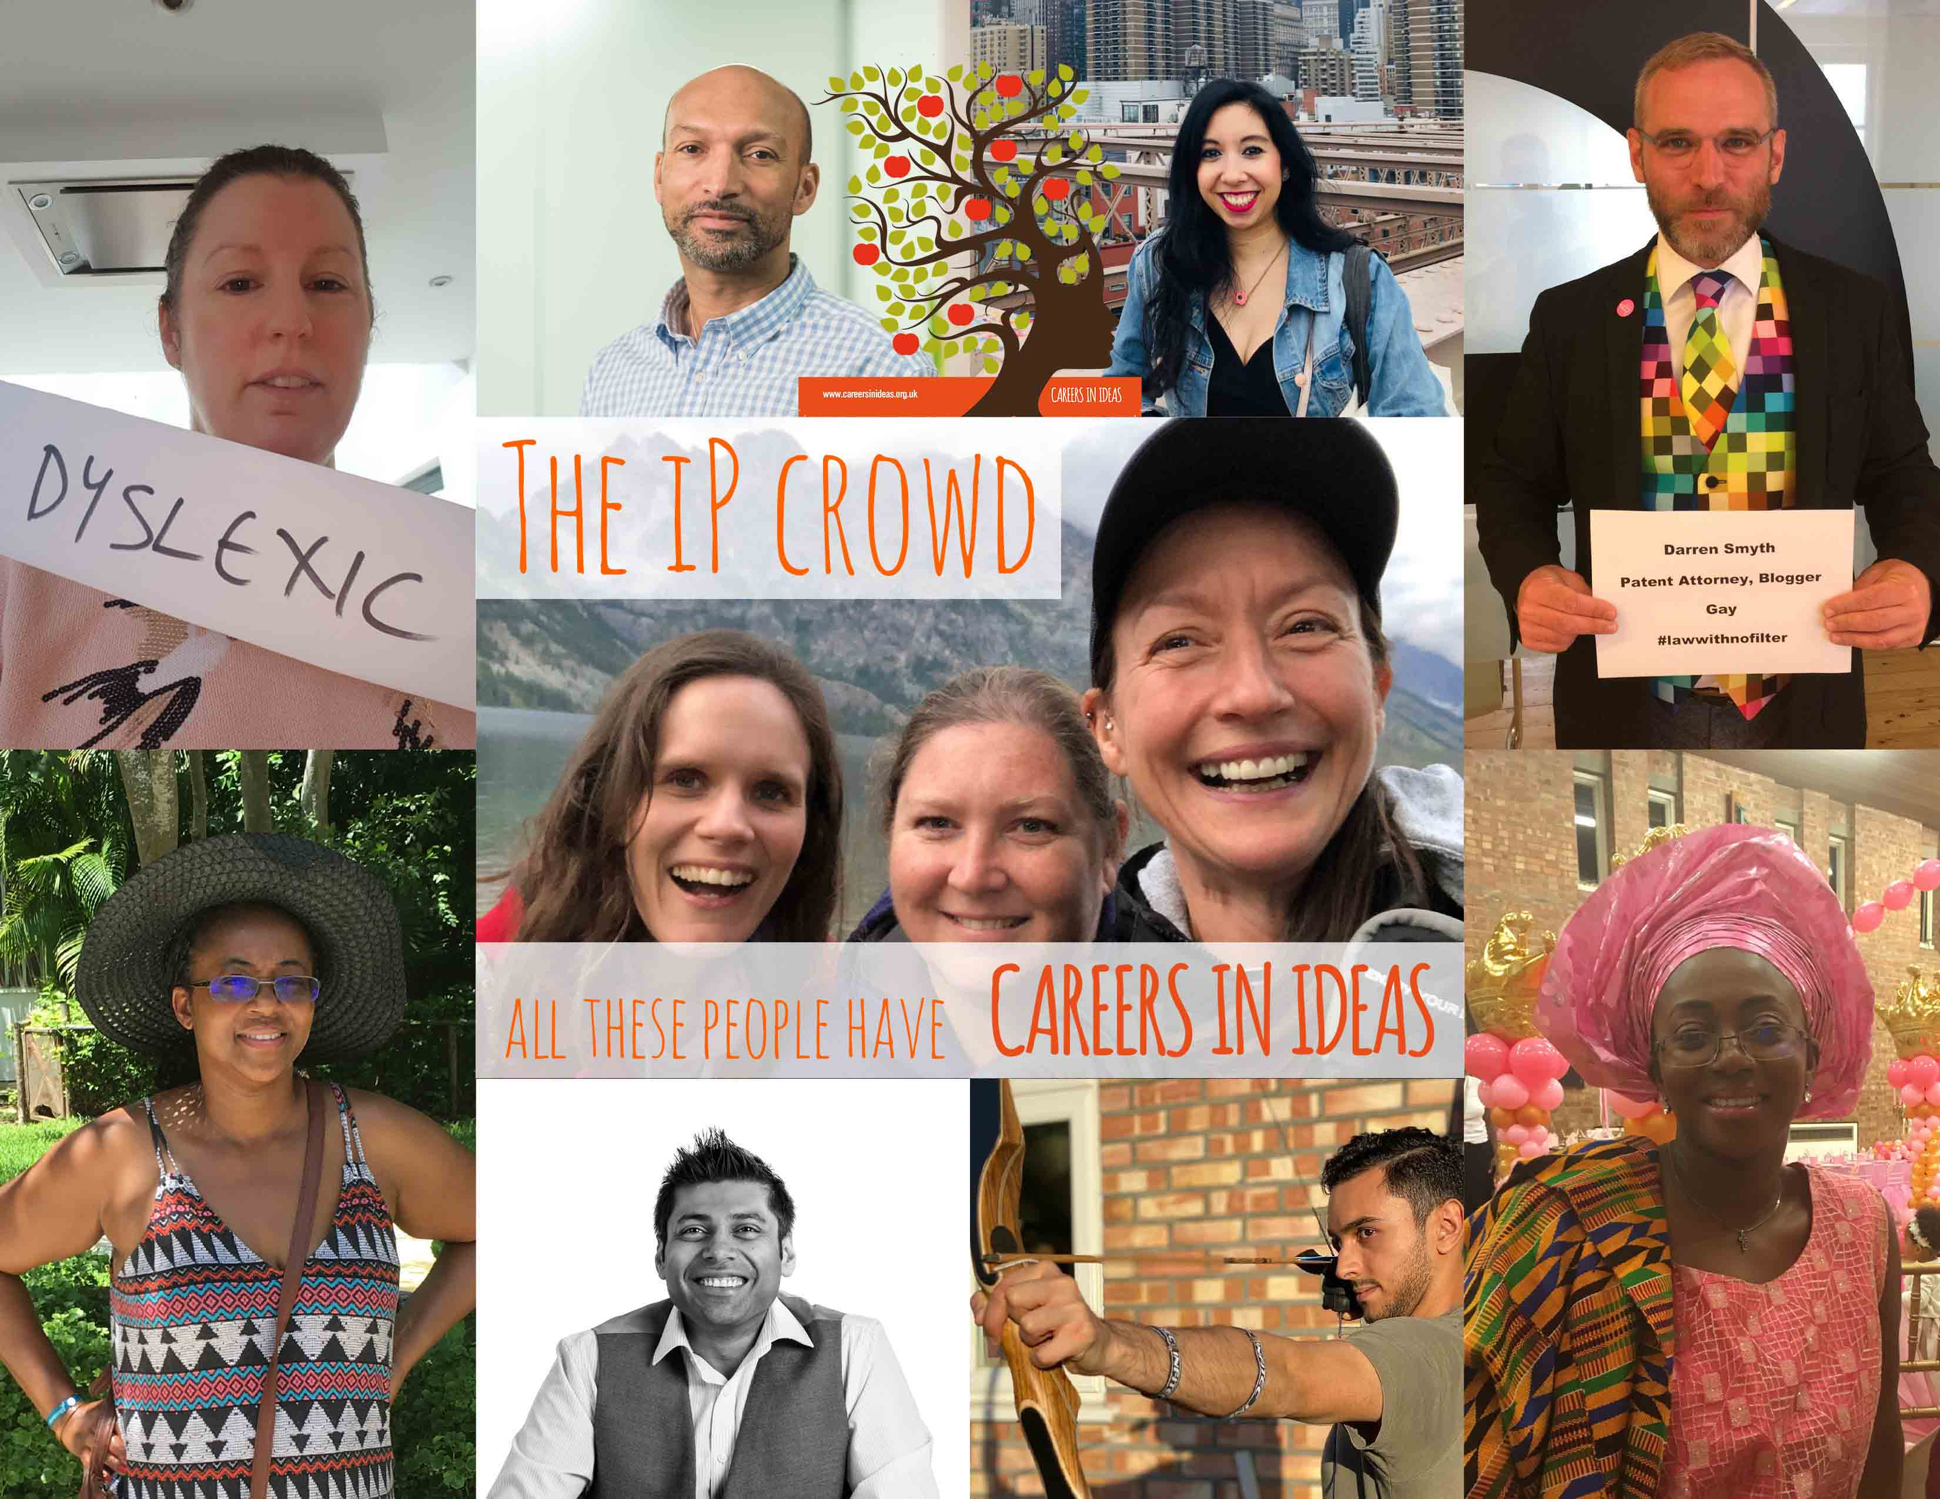
You can access all the collages here.

About Careers in Ideas
Careers in Ideas is an outreach campaign set up to raise awareness of, and improve access to, careers in the UK’s IP professions. It is part of IP Inclusive, a UK-based initiative working to promote equality, diversity, inclusion and wellbeing in the IP professions, and was set up on the basis that the best way to increase diversity within a sector is to diversify the pool of talent that the sector recruits from. Careers in Ideas provides information and resources for use in schools, further and higher education and careers support, and free events and a Mentoring Hub for would-be IP professionals.
You can find out more about Careers in Ideas by visiting its website at https://careersinideas.org.uk/, or the Careers in Ideas page of the IP Inclusive website here. Or follow us on Twitter (@CareersInIdeas) or LinkedIn.

