Carol Nyahasha  is a Senior Trade Mark Attorney  at Baron Warren Redfern  LinkedIn:  https://www.linkedin.com/in/carol-nyahasha-314a5225/ |  |  | “Always look for the opportunity in everything life presents to you, good or bad!”
Likes: | Anything to do with branding, Star Trek and handbags
Dislikes: | Cancel culture and mean girls
Previously worked:
2000-2003 |  | PepsiCo (Dallas) – Trade Mark Paralegal |  | 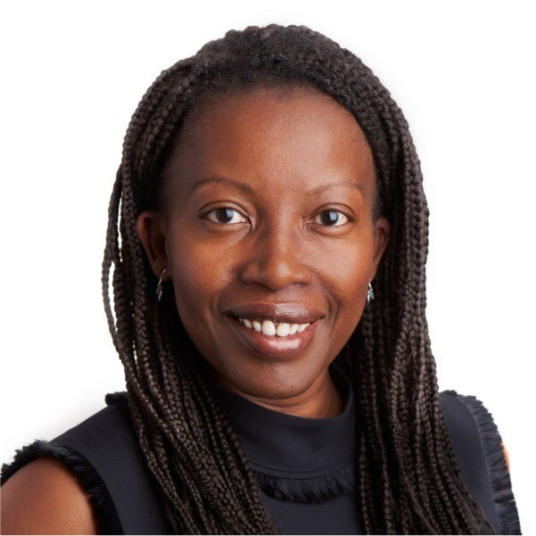
2003-2006 |  | Baker & McKenzie – Trade Mark Assistant |  | YOUR NOTES:  - Please use this space to write questions in advance of the session, or notes during the session.  [your notes]
2006-2013 |  | Taylor Wessing – Trade Mark Attorney
2013-2015 |  | Eversheds Sunderland – Trade Mark Attorney
2015-2018 |  | Self-employed - Lily & Lavender Events  – Event Planner/Designer
2018-2020 |  | Rational IP – Trade Mark Attorney
2020-current |  | Baron Warren Redfern – Trade Mark Attorney
Previously studied:
BA, Economics & Finance
How they found out about the profession:
I started off as a filing clerk in the PepsiCo legal department (part time job to pay for university) and was asked to cover for a paralegal in the trade marks department going on maternity leave and the rest is history!
What does an average day look like?
- My day always starts off with coffee and checking my diary to see what deadlines and deliverables I have for the day
- Answer emails - I try to get back to clients within 24 hours - I make calls if necessary as sometimes that’s easier than an email
- Start tackling the to-do list
- More coffee!
- Check in with my supervising partner - very important nowadays as we are mostly working remotely
- Dedicate 30mins to an hour to Business development (writing/reading articles, following up on potential business etc)
- Do any admin (invoicing, time recording, e-filing of emails etc) - organisation and staying on top of paperwork is key!
Top tips for job applications and interviews?
Prepare, prepare, prepare and remember it is as much an interview of the employer as it is yours so be sure to ask questions to make sure they are good fit for you as well!

Rachel Bell  Don’t be discouraged by rejection – keep knocking on the door and someone will answer eventually!  is Patent Counsel  at GSK  LinkedIn: http://linkedin.com/in/rachelbellphd |  |  |  |  | 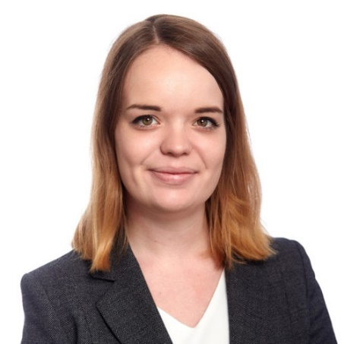
Likes: | Crystal Palace football club  Food – cooking, eating and thinking about it!
Dislikes: | Cartoons
Previously worked:
2021 – present |  |  | Patent Counsel @ GSK
2017 - 2021 |  |  | Trainee Patent Attorney @ Marks & Clerk |  | YOUR NOTES:  - Please use this space to write questions in advance of the session, or notes during the session.  [your notes]
2014 - 2017 |  |  | PhD @ King’s College London
2013 – 2014 |  |  | Graduate Scientist @ Dstl
Previously studied:
BSc in Biological Sciences (Microbiology) at University of Leicester, and then a PhD in cellular and molecular biology at King’s College London
How they found out about the profession:
- Family friend who was a patent attorney
- Got more serious about it after university, did a PhD to improve my chances and spent time during my PhD researching the career and improving my CV for this
What does an average day look like?
- Go into the office in Brentford or log on at home and take a look at the emails that have come in overnight e.g. from my US colleagues
- Then no day is the same! I spend about a third of my day in meetings e.g. to speak to R&D “clients” about new inventions or general IP strategy questions/issues; meetings with team members to catch-up on best practice or developments in the law; to speak to team members including my boss to try and work through specific issues that have come up with our patents
- I spend the other two thirds of my day doing fairly quiet/focused work like drafting or prosecuting patent applications through examination, preparing to oppose a patent or defending our patents against opposition, considering and replying to questions from the business (e.g. in R&D or wider legal), reviewing IP aspects of contracts/agreements, thinking about bigger picture strategy for IP protection for our pharmaceuticals/infrastructure, and providing IP education to internal people who do not work in IP
Top tips for job applications and interviews?
- Specific for patent attorney vacancies – take a look on the European Patent Register and search for the people who are interviewing you to see what kind of cases/subject matter they deal with – you can then see if this aligns to your own knowledge or even read up on some of the basics of the technology to be super prepared on this
- Try to think about your more unusual experience and how this might be relevant for the job. For example, a key skill for a patent attorney is being able to explain complex legal concepts to those with less knowledge of IP, so a relevant experience that demonstrates this skill may not just be being involved in a legal clinic, but also any sort of role where you have had to teach (e.g. a gymnastics instructor, a music teacher, or outreach in a school!)
Vicky Binnie  is an Associate Patent Examiner  at the UK Intellectual Property Office (UKIPO) |  |  |  |  | 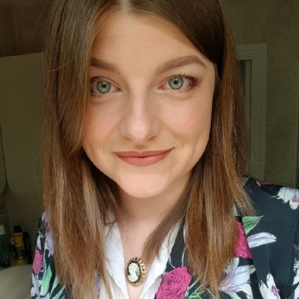  The culture and atmosphere of where you work is just as important as the job you do. If you are happy where you work, you will work to your best ability!
Likes: | Horse riding, walking my dog, pop-punk music from the late 90’s/early 2000s
Dislikes: | Pineapple on a pizza.
Previously worked:
2020-present |  |  | Associate Patent Examiner at IPO
2018-2020 |  |  | Patent Analyst at Patent Seekers Ltd. |  | YOUR NOTES:  - Please use this space to write questions in advance of the session, or notes during the session.  [your notes]
2016-2018 |  |  | Physics teacher in a secondary school
Previously studied:
At university I studied Physics specializing in particle physics and cosmology. My final year project was on the spacetime of inflation and black holes. I contemplated doing a Masters degree but decided I wanted to become a teacher. So I did a PGCE in Physics and secondary school science.
How they found out about the profession:
A patent attorney gave a talk at my uni. A career in IP sounded varied and interesting, and a way to use my degree without needing a postgrad or going into research
I ultimately joined the profession because of this after leaving teaching, and joined the IPO specifically because of the career progression opportunities, culture and environment of the IPO.
What does an average day look like?
- Working predominantly from home, going into the office for meetings, talks or team-building (or if I just feel like it).
- Pick up a case, which will involve reading about and understanding an invention from a specification given to me. I may have to do a search to see if it’s been done before.
- Usually a chat with my manager asking for advice or just catching up. I may have a virtual meeting or two throughout the day.
- Writing reports of my findings, whether I think something is inventive or not, or maybe responding to an agent’s arguments as to why they think an invention is inventive and can obtain a patent. Sometimes chatting to agents on the phone.
- Good technical and communication skills needed. The ability to work things out, be analytical and pay attention to detail. The ability to explain yourself and influence people. If you don’t mind reading (lots) and report writing, and you like figuring out how stuff works, seeing new tech or arguing with people (in the nicest possible way haha), then you will love the job!
Top tips for job applications and interviews?
Give examples of where and how you have shown you have the skills required in the job description. Take your time in the interview to really understand the tasks and questions being asked. Try to explain and articulate your thinking and why you have made certain decisions/reached certain conclusions in the interview.
Katie Atkinson  is an Associate IP Solicitor  at Taylor Wessing UK  LinkedIn: www.linkedin.com/in/katie-atkinson-52805524 |  |  |  |  |  |  | 
Likes: | Theatre, learning languages, walking
Dislikes: | Tomato ketchup
Previously worked: |  |  |  |  |  |  |  | “One of the benefits of training as a solicitor is that the nature of the work varies considerably depending on which department you are placed in.”
2014 |  | University of Cambridge  (Post Doc Research Associate - biomaterials)
2017-2019 |  | Jaguar Land Rover (Materials Engineer - metallurgy) |  |  |  |  |  | YOUR NOTES:  - Please use this space to write questions in advance of the session, or notes during the session.  [your notes]
2019-2021 |  | Allen & Overy LLP (Trainee Solicitor)
2021-2021 |  | Kirkland & Ellis (Associate Solicitor)
2021-Present |  | Taylor Wessing UK (Associate Solicitor)
Previously studied:
I completed an MSci in Experimental and Theoretical Physics at the University of Cambridge. I spent my third year at MIT in Boston as part of the Cambridge-MIT exchange programme. I stayed at the University of Cambridge for a PhD on flexoelectricity in liquid crystal materials for display devices.
How they found out about the profession:
During my PhD, I decided that I did not want to pursue a career in academic research because the prospect of completing multiple postdoctoral research contracts was unappealing. I sat on the committee for the Cambridge University Technology and Enterprise Club. A number of our events were sponsored by IP law firms and I decided to further investigate careers in IP. The prospect of combining knowledge of technology and the law appealed to me. I completed work experience at the World Intellectual Property Office in Geneva, vacation schemes in law firms and some work experience with a firm of patent and trade mark attorneys. Having considered several different roles within the IP professions, I decided that training as a solicitor appealed to me most.
What does an average day look like?
One of the benefits of training as a solicitor is that the nature of the work varies considerably depending on which department you are placed in. Depending on the firm you train with, you are likely to complete 4-6 placements (known as seats) during your training contract. Typical trainee tasks include legal research, drafting sections of transaction documents and assisting in the coordination of transactions, as well as more administrative tasks such as proof-reading or compiling documents.
Top tips for job applications and interviews?
Vacation schemes in law firms and at firms of patent and trade mark attorneys are very competitive. If you are unable to secure a formal work experience placement, consider applying speculatively for legal work experience in-house or in other areas of law. Legal work experience of any nature will strengthen your application and help boost your confidence in interviews.

Nicola Palmer
is an IP Barrister
at PBIP Solicitors Limited
Likes: | Skiing, walking, cooking, socialising |  |  | 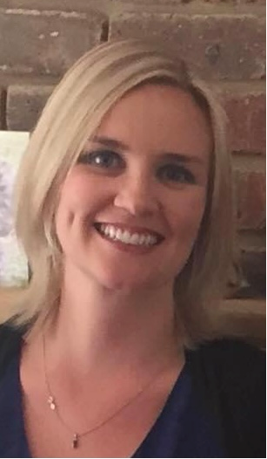
Dislikes: | Counterfeiters!
Previously worked:
2010 to date |  | Employed Barrister (IP) at PBIP Solicitors
2002-2010 |  | Self Employed Barrister (Crime) at Westgate Chambers |  | YOUR NOTES:  - Please use this space to write questions in advance of the session, or notes during the session.  [your notes]
2001-2002 |  | Pupillage (Crime) at 9-12 Bell Yard, London
Previously studied:
- I studied Law (LLB) at the University of Sussex
- I completed the Bar Vocational Course at the Inns of Court School of Law
- I completed the Post Graduate Certificate in Intellectual Property at Bournemouth University
How they found out about the profession:
- I decided on a career in law when I was still at school after a careers talk
- At university I was interested in personal injury initially but then I started outdoor clerking for a criminal law firm and decided that was what I wanted to do.
- I changed to IP law after having a family, as criminal law is not very family friendly.
- My husband is an IP lawyer and ran his own business, which I joined in 2010.
What does an average day look like?
- Anti-counterfeiting work (trade mark infringement)
- Analysis of evidence
- Investigation work
- Drafting of documents
- Considering all possible scenarios when trying to reach settlement
- Negotiation
- Liaising with clients / other lawyers / law enforcement agencies (eg. PIPCU / Trading Standards / UKBF)
Top tips for job applications and interviews?
- I have not had many interviews in my life as I have not moved about much, but I did make my pupillage interviewers laugh and I was offered the pupillage!
- Don’t make mistakes in your CV.
- Tailor a covering letter and make sure you include one.
- Add some personality to the letter/CV.
“Working in London isn’t everything. I decided London was not for me after my pupillage so went to Lewes to work. Working for a smaller firm/at chambers outside London usually gives more flexibility, although the pay may not be as good. Think about your work/life balance. It can change a lot in 10-15 years.”

Other notes from the session

- Please fill this out with any miscellaneous notes you think of…

