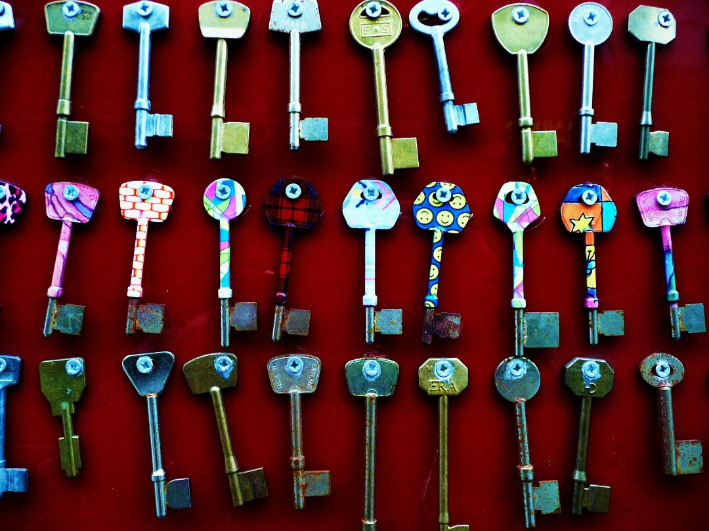

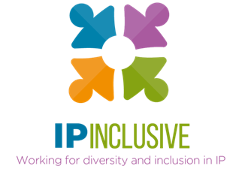
INCLUSIVITY UNLOCKED!
Programme of events

Follow-up resources, for example webinar reports and recordings, can be found in the online post for the relevant event, where you can also access sign-up links for those still to come.

Leaving no one behind (part i)
Date: Tuesday 20 September 2022
Time: 12.30 – 1.30 pm
Location: Zoom
Online event post: https://ipinclusive.org.uk/events/leaving-no-one-behind-part-i/
Our first Inclusivity Unlocked! event kicks off with a panel discussion made up of representatives from our support communities. Our panellists for this event include Josh McLennon (IP & ME), Kevin Rich (IP Out) and Janine Swarbrick (the IP Non-traditional Family Network).
The panel will be discussing how the communities they represent have found the transition into the post-Covid working world. They will share their experiences of adjusting to post-Covid working arrangements, any challenges they have faced, and how working arrangements can be made more inclusive from here on.

Leaving no one behind (part ii)
Date: Tuesday 27 September 2022
Time: 12.30 – 1.30 pm
Location: Zoom
Online event post: https://ipinclusive.org.uk/events/leaving-no-one-behind-part-ii/
The second instalment of our “Leaving no one behind” event will feature a discussion with our other IP Inclusive support communities. This time our panel will include Sanam Habib (IP Futures), Megan Rannard (IP Ability) and Lucy Samuels (Women in IP).
The panel will continue looking at the themes discussed in the previous event and provide additional insights into how working arrangements can be made more inclusive in the post-Covid world.

What’s for starters?
Date: Thursday 13 October 2022
Time: 12.30 – 1.30 pm
Location: Zoom
Online event post: https://ipinclusive.org.uk/events/whats-for-starters/
This joint event with the mental wellbeing charity Jonathan’s Voice will explore the theme of providing early-career support as we emerge from the pandemic and adopt new working arrangements. The event will begin with a summary from Jonathan’s Voice of the findings from our recent joint mental wellbeing survey. This will be followed by a panel discussion involving trainees, trainers and HR professionals, with time for questions at the end.

Harnessing hybrid
Date: Thursday 10 November 2022
Time: 12.30 – 1.30 pm
Location: Zoom
Online event post: https://ipinclusive.org.uk/events/harnessing-hybrid/
Join us for a “fireside chat” with Ruth Gawthorpe, the CEO of Smart Working Revolution, and Jenna Massey, Practice Director at Gill Jennings & Every. Together we will explore the theme of hybrid working models, the challenges and opportunities they bring, and how to design and implement them so as to boost collaboration, innovation and productivity.

Exchanging expectations
Date: Tuesday 15 November 2022
Time: 12.30 – 1.30 pm
Location: Zoom
Online event post: to follow soon
In this joint event with Focal Point Training, we will be looking at team members’ expectations in the post-Covid world. Focal Point director and co-founder Stella Chandler will take us through their “Exchanging Expectations” model, which focuses on how to build two-way, open and trusting relationships in the workplace. The model will help you identify a more inclusive way of working and provide you with practical tools to use in your own organisation.

Look out for more events in the Inclusivity Unlocked!, series, on topics such as business development in the hybrid world, menopause inclusivity, and the impact of new working patterns on mental wellbeing. We’ll post details on our website events page at https://ipinclusive.org.uk/events/.

