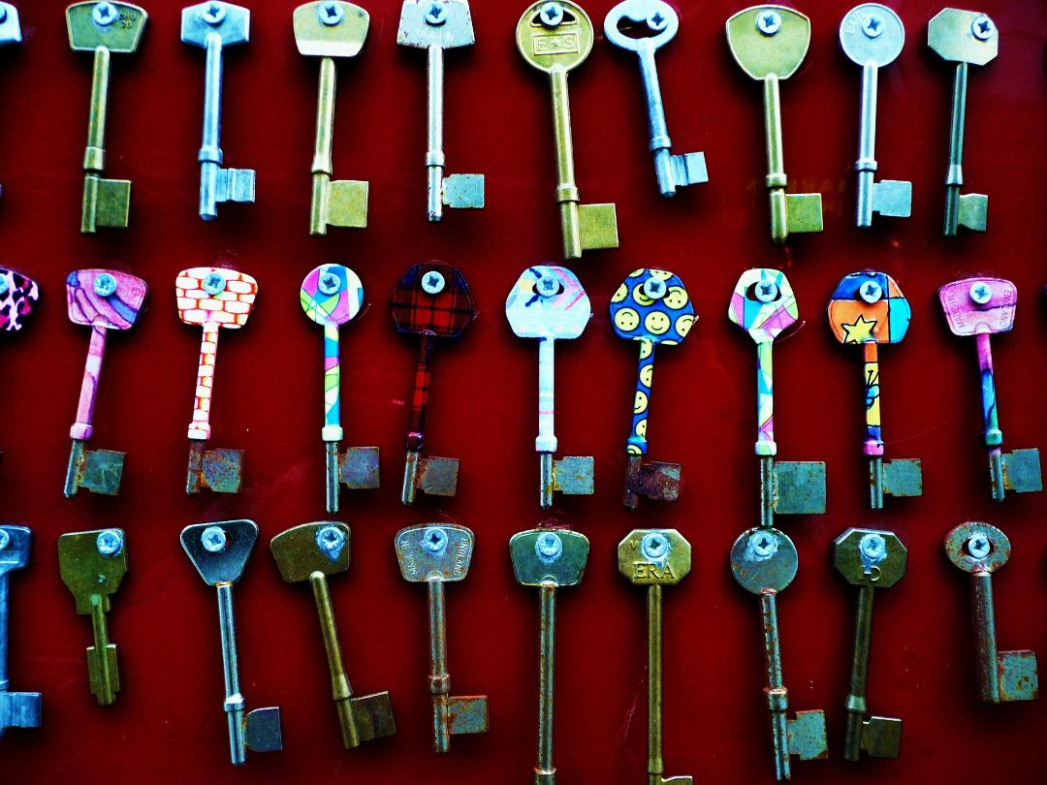

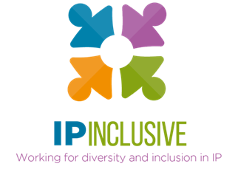
INCLUSIVITY UNLOCKED!
Programme of events

Follow-up resources, for example webinar reports and recordings, can be found in the online posts for the relevant events: see our website events page, where you can also access sign-up links for those still to come. We’ve also included links to the recordings, reports and “top tips” slides in the annexed summary of past events.
If you have suggestions for other event themes or formats, please let us know by taking our quick survey at https://www.surveymonkey.co.uk/r/M682YMT.

Online, but not forgotten
Date: Thursday 9 March 2023
Time: 12.30 – 1.30 pm
Location: Zoom
Online event post: https://ipinclusive.org.uk/events/online-but-not-forgotten/
This is a joint event with our IP Ability community and CIPA. It will look at the challenges faced by disabled (including neurodivergent) people when interacting with online content such as websites, registration forms and event access. With the help of Chris Naylor from bnode, together with disabled IP professionals, we’ll be asking how IP organisations can make their websites and digital systems more user-friendly for everyone.

Menopause: what’s changing?
Date: Wednesday 22 March 2023
Time: 4.30 – 5.30 pm
Location: Zoom
Online event post: https://ipinclusive.org.uk/events/menopause-whats-changing/
Guest speaker Lauren Chiren, founder and CEO of Women of a Certain Stage, will talk us through the changes she's witnessed in perceptions of, and help with, menopause and perimenopause. She and her fellow panellists from the IP professions will provide tips for both individual professionals and their employers to create more menopause-savvy workplaces. They’ll also address the commercial and ethical cases for making these changes. This is a webinar for IP professionals in all roles and of all genders and ages – including those who want to be allies for people going through the (peri)menopause.

Too busy to flourish?
Date: Monday 27 March 2023
Time: 12.30 – 1.30 pm
Location: Zoom
Online event post: https://ipinclusive.org.uk/events/too-busy-to-flourish/
This joint webinar with LawCare will help employers and managers think more creatively about working practices and culture, so as to tackle our increasing mental health problems whilst also reaping the benefits of what we learned during lockdown. We'll review the drivers for change; look at the SRA's 2022 Workplace Culture Thematic Review and associated guidance; and explore tough practical issues such as working hours, billing targets and work-life boundaries, as well as overall best practices for reducing stress in the workplace.



Annex:
INCLUSIVITY UNLOCKED!
Past events & resources

Leaving no one behind (part i)
Date: Tuesday 20 September 2022
Time: 12.30 – 1.30 pm
Location: Zoom
Online event post: https://ipinclusive.org.uk/events/leaving-no-one-behind-part-i/
Our first Inclusivity Unlocked! event kicked off with a panel discussion made up of representatives from our support communities. Our panellists for this event were Josh McLennon (IP & ME), Kevin Rich (IP Out) and Janine Swarbrick (the IP Non-traditional Family Network).
The panel discussed how the communities they represent have found the transition into the post-Covid working world. They shared their experiences of adjusting to post-Covid working arrangements, challenges they had faced, and how working arrangements can be made more inclusive from here on.
Recording available at: https://youtu.be/XHyVBfynVnM
Event report at: https://ipinclusive.org.uk/newsandfeatures/leaving-no-one-behind-event-report/
Top tips at: see part ii below

Leaving no one behind (part ii)
Date: Tuesday 27 September 2022
Time: 12.30 – 1.30 pm
Location: Zoom
Online event post: https://ipinclusive.org.uk/events/leaving-no-one-behind-part-ii/
The second instalment of our “Leaving no one behind” event featured a discussion with our other IP Inclusive communities. This time our panellists were Sanam Habib (IP Futures), Megan Rannard (IP Ability) and Lucy Samuels (Women in IP).
The panel continued looking at the themes discussed in the previous event and provided additional insights into how working arrangements can be made more inclusive in the post-Covid world.
Recording available at: https://youtu.be/Cdl89CzMBxI
Event report at: https://ipinclusive.org.uk/newsandfeatures/leaving-no-one-behind-event-report/
Top tips at:
- For organisations: https://ipinclusive.org.uk/wp-content/uploads/2022/11/221103-leaving-no-one-behind-top-tips-for-organisations.pdf
- For individuals: https://ipinclusive.org.uk/wp-content/uploads/2022/11/221103-leaving-no-one-behind-top-tips-for-individuals.pdf
- For managers: https://ipinclusive.org.uk/wp-content/uploads/2022/11/221103-leaving-no-one-behind-top-tips-for-managers.pdf

What’s for starters?
Date: Thursday 13 October 2022
Time: 12.30 – 1.30 pm
Location: Zoom
Online event post: https://ipinclusive.org.uk/events/whats-for-starters/
This joint event with the mental wellbeing charity Jonathan’s Voice explored the theme of providing early-career support as we emerge from the pandemic and adopt new working arrangements. The event began with a summary of relevant findings from our recent joint mental wellbeing survey. This was followed by a panel discussion involving trainees, trainers and HR professionals, chaired by mental health consultant Penelope Aspinall.
Recording available at: https://youtu.be/ov1cxA_DNgU
Event report at: https://ipinclusive.org.uk/newsandfeatures/whats-for-starters-on-the-mental-health-menu/
Top tips at:
- For organisations: https://ipinclusive.org.uk/wp-content/uploads/2022/11/221108-whats-for-starters-top-tips-for-organisations.pdf
- For individuals: https://ipinclusive.org.uk/wp-content/uploads/2022/11/221108-whats-for-starters-top-tips-for-individuals.pdf
- For managers: https://ipinclusive.org.uk/wp-content/uploads/2022/11/221108-whats-for-starters-top-tips-for-managers.pdf
See also our “taking the long view” tips for managing workloads to reduce mental health problems:
- For organisations: https://ipinclusive.org.uk/wp-content/uploads/2022/11/221109-taking-the-long-view-top-tips-for-organisations.pdf
- For managers: https://ipinclusive.org.uk/wp-content/uploads/2022/11/221109-taking-the-long-view-top-tips-for-managers.pdf
- For small businesses: https://ipinclusive.org.uk/wp-content/uploads/2022/11/221109-taking-the-long-view-top-tips-for-small-businesses.pdf

Harnessing hybrid
Date: Thursday 10 November 2022
Time: 12.30 – 1.30 pm
Location: Zoom
Online event post: https://ipinclusive.org.uk/events/harnessing-hybrid/
In this “fireside chat” with Ruth Gawthorpe (CEO of Smart Working Revolution) and Jenna Massey (Practice Director at Gill Jennings & Every), we looked at building more effective and inclusive hybrid working models. The webinar explored the challenges and opportunities these models can bring, and how to design and implement them so as to boost collaboration, innovation and productivity.
Recording available at: https://youtu.be/Fm-0PsL30zA
Event report at: https://ipinclusive.org.uk/newsandfeatures/harnessing-hybrid-what-we-learnt/
Top tips at:
- For organisations: https://ipinclusive.org.uk/wp-content/uploads/2022/12/221201-harnessing-hybrid-top-tips-for-organisations.pdf
- For individuals: https://ipinclusive.org.uk/wp-content/uploads/2022/12/221201-harnessing-hybrid-top-tips-for-individuals.pdf
- For managers: https://ipinclusive.org.uk/wp-content/uploads/2022/12/221201-harnessing-hybrid-top-tips-for-managers.pdf

Teamwork, Trust and the post-Covid Tide
Date: Tuesday 15 November 2022
Time: 12.30 – 1.30 pm
Location: Zoom
Online event post: https://ipinclusive.org.uk/events/teamwork-trust-and-the-post-covid-tide/
This was a joint event with Focal Point Training, in which we looked at team members’ expectations in the post-Covid world. Focal Point director and co-founder Stella Chandler talked us through their “Exchanging Expectations” model, which focuses on how to build two-way, open and trusting relationships in the workplace. The model will help you identify a more inclusive way of working and provide you with practical tools to use in your own organisation.
Recording available at: https://youtu.be/2zqTX-Y9WzY
Event report at: https://ipinclusive.org.uk/newsandfeatures/teamwork-trust-and-the-post-covid-tide-webinar-report/
Top tips at: https://ipinclusive.org.uk/wp-content/uploads/2022/12/221215-teamwork-trust-post-covid-tide-top-tips.pdf

(Office) space: the final frontier?
Date: Monday 30 January 2023
Time: 12.30 – 1.30 pm
Location: Zoom
Online event post: https://ipinclusive.org.uk/events/office-space-the-final-frontier/
This webinar was about reshaping workspaces to optimise inclusion, cohesion and efficiency in the wake of the Covid-19 lockdowns. With the help of guest speakers Emma Wharton Love and Sarah Pasquall, from office fit-out and design specialists Interaction, and panellists from within the IP sector, we looked at what's new on the workspace design front, how we can use it to entice team members into the office, and how to optimise accessibility, inclusivity and connectivity for our new working arrangements. Discussions also covered strategic aspects of designing a workspace that aligns with the overall organisational culture.
Recording available at: https://youtu.be/lj_clzOBDEQ
Event report at: https://ipinclusive.org.uk/newsandfeatures/workspace-design-post-covid/
Top tips at: https://ipinclusive.org.uk/wp-content/uploads/2023/02/230227-workspace-design-top-tips.pdf
- See also our associated “opportunities & considerations” at https://ipinclusive.org.uk/wp-content/uploads/2023/02/230227-workspace-design-opportunities-considerations.pdf

Rainmaking for everyone
Date: Tuesday 8 February 2023
Time: 12.30 – 1.30 pm
Location: Zoom
Online event post: https://ipinclusive.org.uk/events/rainmaking-for-everyone/
This event explored modern, more inclusive approaches to business development (BD). Featuring Bernard Savage, a BD “guru” from Size 10½ Boots, it explained how virtually anyone can contribute to business growth if we're open to different approaches and more broad-minded success measures. We explored how the Covid-19 lockdowns have made that easier by introducing us to new ways of interacting with one another, and how that in turn can help us engage more inclusively with our clients.
Recording available at: https://youtu.be/uMqG0CnqMt0
Event report at: https://ipinclusive.org.uk/newsandfeatures/why-everyone-can-be-a-rainmaker/
Top tips at:
- For organisations: https://ipinclusive.org.uk/wp-content/uploads/2023/03/230303-rainmaking-for-everyone-top-tips-for-organisations.pdf
- For individuals: https://ipinclusive.org.uk/wp-content/uploads/2023/03/230303-rainmaking-for-everyone-top-tips-for-individuals.pdf
- For managers: https://ipinclusive.org.uk/wp-content/uploads/2023/03/230303-rainmaking-for-everyone-top-tips-for-managers.pdf

