

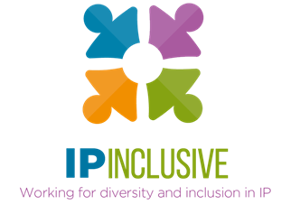
INCLUSIVITY UNLOCKED!
“Top Tips” compilation

These are the top tips we’ve distilled from our Inclusivity Unlocked! events so far.
Beneath each image we’ve provided a link to a pdf version: please feel free to download these and share them with your colleagues.
Other follow-up resources, for example webinar reports and recordings, can be found in the online posts for the relevant events: see our website events page, where you can also access sign-up links for those still to come.

Leaving no one behind (parts i and ii)
Dates: 20 & 27 September 2022
Online event posts: https://ipinclusive.org.uk/events/leaving-no-one-behind-part-i/ and https://ipinclusive.org.uk/events/leaving-no-one-behind-part-ii/
Panel discussions with our six communities, about opportunities and challenges in the post-Covid world for the specific groups they represent.

Top tips for organisations:
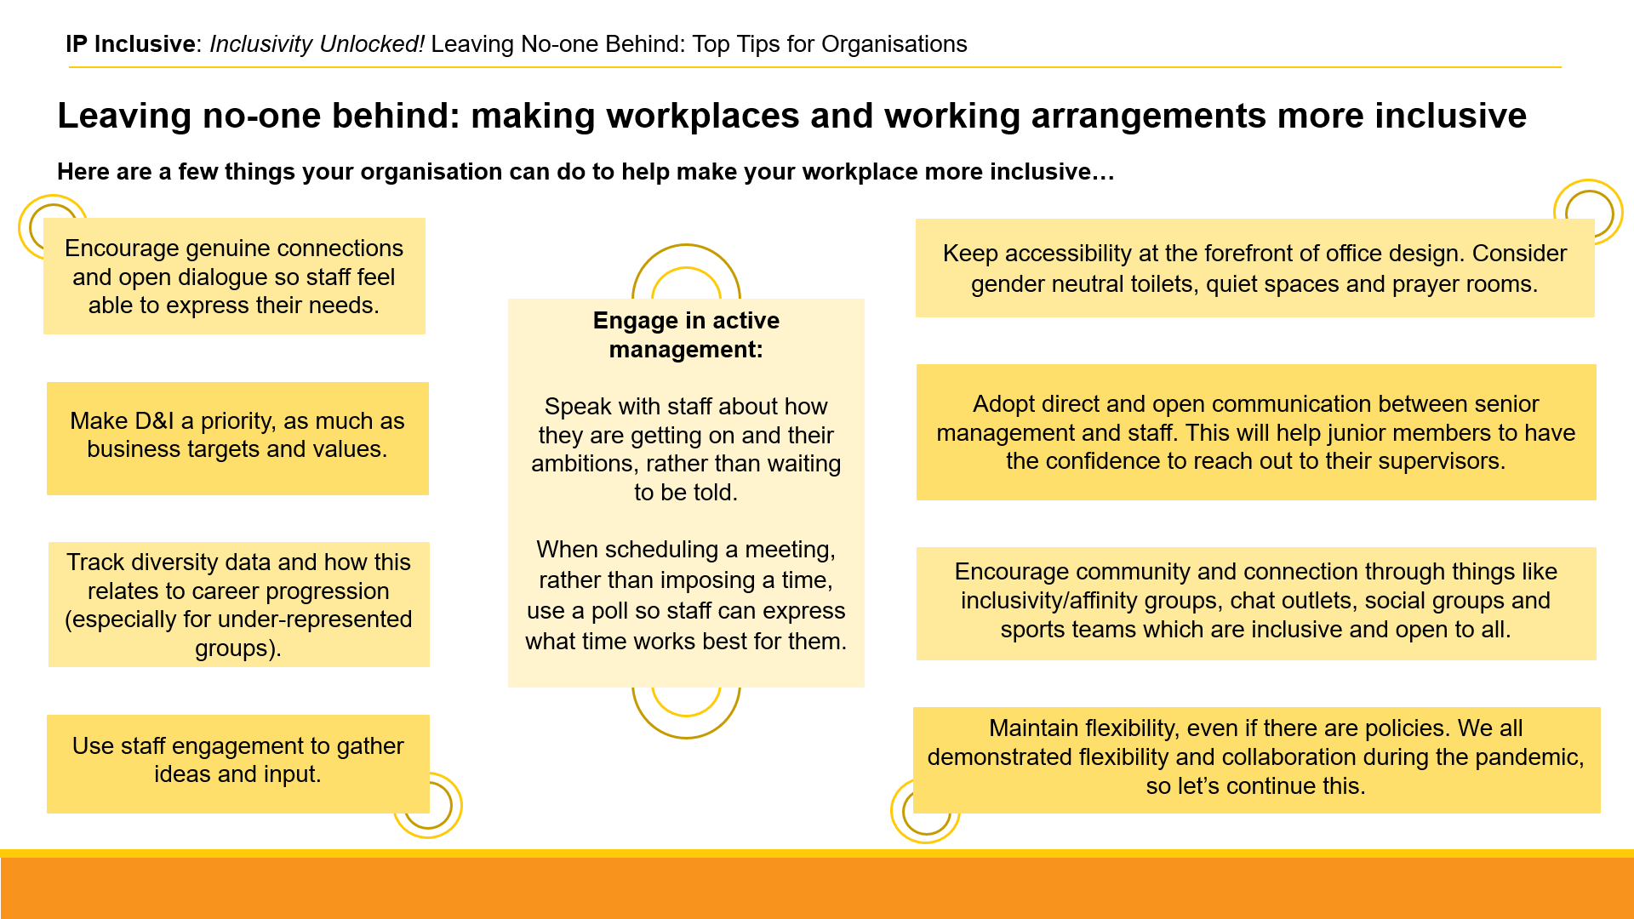
https://ipinclusive.org.uk/wp-content/uploads/2022/11/221103-leaving-no-one-behind-top-tips-for-organisations.pdf

Top tips for individuals:
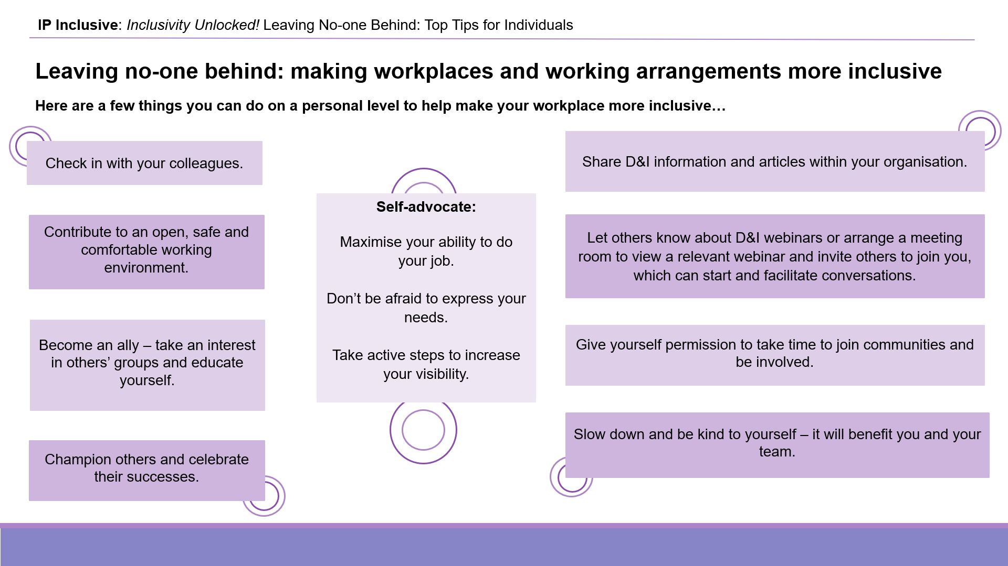
https://ipinclusive.org.uk/wp-content/uploads/2022/11/221103-leaving-no-one-behind-top-tips-for-individuals.pdf

Top tips for managers:
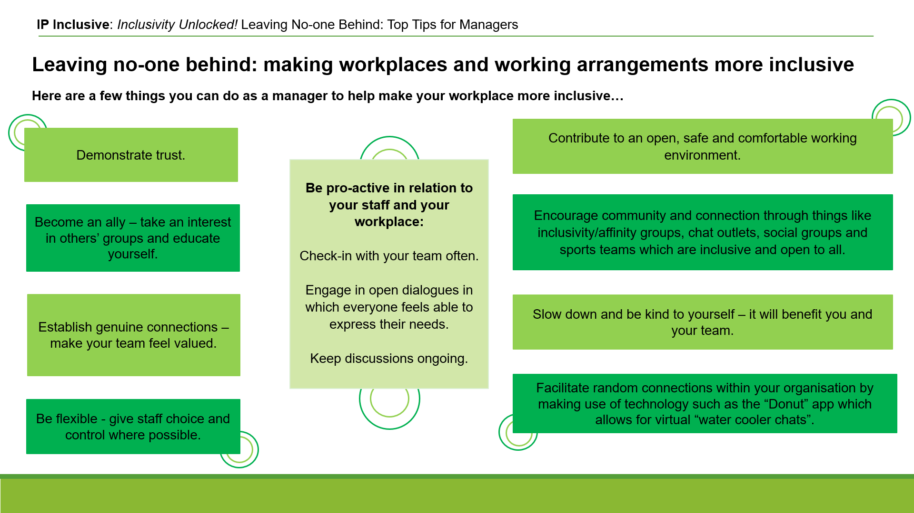
https://ipinclusive.org.uk/wp-content/uploads/2022/11/221103-leaving-no-one-behind-top-tips-for-managers.pdf

