

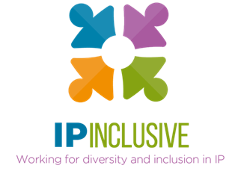
INCLUSIVITY UNLOCKED!
Programme of events

Follow-up resources, for example webinar reports and recordings, can be found in the online posts for the relevant events: see our website events page, where you can also access sign-up links for those still to come. We’ve also included links to the recordings, reports and “top tips” slides in the annexed summary of past events.

Harnessing hybrid
Date: Thursday 10 November 2022
Time: 12.30 – 1.30 pm
Location: Zoom
Online event post: https://ipinclusive.org.uk/events/harnessing-hybrid/
Join us for a “fireside chat” with Ruth Gawthorpe, the CEO of Smart Working Revolution, and Jenna Massey, Practice Director at Gill Jennings & Every. Together we will explore the theme of hybrid working models, the challenges and opportunities they bring, and how to design and implement them so as to boost collaboration, innovation and productivity.

Teamwork, Trust and the post-Covid Tide
Date: Tuesday 15 November 2022
Time: 12.30 – 1.30 pm
Location: Zoom
Online event post: https://ipinclusive.org.uk/events/teamwork-trust-and-the-post-covid-tide/
In this joint event with Focal Point Training, we will be looking at team members’ expectations in the post-Covid world. Focal Point director and co-founder Stella Chandler will take us through their “Exchanging Expectations” model, which focuses on how to build two-way, open and trusting relationships in the workplace. The model will help you identify a more inclusive way of working and provide you with practical tools to use in your own organisation.

Look out for more events in the Inclusivity Unlocked!, series, on topics such as business development in the hybrid world, menopause inclusivity, workspace design and the impact of new working patterns on mental wellbeing. We’ll post details on our website events page at https://ipinclusive.org.uk/events/.

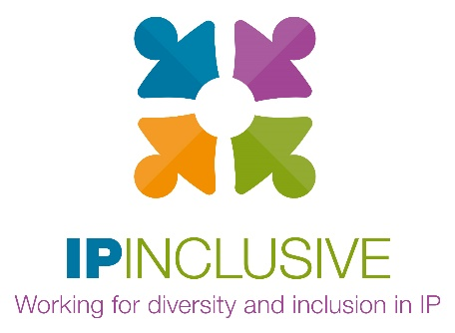

Annex:
INCLUSIVITY UNLOCKED!
Past events & resources

Leaving no one behind (part i)
Date: Tuesday 20 September 2022
Time: 12.30 – 1.30 pm
Location: Zoom
Online event post: https://ipinclusive.org.uk/events/leaving-no-one-behind-part-i/
Our first Inclusivity Unlocked! event kicked off with a panel discussion made up of representatives from our support communities. Our panellists for this event were Josh McLennon (IP & ME), Kevin Rich (IP Out) and Janine Swarbrick (the IP Non-traditional Family Network).
The panel discussed how the communities they represent have found the transition into the post-Covid working world. They shared their experiences of adjusting to post-Covid working arrangements, challenges they had faced, and how working arrangements can be made more inclusive from here on.
Recording available at: https://youtu.be/XHyVBfynVnM
Event report at: https://ipinclusive.org.uk/newsandfeatures/leaving-no-one-behind-event-report/
Top tips at: see part ii below

Leaving no one behind (part ii)
Date: Tuesday 27 September 2022
Time: 12.30 – 1.30 pm
Location: Zoom
Online event post: https://ipinclusive.org.uk/events/leaving-no-one-behind-part-ii/
The second instalment of our “Leaving no one behind” event featured a discussion with our other IP Inclusive communities. This time our panellists were Sanam Habib (IP Futures), Megan Rannard (IP Ability) and Lucy Samuels (Women in IP).
The panel continued looking at the themes discussed in the previous event and provided additional insights into how working arrangements can be made more inclusive in the post-Covid world.
Recording available at: https://youtu.be/Cdl89CzMBxI
Event report at: https://ipinclusive.org.uk/newsandfeatures/leaving-no-one-behind-event-report/
Top tips at:
- For organisations: https://ipinclusive.org.uk/wp-content/uploads/2022/11/221103-leaving-no-one-behind-top-tips-for-organisations.pdf
- For individuals: https://ipinclusive.org.uk/wp-content/uploads/2022/11/221103-leaving-no-one-behind-top-tips-for-individuals.pdf
- For managers: https://ipinclusive.org.uk/wp-content/uploads/2022/11/221103-leaving-no-one-behind-top-tips-for-managers.pdf

What’s for starters?
Date: Thursday 13 October 2022
Time: 12.30 – 1.30 pm
Location: Zoom
Online event post: https://ipinclusive.org.uk/events/whats-for-starters/
This joint event with the mental wellbeing charity Jonathan’s Voice explored the theme of providing early-career support as we emerge from the pandemic and adopt new working arrangements. The event began with a summary of relevant findings from our recent joint mental wellbeing survey. This was followed by a panel discussion involving trainees, trainers and HR professionals, chaired by mental health consultant Penelope Aspinall.
Recording available at: https://youtu.be/ov1cxA_DNgU
Event report at: https://ipinclusive.org.uk/newsandfeatures/whats-for-starters-on-the-mental-health-menu/
Top tips at:
- For organisations: https://ipinclusive.org.uk/wp-content/uploads/2022/11/221108-whats-for-starters-top-tips-for-organisations.pdf
- For individuals: https://ipinclusive.org.uk/wp-content/uploads/2022/11/221108-whats-for-starters-top-tips-for-individuals.pdf
- For managers: https://ipinclusive.org.uk/wp-content/uploads/2022/11/221108-whats-for-starters-top-tips-for-managers.pdf

