


INCLUSIVITY UNLOCKED!
“Top Tips” compilation

These are the top tips we’ve distilled from our Inclusivity Unlocked! events so far.
Beneath each image we’ve provided a link to a pdf version: please feel free to download these and share them with your colleagues.
Other follow-up resources, for example webinar reports and recordings, can be found in the online posts for the relevant events: see our website events page, where you can also access sign-up links for those still to come.

If you have suggestions for other event themes or formats, please let us know by taking our quick survey at https://www.surveymonkey.co.uk/r/M682YMT.

Leaving no one behind (parts i and ii)
Dates: 20 & 27 September 2022
Online event posts: https://ipinclusive.org.uk/events/leaving-no-one-behind-part-i/ and https://ipinclusive.org.uk/events/leaving-no-one-behind-part-ii/
Panel discussions with our six communities, about opportunities and challenges in the post-Covid world for the specific groups they represent.

Top tips for organisations:
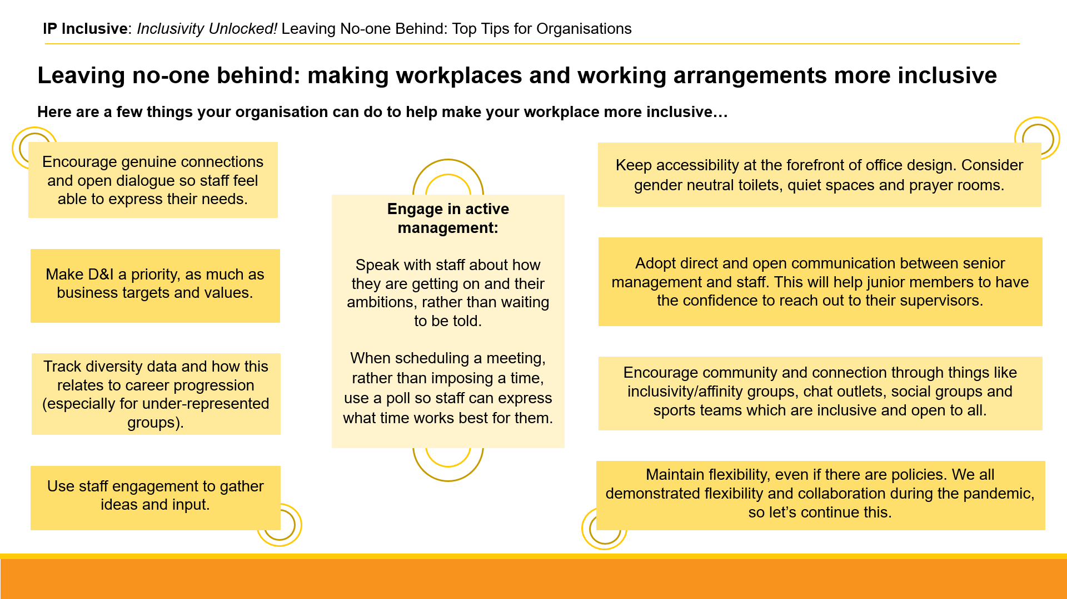
https://ipinclusive.org.uk/wp-content/uploads/2022/11/221103-leaving-no-one-behind-top-tips-for-organisations.pdf

Top tips for individuals:
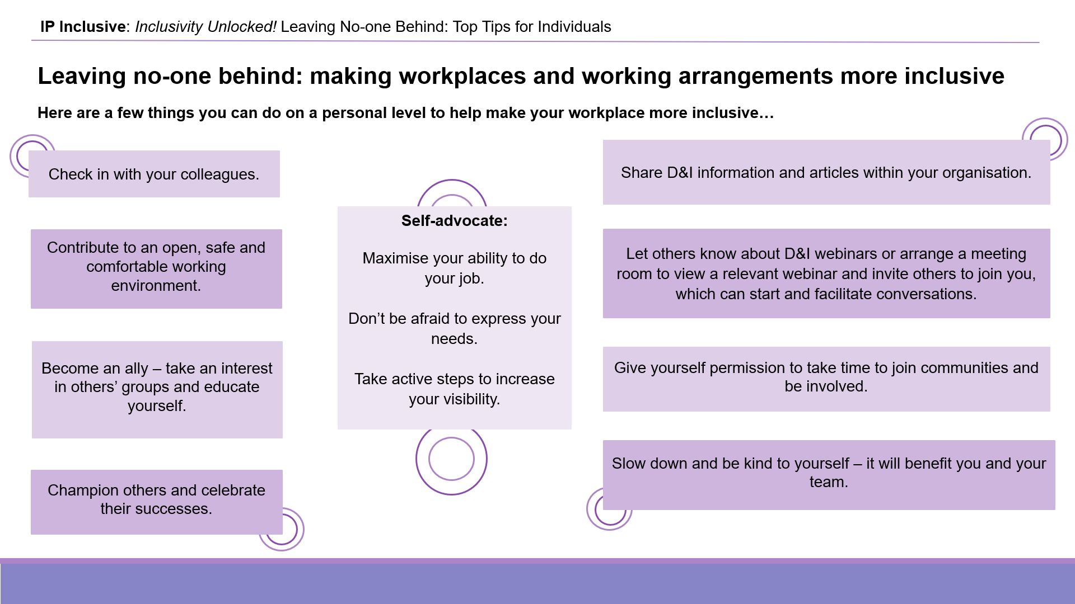
https://ipinclusive.org.uk/wp-content/uploads/2022/11/221103-leaving-no-one-behind-top-tips-for-individuals.pdf

Top tips for managers:
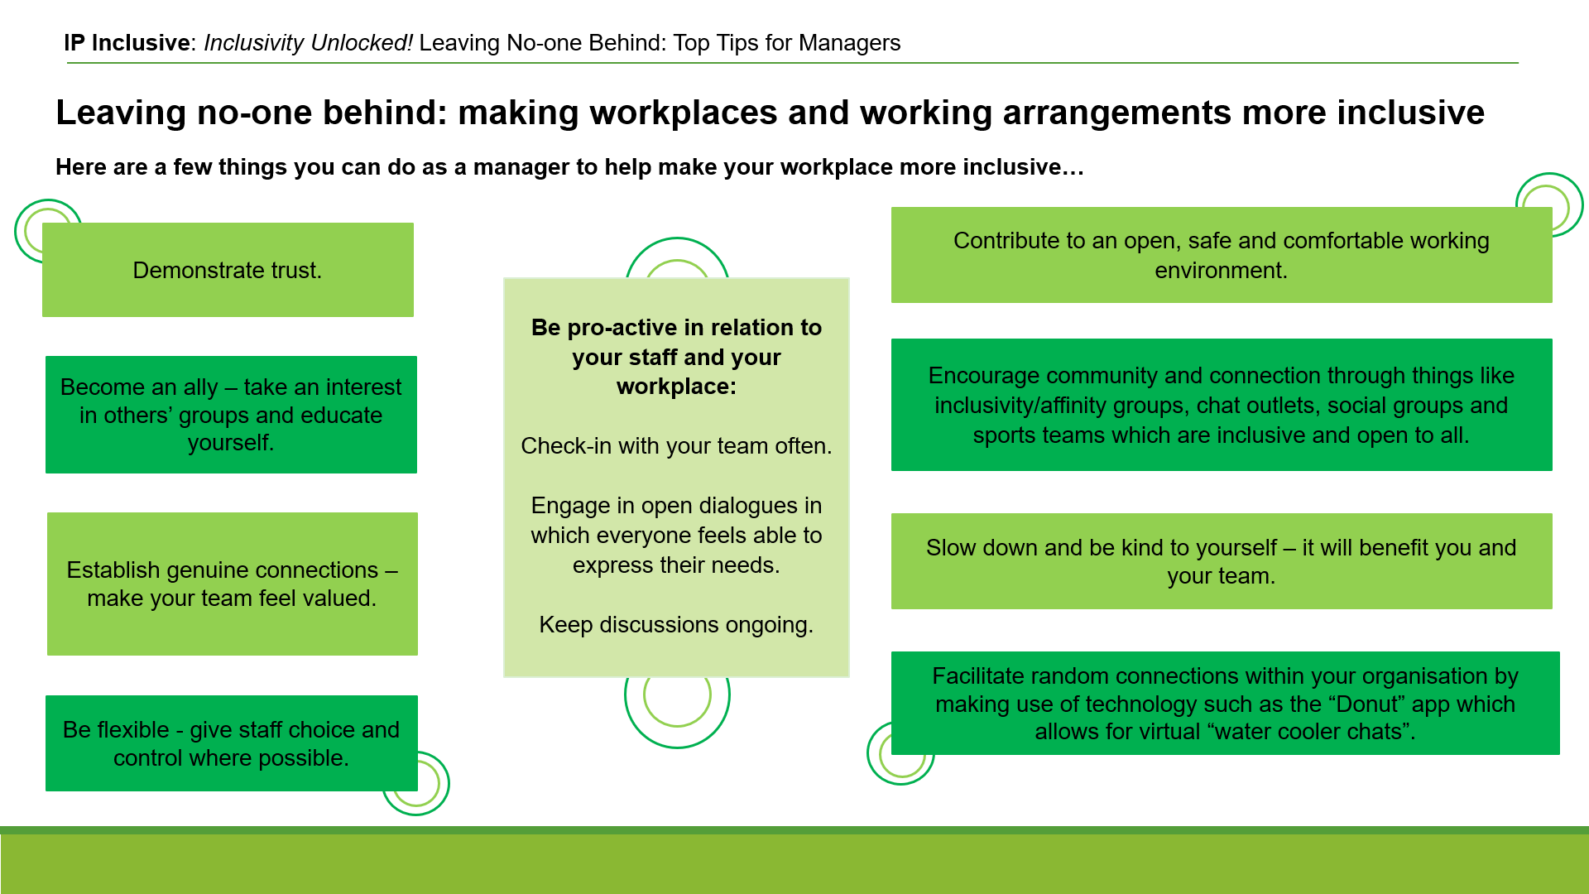
https://ipinclusive.org.uk/wp-content/uploads/2022/11/221103-leaving-no-one-behind-top-tips-for-managers.pdf

What’s for starters?
Date: 13 October 2022
Online event post: https://ipinclusive.org.uk/events/whats-for-starters/
Joint event with Jonathan’s Voice about supporting mental wellbeing for early-career IP professionals.

Top tips for organisations:
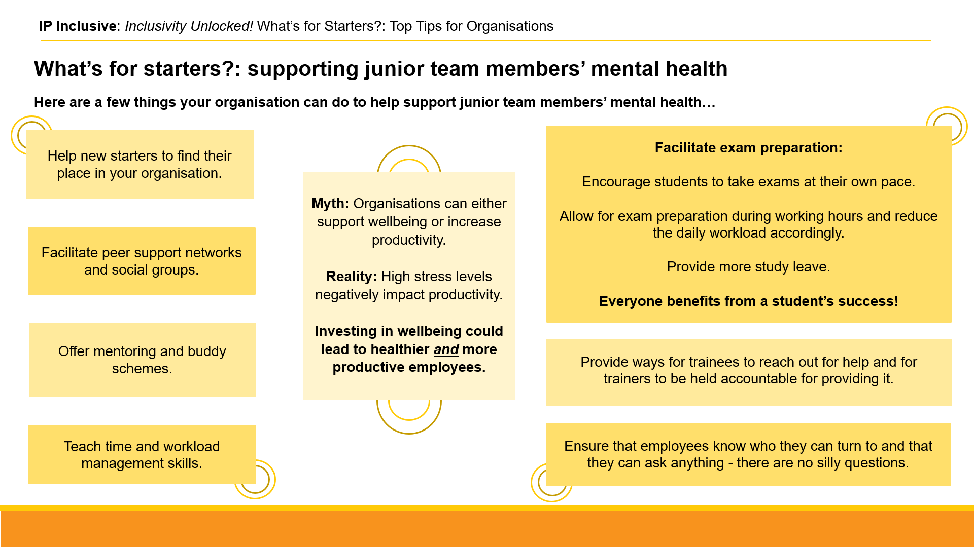
https://ipinclusive.org.uk/wp-content/uploads/2022/11/221108-whats-for-starters-top-tips-for-organisations.pdf

Top tips for individuals:
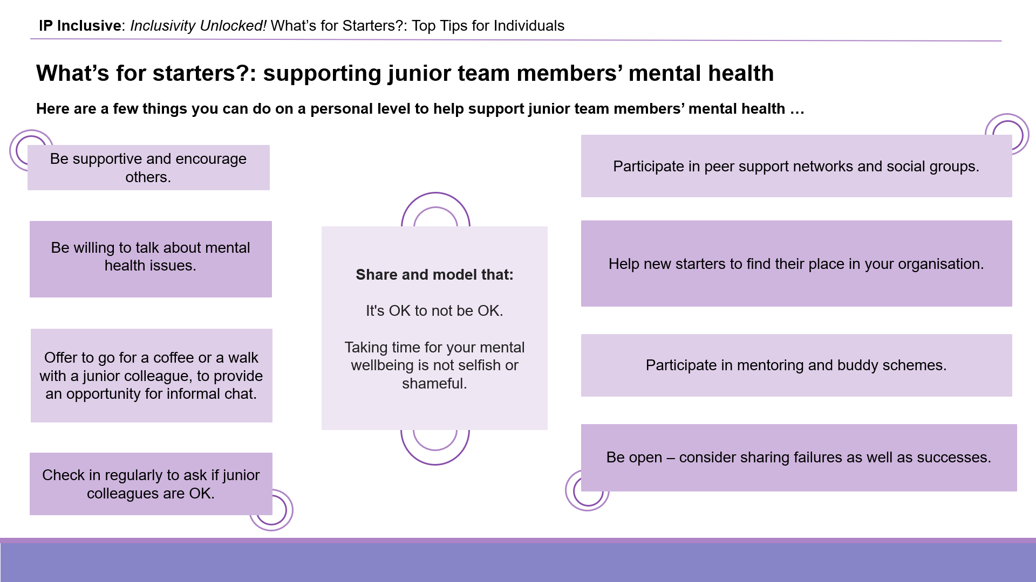
https://ipinclusive.org.uk/wp-content/uploads/2022/11/221108-whats-for-starters-top-tips-for-individuals.pdf

Top tips for managers:
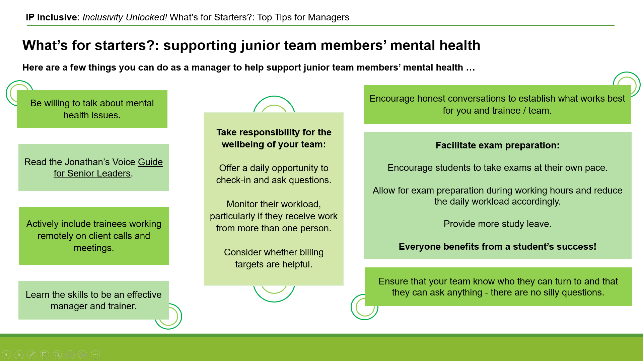
https://ipinclusive.org.uk/wp-content/uploads/2022/11/221108-whats-for-starters-top-tips-for-managers.pdf

Taking the long view:
tackling the causes of stress and anxiety by managing workloads
Following on from our “What’s for starters?” event above, and the results of our 2022 mental wellbeing survey with Jonathan’s Voice, we’ve produced some practical tips on workload management to reduce stress and other mental health problems in the workplace. See also our Lead Executive Officer Andrea Brewster’s discussion at https://ipinclusive.org.uk/newsandfeatures/mental-health-taking-the-long-view/.

Top tips for organisations:
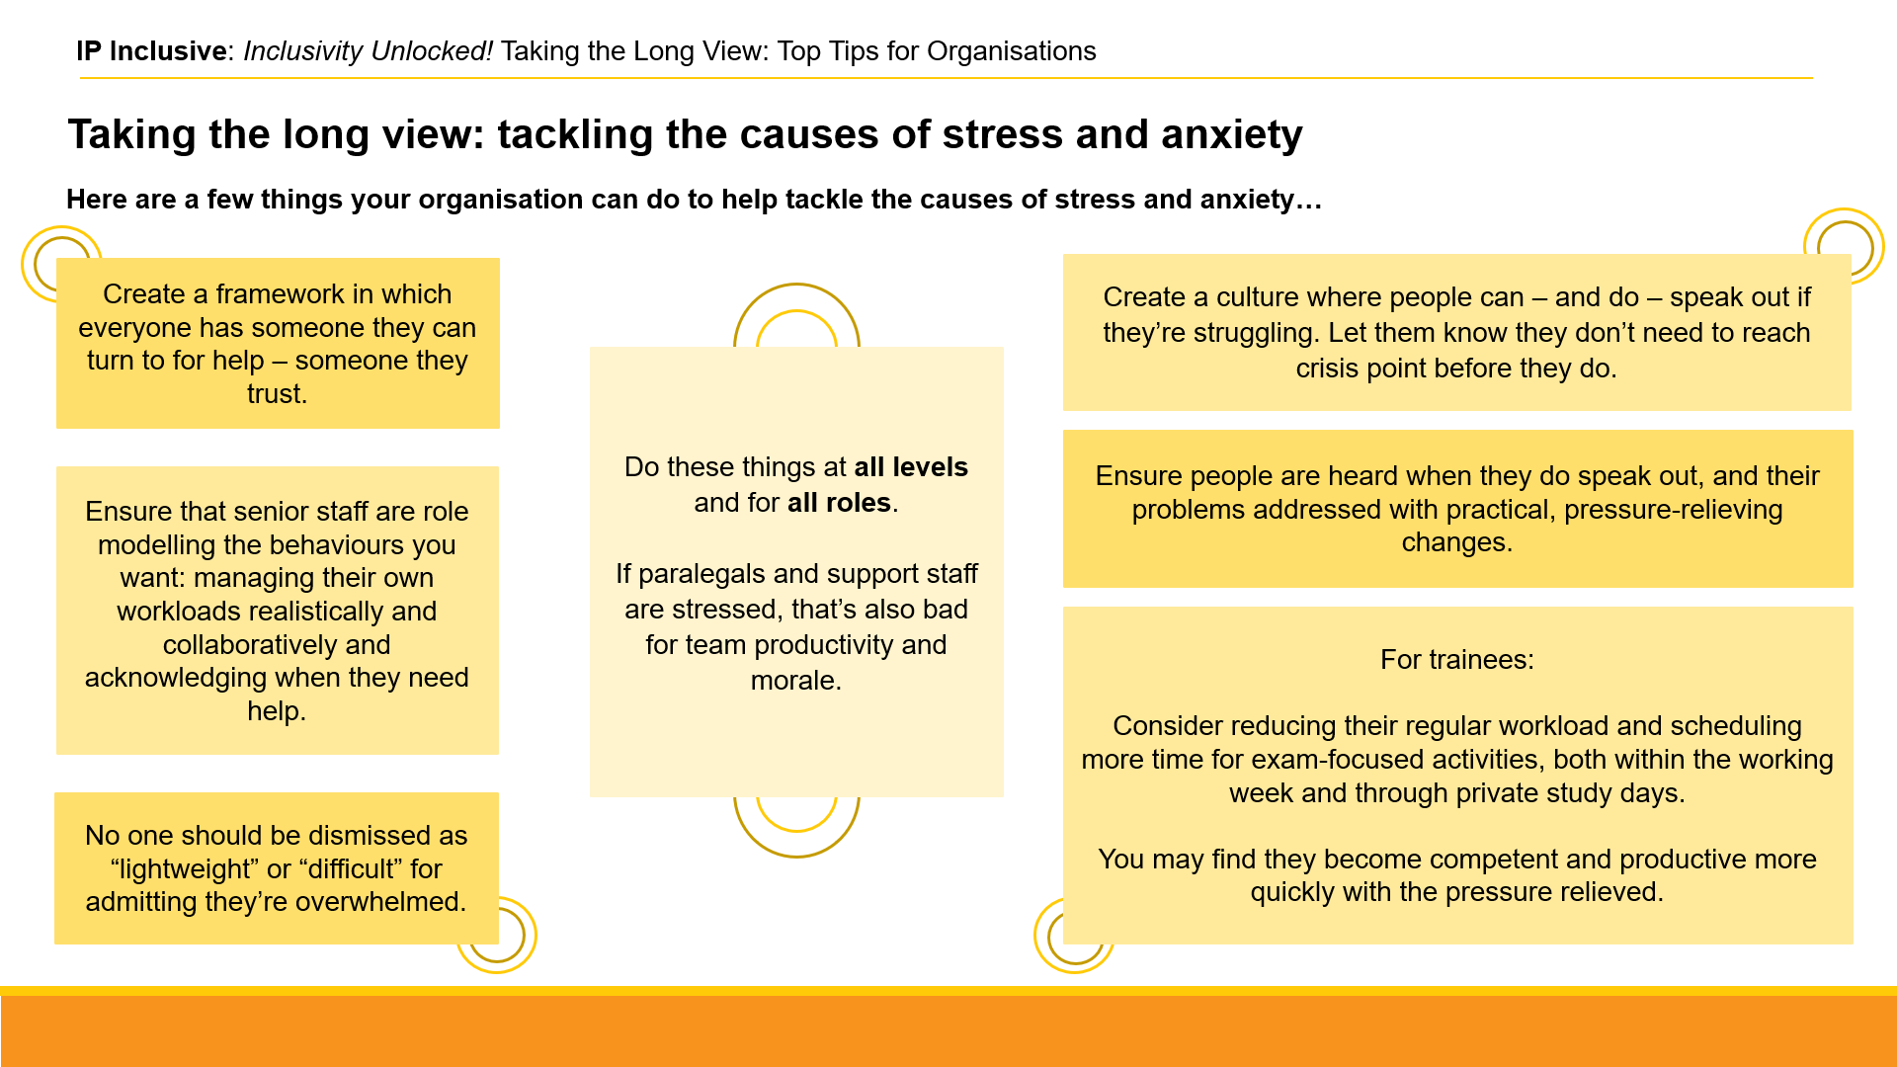
https://ipinclusive.org.uk/wp-content/uploads/2022/11/221109-taking-the-long-view-top-tips-for-organisations.pdf

Top tips for managers:
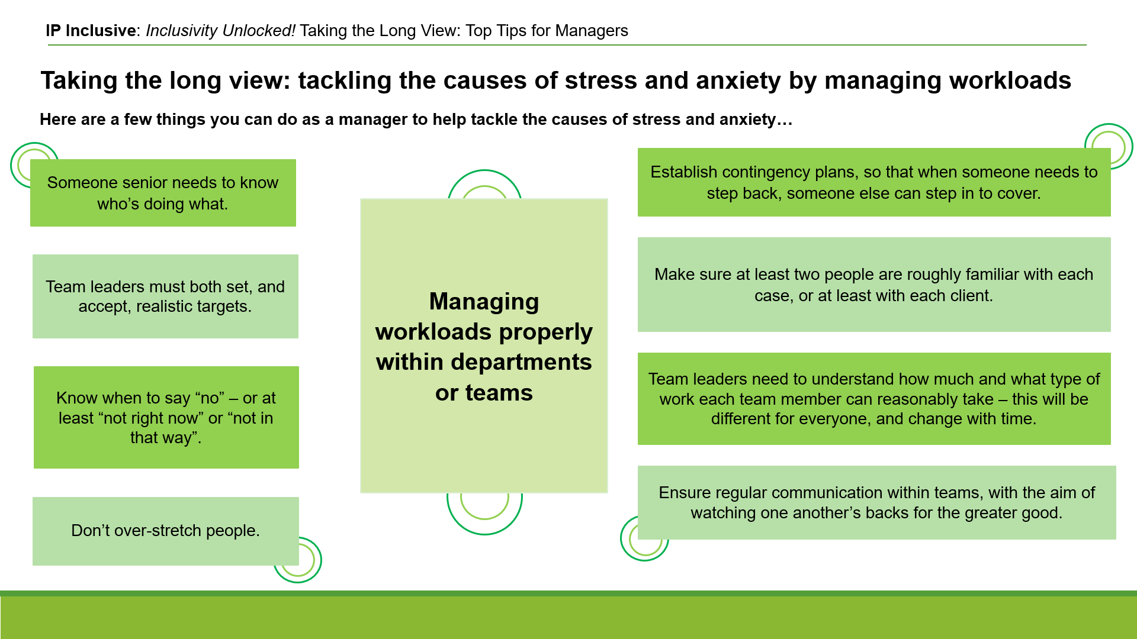
https://ipinclusive.org.uk/wp-content/uploads/2022/11/221109-taking-the-long-view-top-tips-for-managers.pdf

Top tips for small businesses:
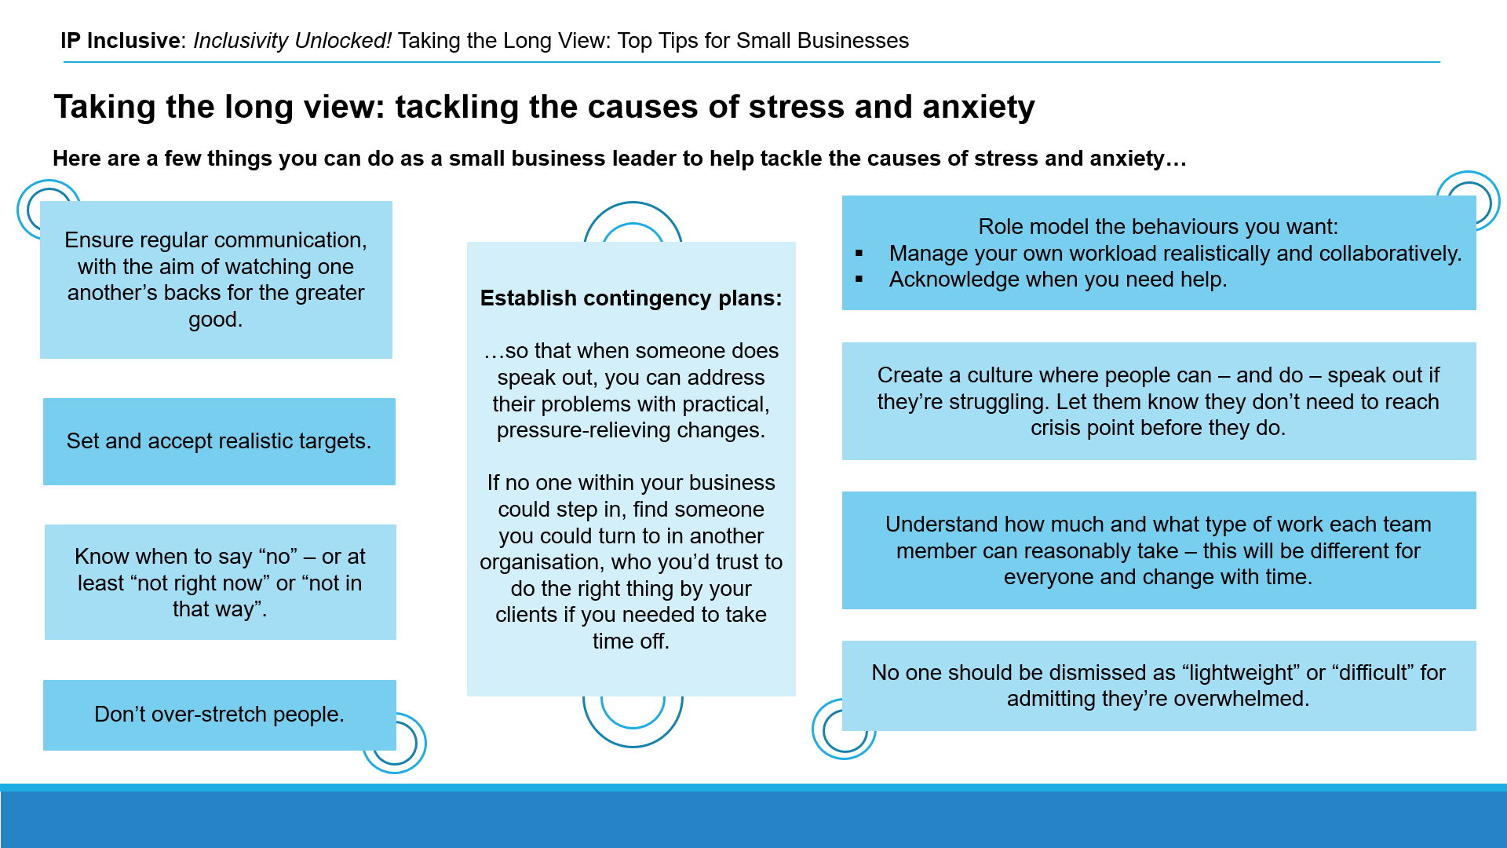
https://ipinclusive.org.uk/wp-content/uploads/2022/11/221109-taking-the-long-view-top-tips-for-small-businesses.pdf

Harnessing hybrid
Date: 10 November 2022
Online event post: https://ipinclusive.org.uk/events/harnessing-hybrid/
Webinar about optimising hybrid working arrangements post-Covid.

Top tips for organisations:
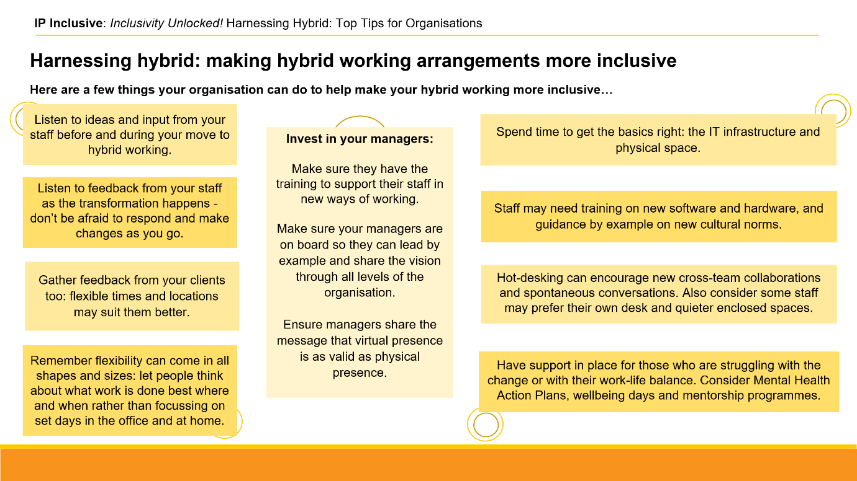
https://ipinclusive.org.uk/wp-content/uploads/2022/12/221201-harnessing-hybrid-top-tips-for-organisations.png

Top tips for individuals:
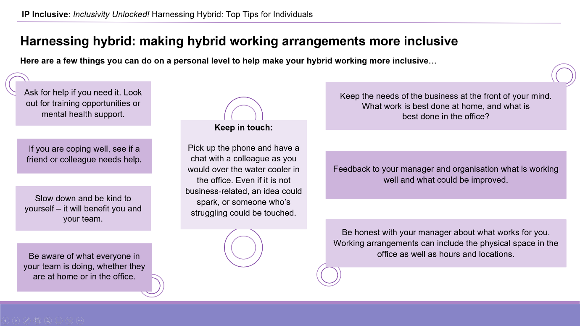
https://ipinclusive.org.uk/wp-content/uploads/2022/12/221201-harnessing-hybrid-top-tips-for-individuals.pdf

Top tips for managers:
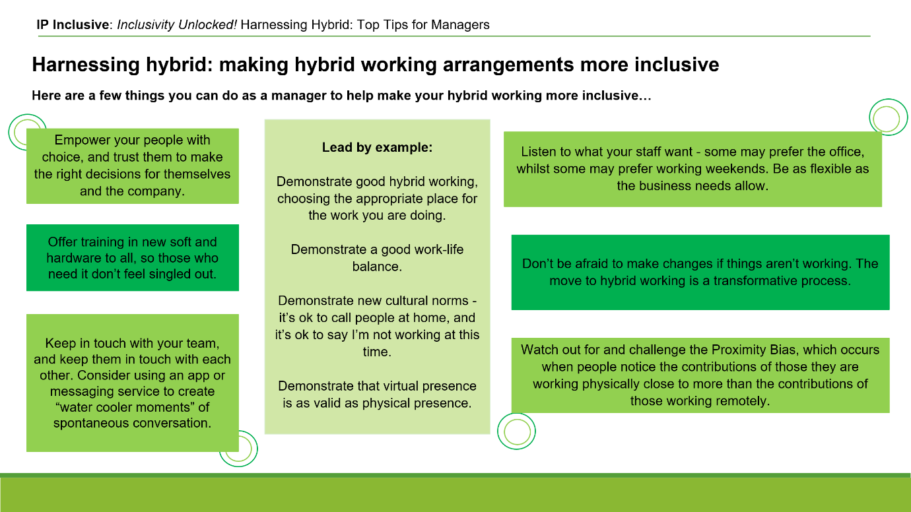
https://ipinclusive.org.uk/wp-content/uploads/2022/12/221201-harnessing-hybrid-top-tips-for-managers.pdf



See https://ipinclusive.org.uk/newsandfeatures/the-results-of-our-2022-mental-wellbeing-survey/

