INCLUSIVITY UNLOCKED!
“Top Tips” compilation

These are the top tips we’ve distilled from our Inclusivity Unlocked! events so far.
Beneath each image we’ve provided a link to a pdf version: please feel free to download these and share them with your colleagues.
Other follow-up resources, for example webinar reports and recordings, can be found in the online posts for the relevant events: see our website events page, where you can also access sign-up links for those still to come.

If you have suggestions for other event themes or formats, please let us know
by emailing us at contactipinclusive@gmail.com.

Leaving no one behind (parts i and ii)
Dates: 20 & 27 September 2022
Online event posts: https://ipinclusive.org.uk/events/leaving-no-one-behind-part-i/ and https://ipinclusive.org.uk/events/leaving-no-one-behind-part-ii/
Panel discussions with our six communities, about opportunities and challenges in the post-Covid world for the specific groups they represent.

Top tips for organisations:
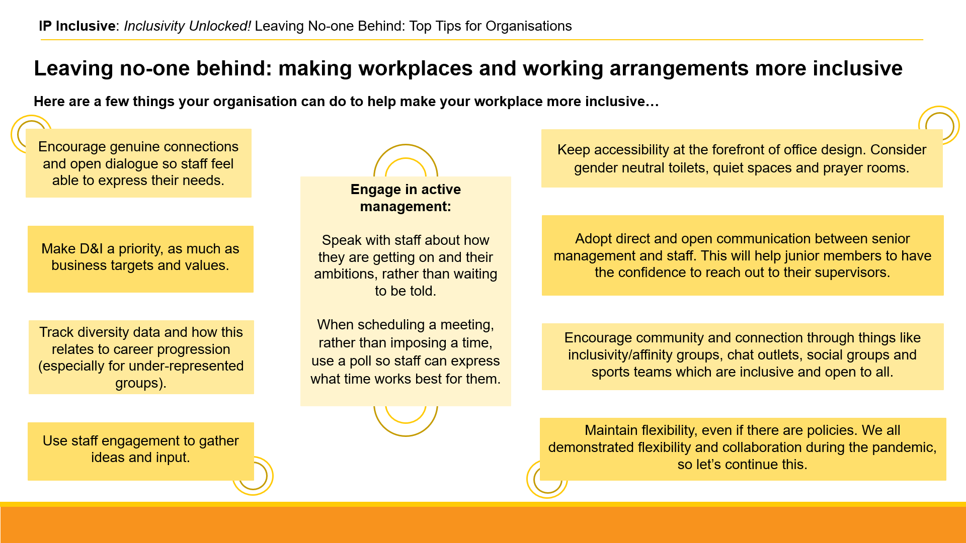
https://ipinclusive.org.uk/wp-content/uploads/2022/11/221103-leaving-no-one-behind-top-tips-for-organisations.pdf

Top tips for individuals:
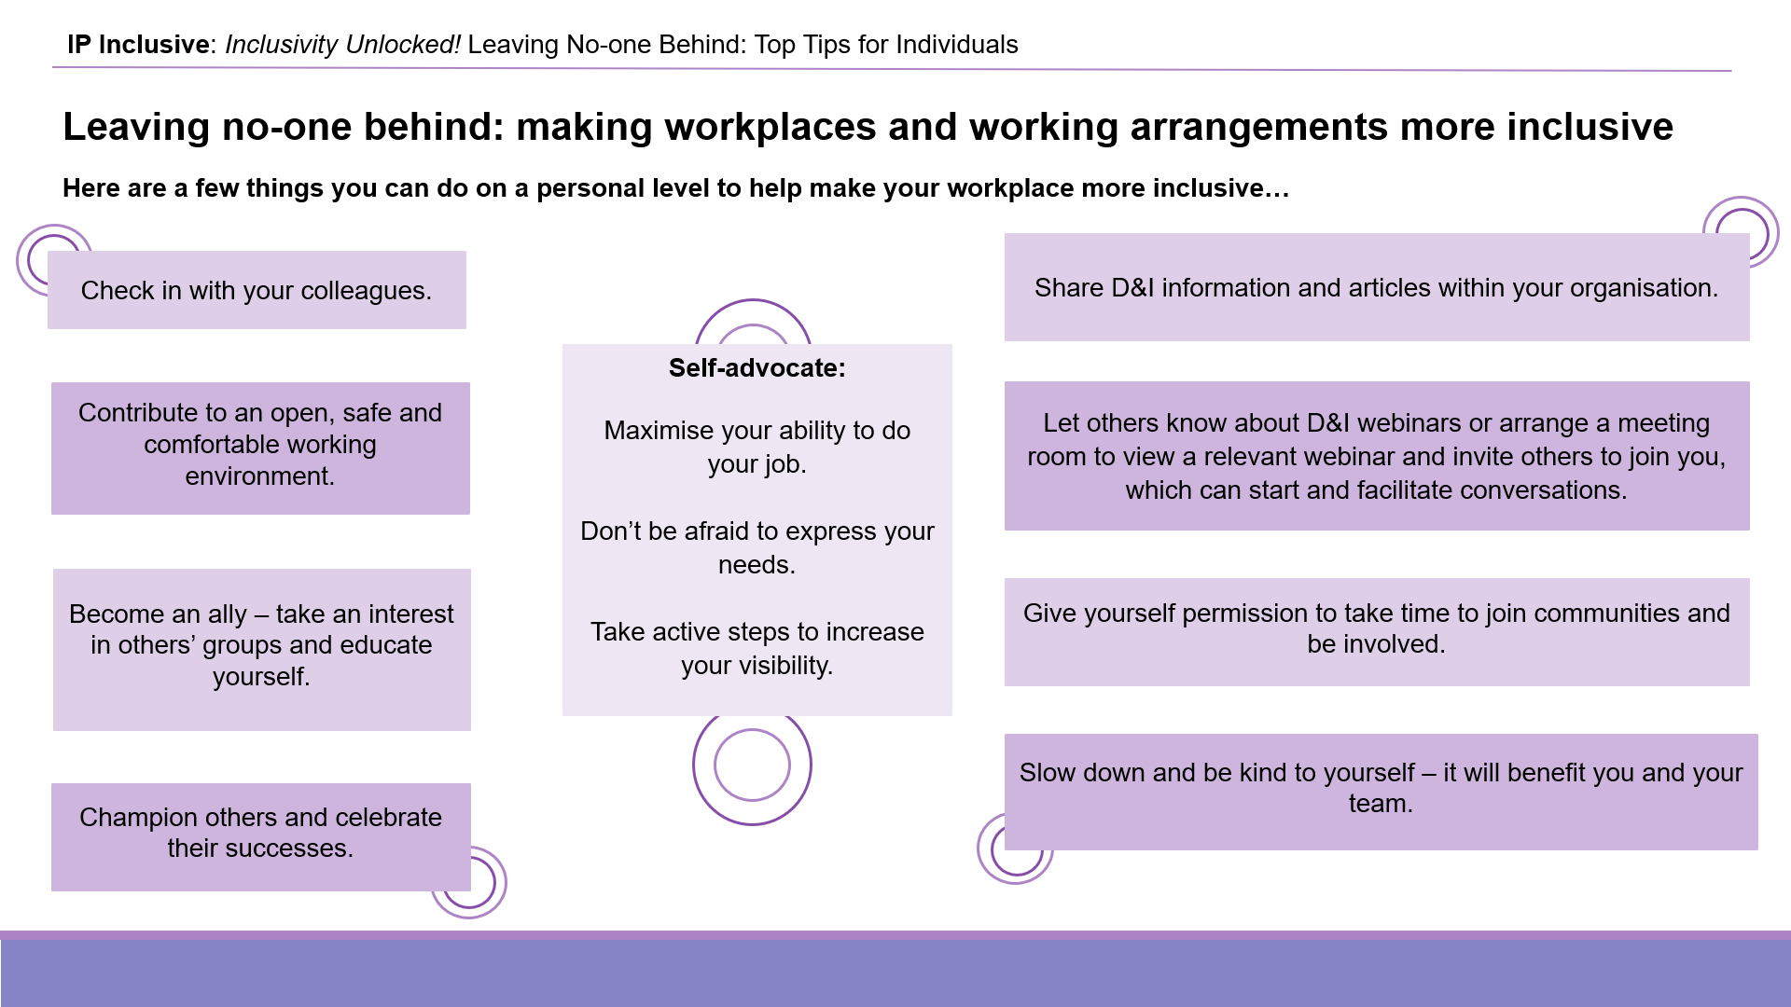
https://ipinclusive.org.uk/wp-content/uploads/2022/11/221103-leaving-no-one-behind-top-tips-for-individuals.pdf

Top tips for managers:
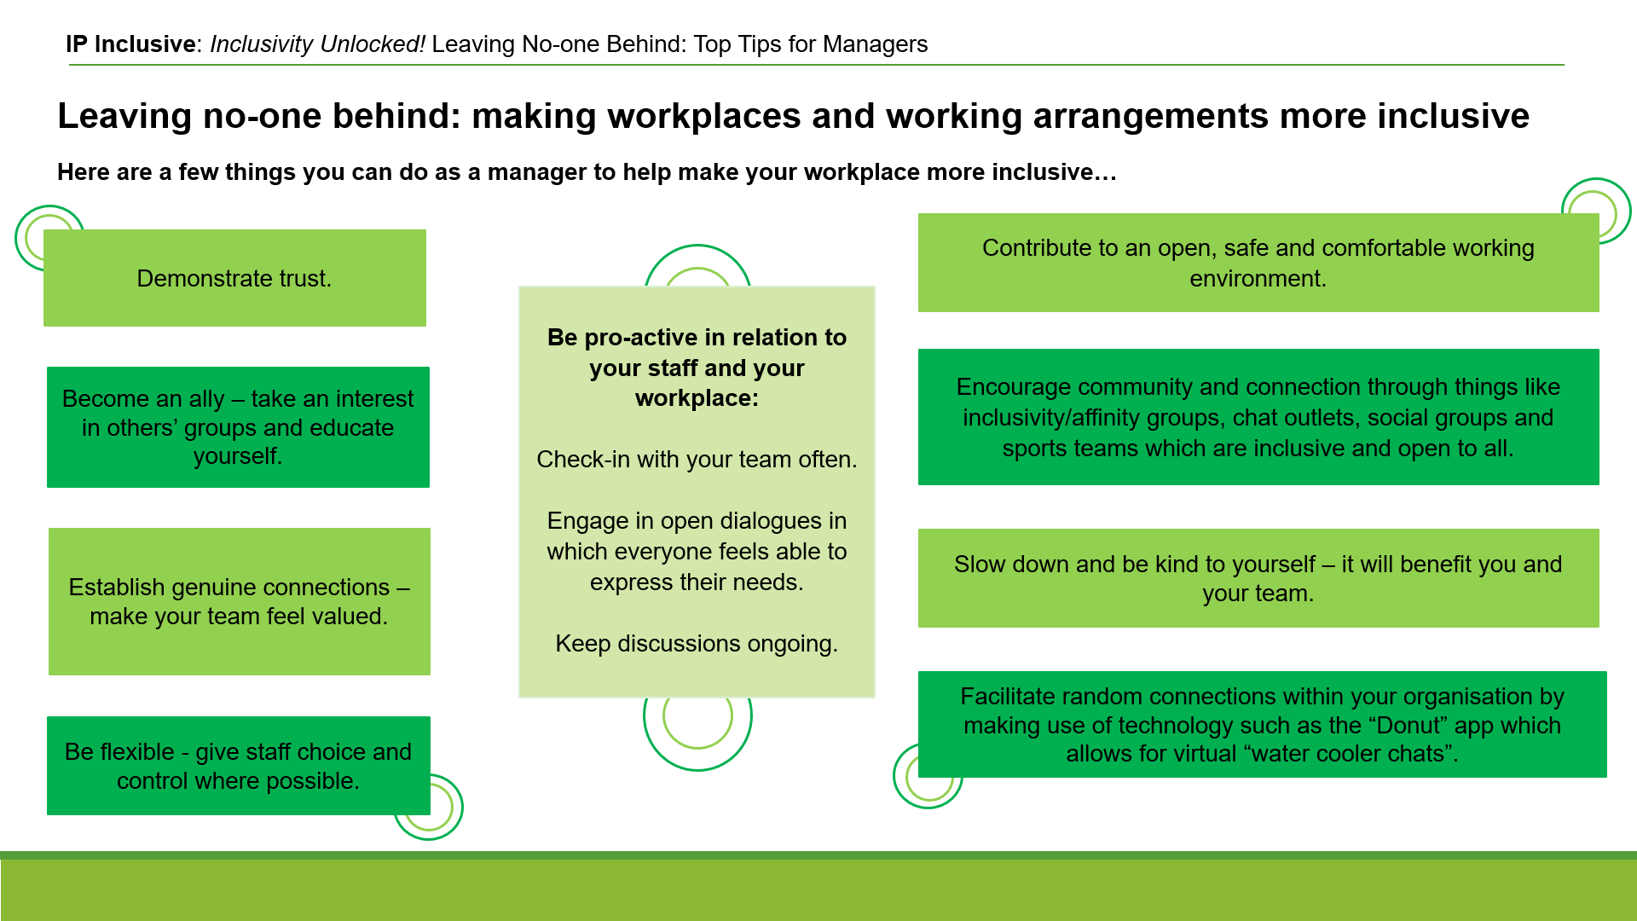
https://ipinclusive.org.uk/wp-content/uploads/2022/11/221103-leaving-no-one-behind-top-tips-for-managers.pdf

What’s for starters?
Date: 13 October 2022
Online event post: https://ipinclusive.org.uk/events/whats-for-starters/
Joint event with Jonathan’s Voice about supporting mental wellbeing for early-career IP professionals.

Top tips for organisations:
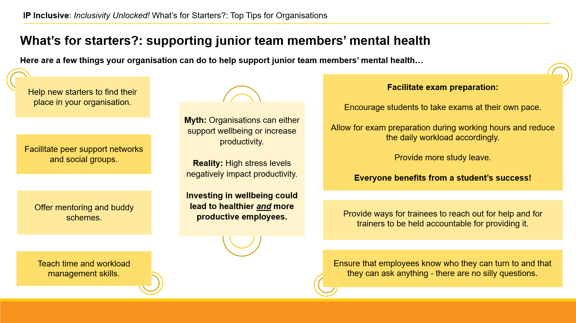
https://ipinclusive.org.uk/wp-content/uploads/2022/11/221108-whats-for-starters-top-tips-for-organisations.pdf

Top tips for individuals:
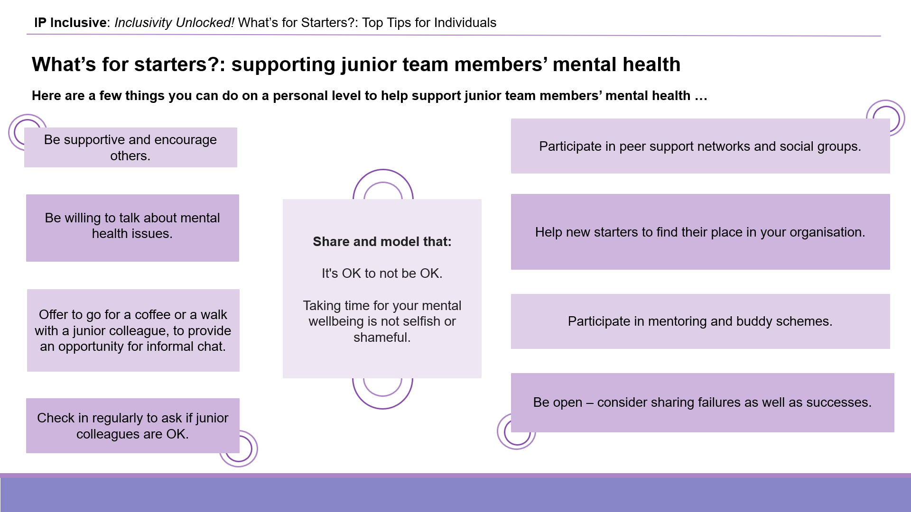
https://ipinclusive.org.uk/wp-content/uploads/2022/11/221108-whats-for-starters-top-tips-for-individuals.pdf

Top tips for managers:
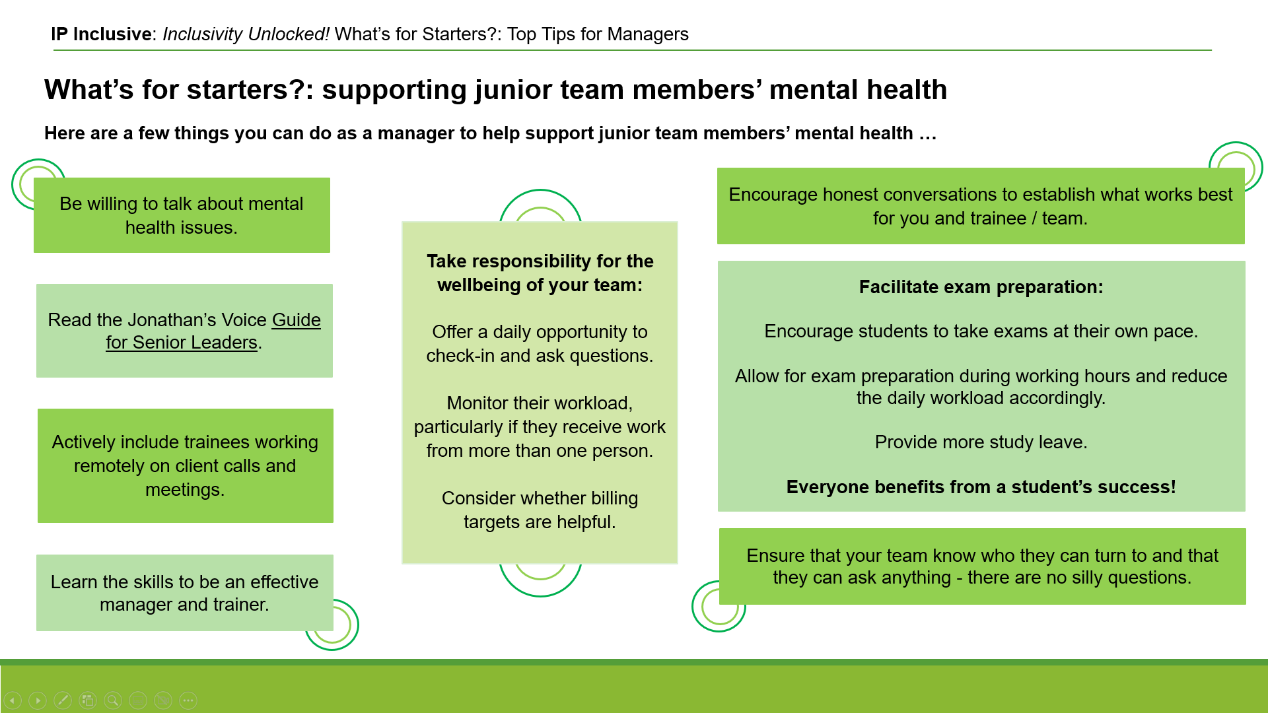
https://ipinclusive.org.uk/wp-content/uploads/2022/11/221108-whats-for-starters-top-tips-for-managers.pdf

Taking the long view:
tackling the causes of stress and anxiety by managing workloads
Following on from our “What’s for starters?” event above, and the results of our 2022 mental wellbeing survey with Jonathan’s Voice, we’ve produced some practical tips on workload management to reduce stress and other mental health problems in the workplace. See also our Lead Executive Officer Andrea Brewster’s discussion at https://ipinclusive.org.uk/newsandfeatures/mental-health-taking-the-long-view/.

Top tips for organisations:
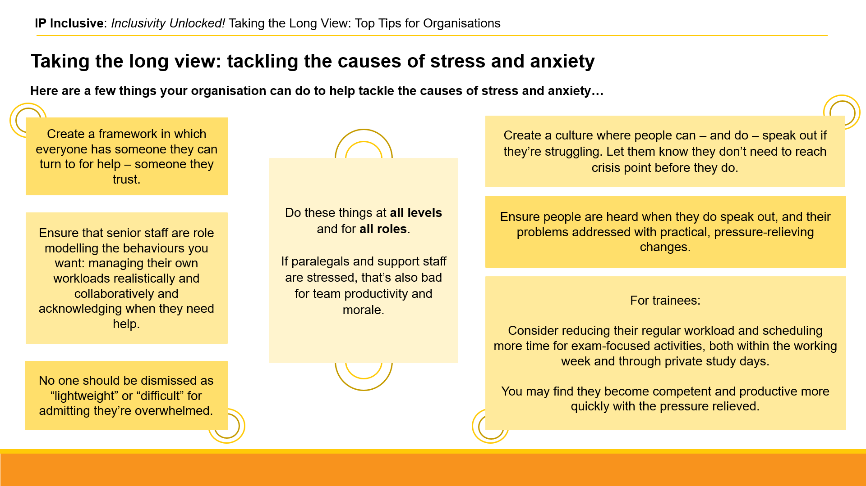
https://ipinclusive.org.uk/wp-content/uploads/2022/11/221109-taking-the-long-view-top-tips-for-organisations.pdf

Top tips for managers:
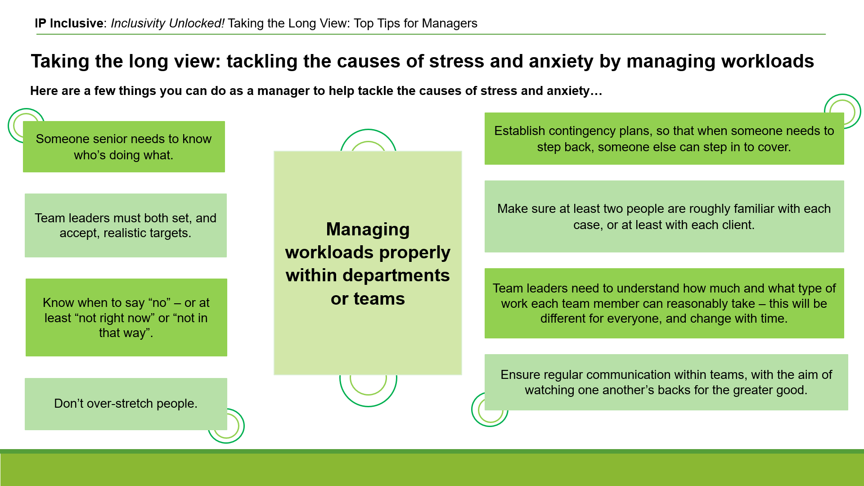
https://ipinclusive.org.uk/wp-content/uploads/2022/11/221109-taking-the-long-view-top-tips-for-managers.pdf

Top tips for small businesses:
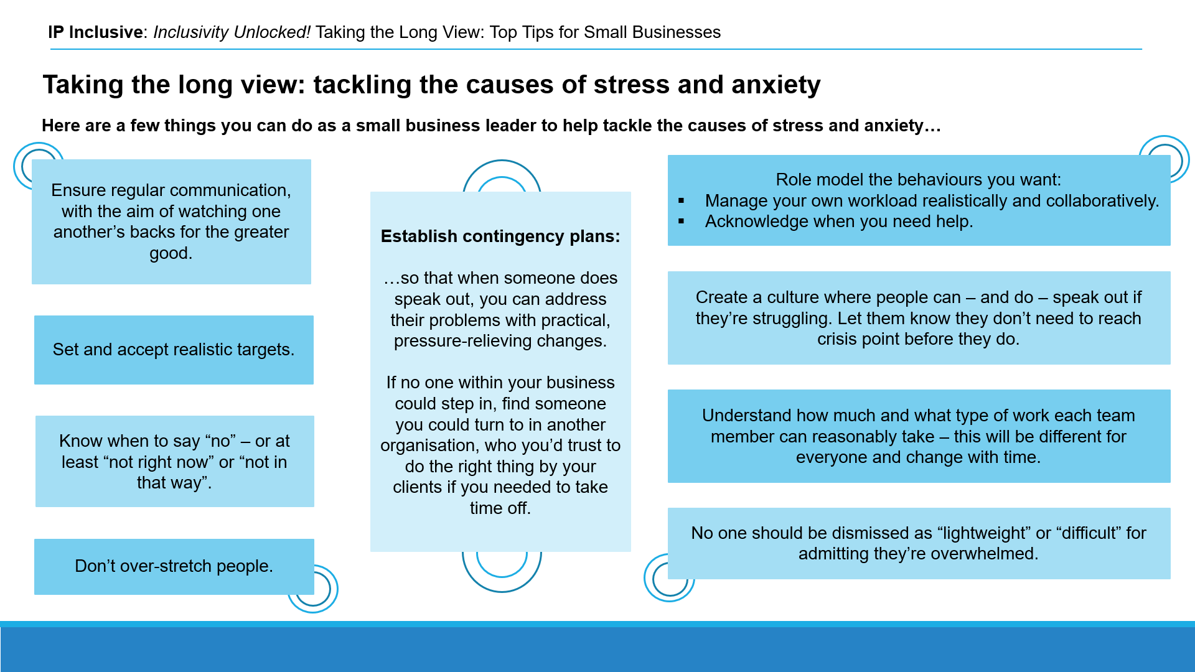
https://ipinclusive.org.uk/wp-content/uploads/2022/11/221109-taking-the-long-view-top-tips-for-small-businesses.pdf

Harnessing hybrid
Date: 10 November 2022
Online event post: https://ipinclusive.org.uk/events/harnessing-hybrid/
Webinar about optimising hybrid working arrangements post-Covid.

Top tips for organisations:
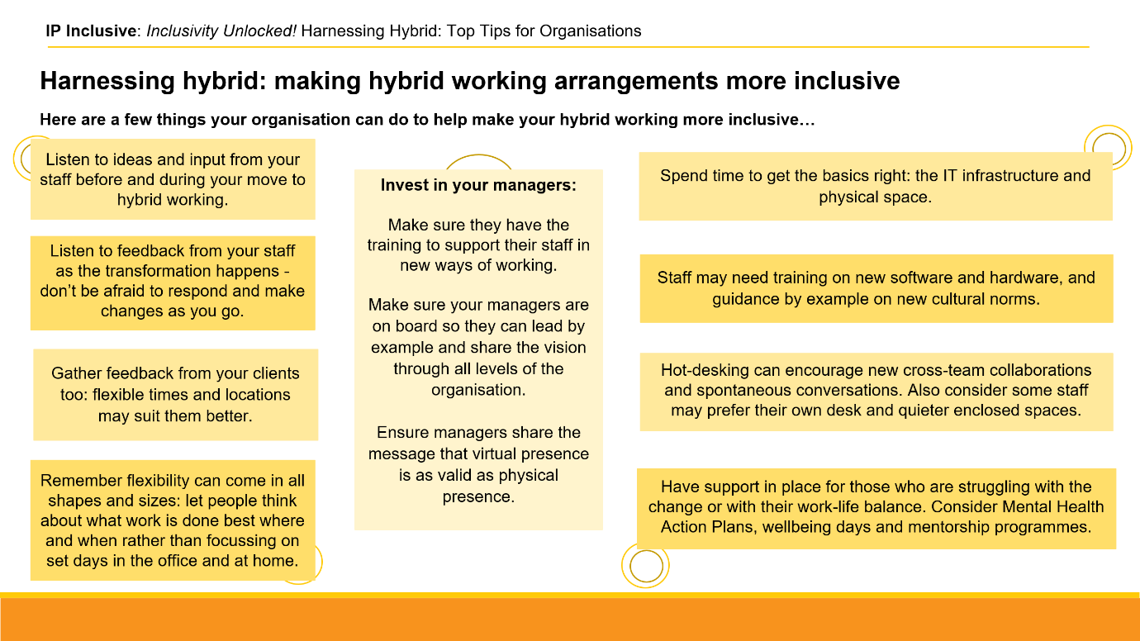
https://ipinclusive.org.uk/wp-content/uploads/2022/12/221201-harnessing-hybrid-top-tips-for-organisations.pdf

Top tips for individuals:
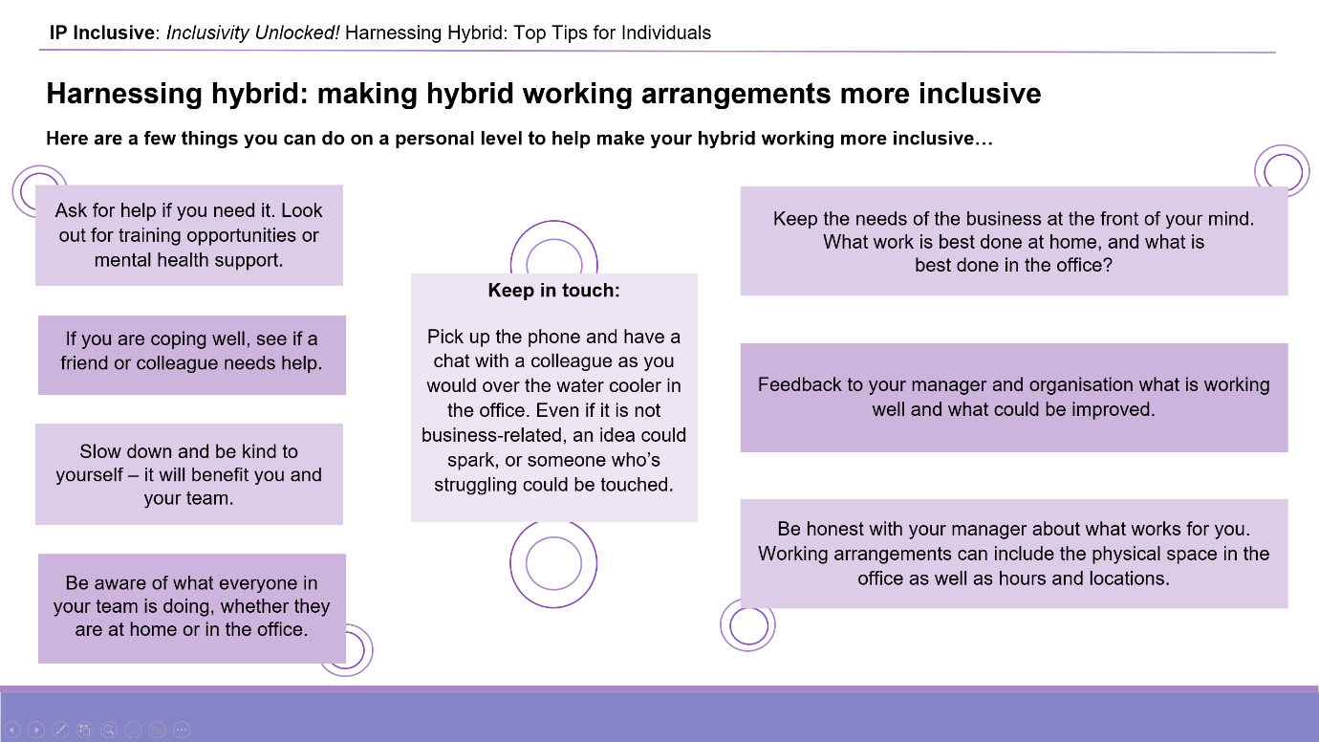
https://ipinclusive.org.uk/wp-content/uploads/2022/12/221201-harnessing-hybrid-top-tips-for-individuals.pdf

Top tips for managers:
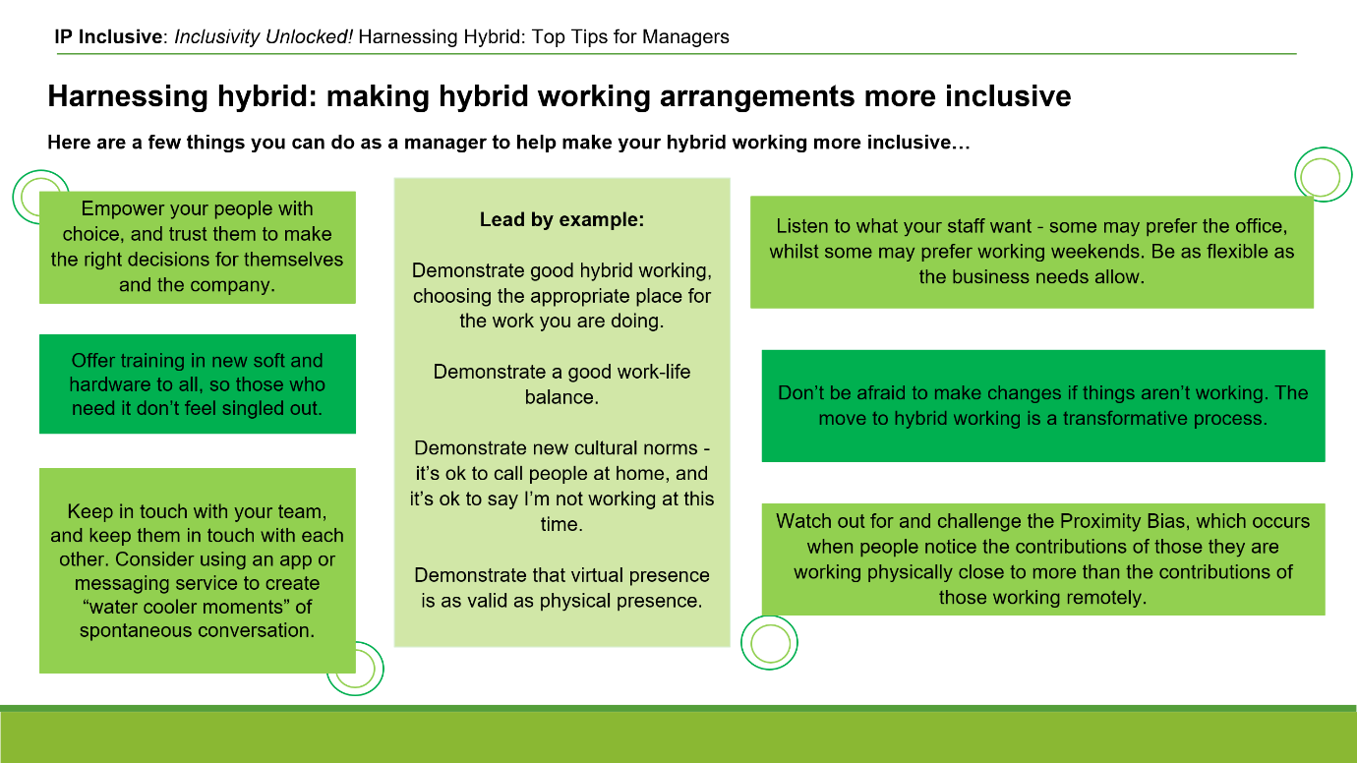
https://ipinclusive.org.uk/wp-content/uploads/2022/12/221201-harnessing-hybrid-top-tips-for-managers.pdf

Teamwork, Trust and the post-Covid Tide
Date: 15 November 2022
Online event post: https://ipinclusive.org.uk/events/teamwork-trust-and-the-post-covid-tide/
Joint event with Focal Point Training, looking at team members’ expectations and effective working relationships in the post-Covid world.

Top tips:
[Only one set for this topic, since the exchanging of expectations is good practice between everyone who needs to work together in an organisation]

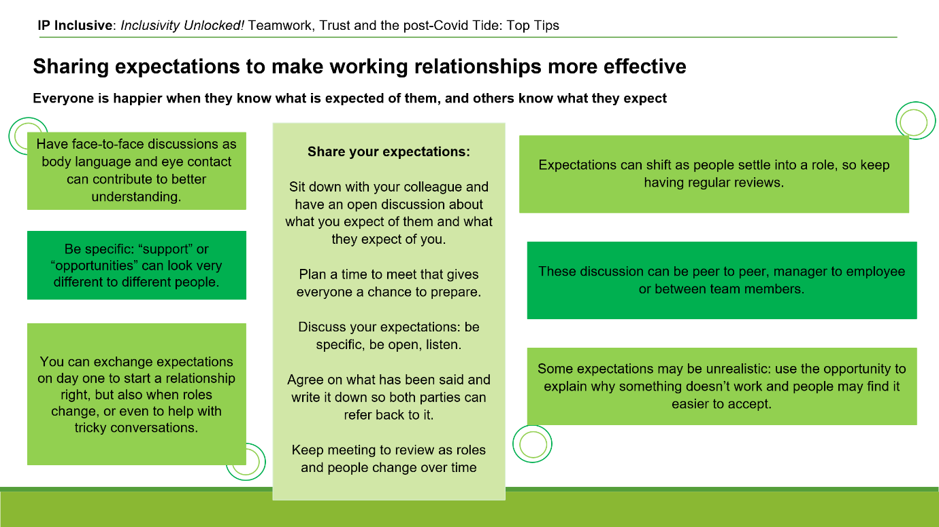
https://ipinclusive.org.uk/wp-content/uploads/2022/12/221215-teamwork-trust-post-covid-tide-top-tips.pdf

(Office) space: the final frontier?
Date: 30 January 2023
Online event post: https://ipinclusive.org.uk/events/office-space-the-final-frontier/
Webinar about reshaping workspaces to optimise inclusion, cohesion and efficiency in the wake of the Covid-19 lockdowns.

Top tips:
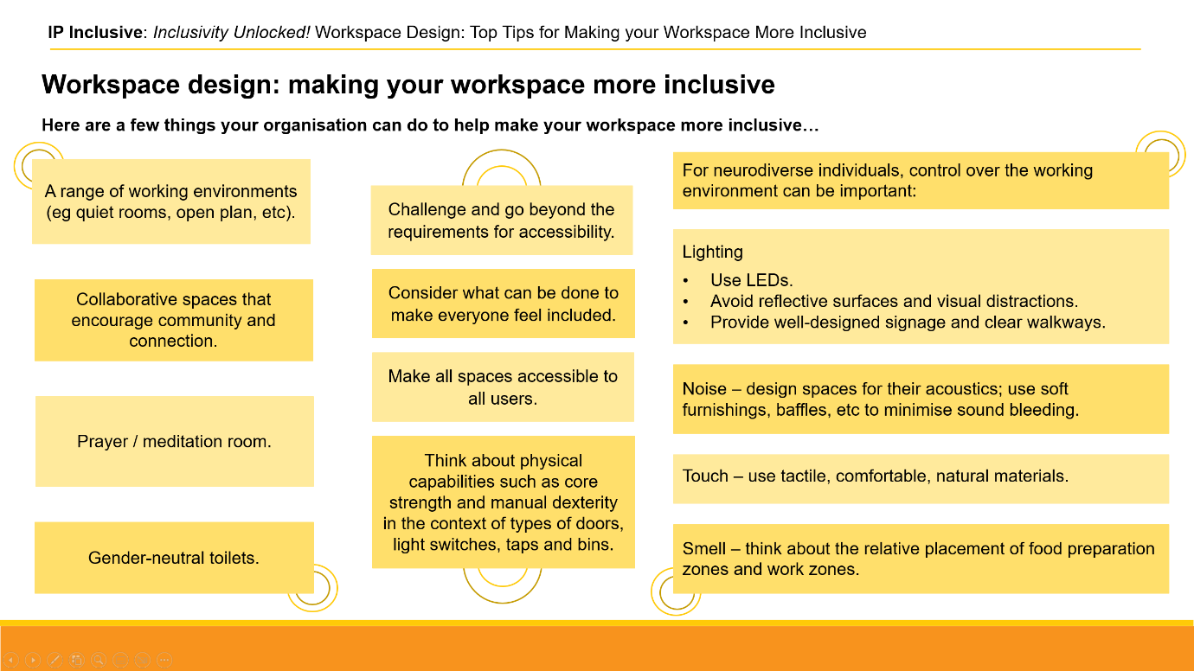
https://ipinclusive.org.uk/wp-content/uploads/2023/02/230227-workspace-design-top-tips.pdf

Associated opportunities and considerations:
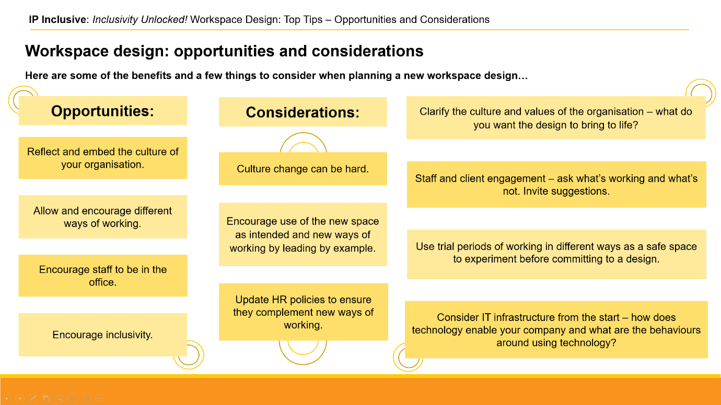
https://ipinclusive.org.uk/wp-content/uploads/2023/02/230227-workspace-design-opportunities-considerations.pdf

Rainmaking for everyone
Date: 8 February 2023
Online event post: https://ipinclusive.org.uk/events/rainmaking-for-everyone/
Webinar about how the Covid-19 lockdowns have helped us find more inclusive approaches to business development.

Top tips for organisations:
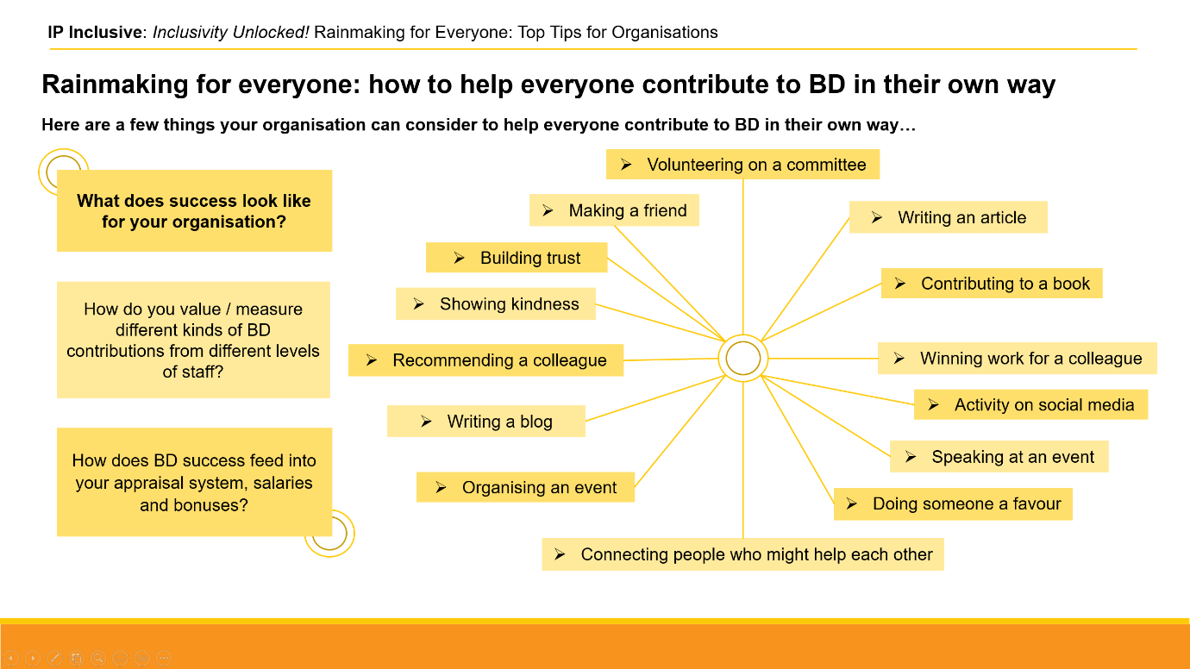
https://ipinclusive.org.uk/wp-content/uploads/2023/03/230303-rainmaking-for-everyone-top-tips-for-organisations.pdf

Top tips for individuals:
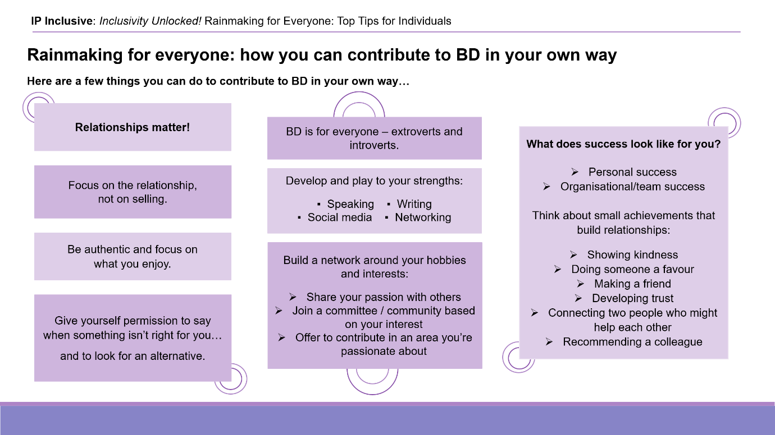
https://ipinclusive.org.uk/wp-content/uploads/2023/03/230303-rainmaking-for-everyone-top-tips-for-individuals.pdf

Top tips for managers:
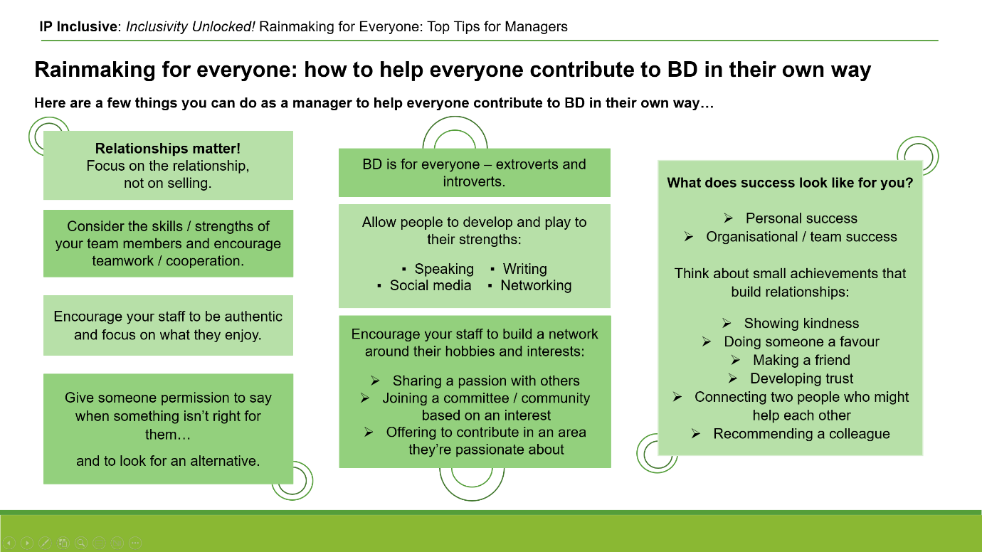
https://ipinclusive.org.uk/wp-content/uploads/2023/03/230303-rainmaking-for-everyone-top-tips-for-managers.pdf

Online, but not forgotten
Date: 9 March 2023
Online event post: https://ipinclusive.org.uk/events/online-but-not-forgotten/
Joint webinar with IP Ability and CIPA, about online accessibility and the technology available to help.

Top tips for organisations:
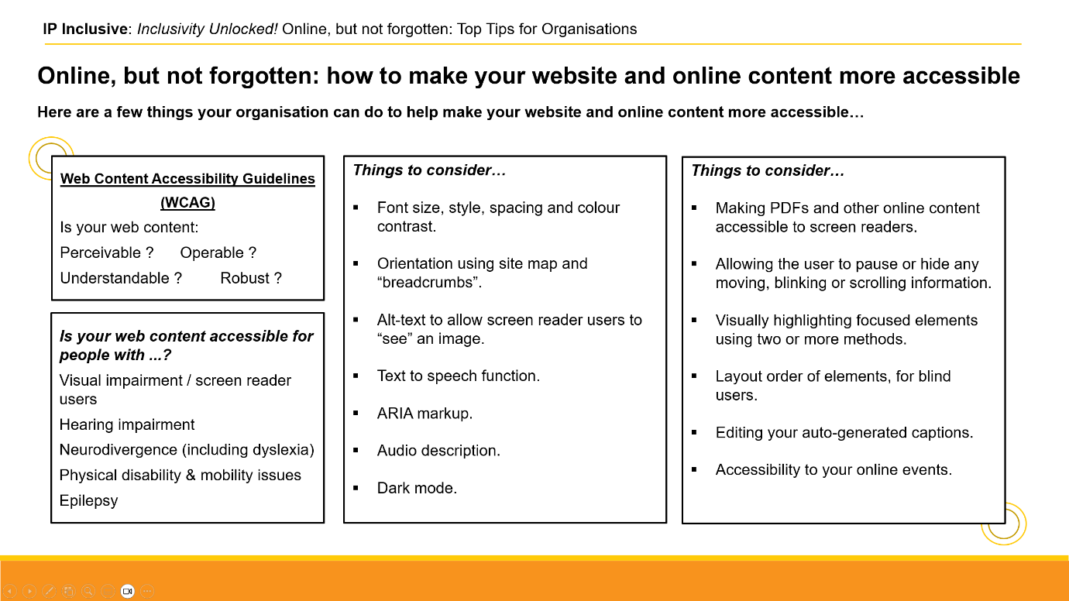
https://ipinclusive.org.uk/wp-content/uploads/2023/06/230613-online-but-not-forgotten-top-tips.pdf

Menopause: what’s changing?
Date: 22 March 2023
Online event post: https://ipinclusive.org.uk/events/menopause-whats-changing/
Webinar about recent changes in perceptions of, and help with, menopause and perimenopause, and how to create menopause-savvy and supportive workplaces.

Top tips for organisations:
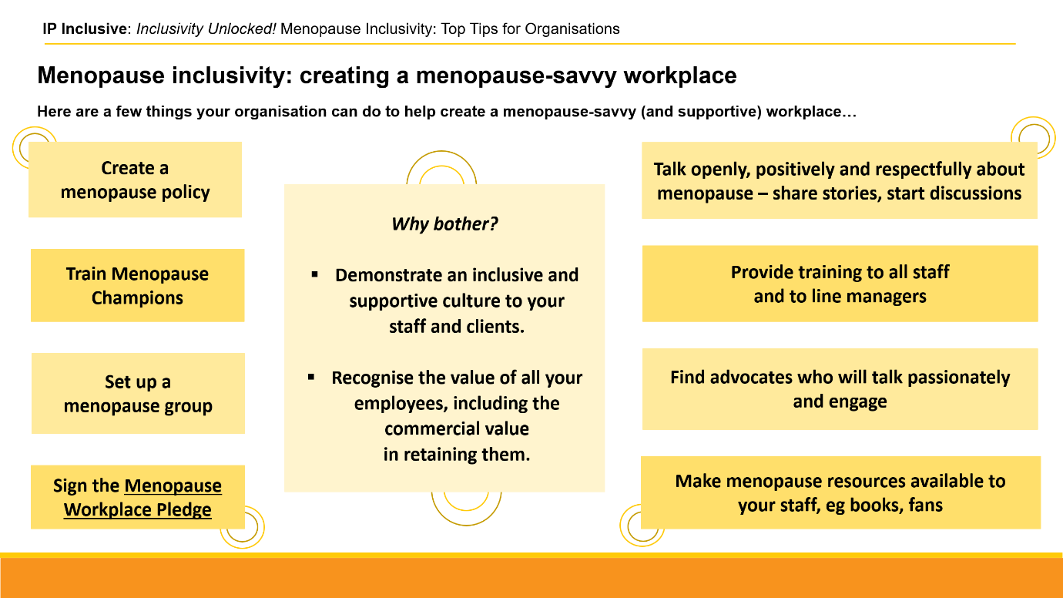
https://ipinclusive.org.uk/wp-content/uploads/2023/05/230505-menopause-inclusivity-top-tips.pdf

Too busy to flourish?
Date: 27 March 2023
Online event post: https://ipinclusive.org.uk/events/too-busy-to-flourish/
Joint webinar with LawCare about the impact of post-Covid working practices and culture on mental wellbeing.

Top tips for organisations:
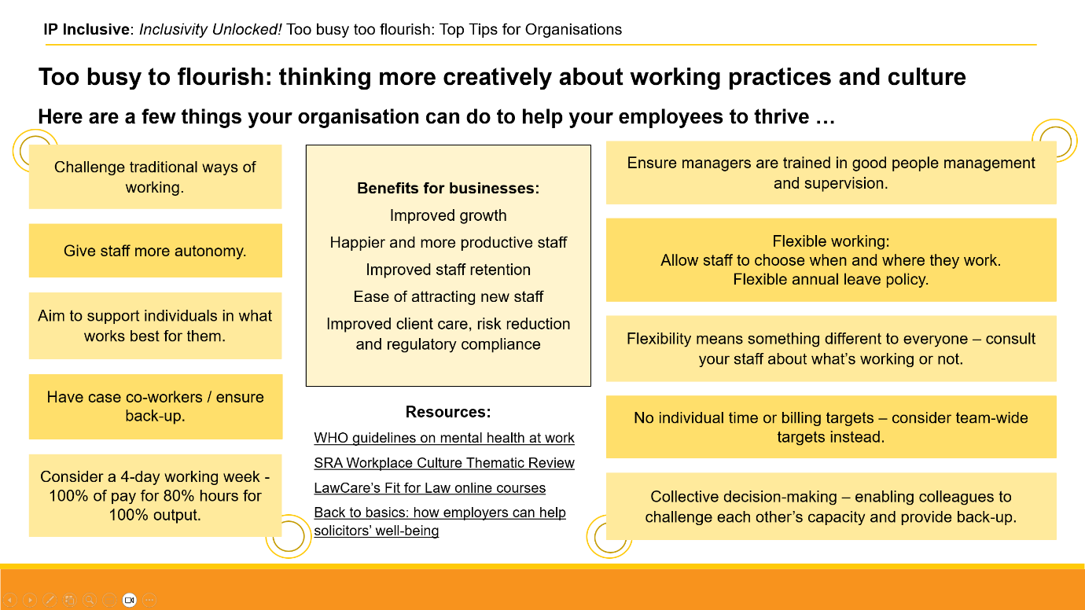
https://ipinclusive.org.uk/wp-content/uploads/2023/06/230613-too-busy-to-flourish-top-tips-for-organisations.pdf

Top tips for managers:
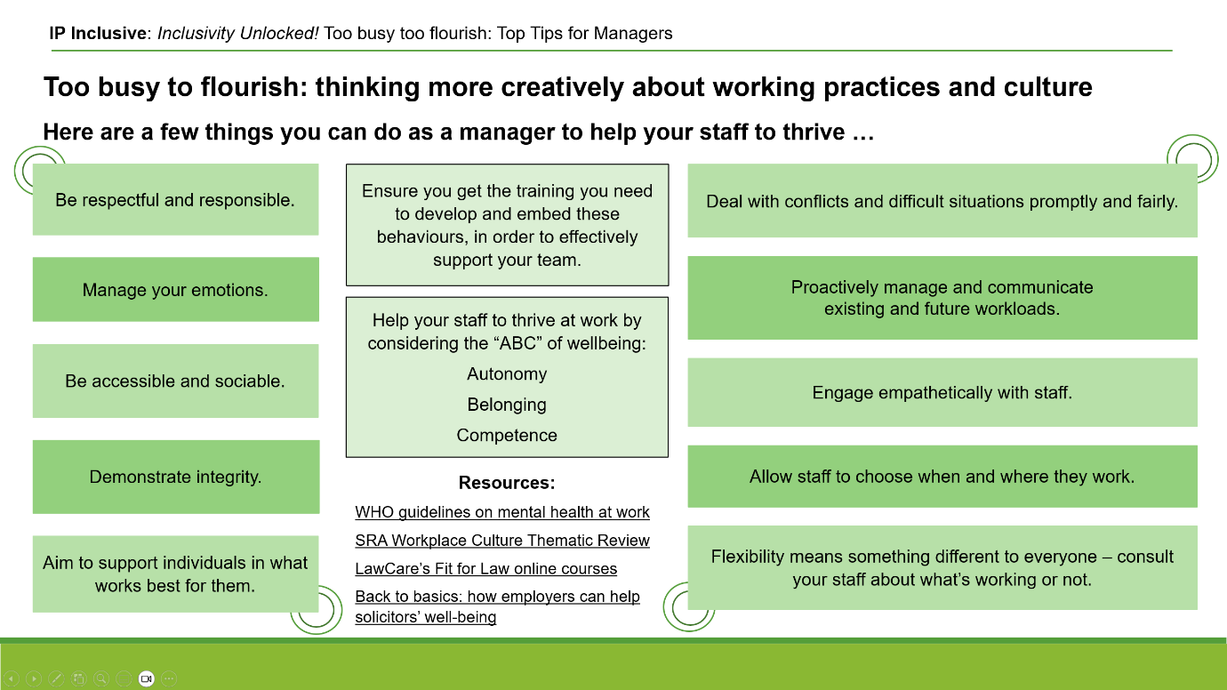
https://ipinclusive.org.uk/wp-content/uploads/2023/06/230613-too-busy-to-flourish-top-tips-for-managers.pdf

See https://ipinclusive.org.uk/newsandfeatures/the-results-of-our-2022-mental-wellbeing-survey/

