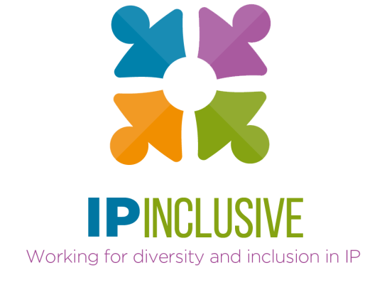

Menopause Resources

General information on the menopause 2
Treatments and symptom management 4
HRT 4
Lifestyle 4
Diet 4
Exercise 4
Other remedies 4
Menopause in the workplace 5
Support in the IP Sector 7
IP Inclusive menopause coffee dates 7
What’s App group 7
LinkedIn group 7
Speakers, coaches and training 8
Recommended reading, listening and viewing 9
Books 9
Women championing conversations on the menopause in the media 12

These resources have been collated based on recommendations and suggestions from a variety of sources. The intention is that this is an organic document for you to both refer to and contribute to (please email suggestions to helenipinclusive@gmail.com). We hope they continue to grow and be a useful tool to equip women and their allies to have a better menopause experience both in the workplace and in their personal lives.
Please be aware that we are unable to review and verify the recommended resources. In particular, we have included examples of publicly available guidance from various employers and unions with regard to menopause in the workplace, as well as menopause policies from various organisations, but this is provided for information only, and not as an endorsement of the guidance or policy.

General information on the menopause

NHS | www.nhs.uk/conditions/menopause/ | NHS advice around managing symptoms.
International Menopause Society | www.imsociety.org  World Menopause Day - 18th October | Promoting education and research on midlife women’s health.
British Menopause Society (BMS) | thebms.org.uk/ | Aimed at healthcare professionals and includes their Register of Menopause Specialists.
Women’s Health Concern | https://www.womens-health-concern.org/ | The patient arm of the BMS, providing a range of factsheets and other resources.
Daisy Network | https://www.daisynetwork.org/ | Provides information and support to women diagnosed with Premature Ovarian Insufficiency, also known as Premature Menopause.
The Menopause Charity | https://www.themenopausecharity.org/ | Founded by menopause specialist Dr Louise Newson to help people understand the mental and physical changes that occur during perimenopause and menopause and provide them with the tools and treatments needed to manage those.
Menopause Mandate | https://www.menopausemandate.com/ | Mariella Frostrup and Alice Smellie – Campaigning for education for all around menopause and HRT.
Let’s All Talk Menopause | https://www.letsalltalkmenopause.com/ | Hosts live and on demand talks from menopause experts and clinicians.
Menopause Matters | https://www.menopausematters.co.uk/ | An independent website founded by Trustee of BMS Dr Heather Currie, which provides information about the menopause, menopausal symptoms and treatment options.
Menopause and Me | https://www.menopauseandme.co.uk/en-gb | Easy to understand guidance provided by Viatris.
Menopause Support | https://menopausesupport.co.uk/ | More easy to read guides. Menopause Support is a not-for-profit community interest company and the home of the national #MakeMenopauseMatter campaign, both founded by Diane Danzebrink.
My Menopause Centre | https://www.mymenopausecentre.com/ | Online menopause clinic with free access to a wealth of information and resources.
Manage My Menopause | https://www.managemymenopause.co.uk/ | Online questionnaire and handbook to help with your decision making around menopause treatments.
Hot Flush Club | https://hotflushclub.com/ | A lifestyle forum for women on the journey through menopause, including women sharing stories and experiences.
Henpicked Menopause Hub | https://henpicked.net/menopause-hub/ | A website for women “who weren’t born yesterday” - a place for discussion and bringing about positive change.

Treatments and symptom management

NHS | www.nhs.uk/conditions/menopause/ | NHS advice around managing symptoms.
Greater Good Magazine | https://lnkd.in/dAjBVbfY | How men can support their partners through menopause.  Greater Good magazine is published by the Greater Good Science Center (GGSC) at the University of California, Berkeley and provides interesting resources and newsletters on a range of issues.

HRT
Text to follow!

Lifestyle
Text to follow!

Diet
Text to follow!

Exercise
Text to follow!

Other remedies
Text to follow!

Menopause in the workplace

Faculty of Occupational Medicine | Guidance on menopause and the workplace | Practical guidance on supporting people at work for both people experiencing  menopause and their employers.
Chartered Institute of Personnel and Development | Knowledge Hub: Let’s talk menopause | Guidance and printable resources for HR and line managers.
ACAS | Menopause at work  Menopause and the law
Fawcett Society | Menopause and the workplace | 2022 report from the charity campaigning for women’s rights at work.
The Law Society | Experiencing menopause in the legal profession
Law Society of Scotland | Menopause Support Resource | Menopause guidance to help individuals and firms access the support they need.
Business in the Community (BITC) | Menopause in the workplace | A practical guide for HR, Wellbeing and  Occupational Health practitioners.
UK Government | Menopause transition: effects on women’s economic participation | Research into the extent to which the menopause transition is a problem for working women.
House of Commons Women and Equalities Committee | https://lnkd.in/d5yhpqXx  https://lnkd.in/dqJAxPSV | Menopause and the workplace report (July 2022)  Summary of report
LawCare | Menopause
Examples of guidance from employers
NHS Employers | Guidance on menopause at work
Civil Service HR | Menopause: Guiding principles for Employees and their Managers  Menopause at work - Employees
College of Policing | Management of menopause transition in the police service 2021
Examples of guidance from unions
Royal College of Nursing | The Menopause and Work:  Guidance for RCN Representatives
National Union of Teachers | Managing the Menopause in the Workplace
TUC | Menopause at work
Unison | Menopause guidance and model policy
Examples of menopause policies
Nottinghamshire Police | Menopause Policy
Age UK | Menopause policy
NHS Fife | Menopause policy
University of Dundee | Menopause policy
Channel 4 | Menopause policy
NASUWT (The Teachers’ Union) | Model menopause policy
National Education Union | Model menopause policy
LawCare | The Legal mind podcast: Menopause in the workplace

Support in the IP Sector

IP Inclusive menopause coffee dates
It’s time we talked more about menopause and perimenopause, and how to support one another through them. A group of IP Inclusive supporters have got together to organise regular “coffee date”-style gatherings, open to anyone who wants to drop by and have a chat. They are intended as a safe space to talk about (peri)menopause without shame or censure, to share experiences as well as ideas for making our working lives more menopause-inclusive.
These get-togethers are for everyone who works in the UK’s IP sector. All genders and all ages are welcome, as are people from all roles and career levels. You might be going through (peri)menopause yourself, or already have done so, or just want to know more for the future. You might be joining us to find out how you can support family, friends and colleagues who are going through (peri)menopause.
Feel free to invite a friend or colleague to come along with you – someone in a different role or at a different career level, perhaps, or a colleague who’s not yet involved with IP Inclusive. They’ll be most welcome!
Check out our Events page for the next date.

WhatsApp group
If you’d like to join a (peri)menopause-focussed WhatsApp group, please contact Vicky Maynard via contactipinclusive@gmail.com.

LinkedIn group
We’ve established a LinkedIn group for UK IP professionals who want to exchange news, views and ideas about the (peri)menopause. It’s a private group so just send us a request to join and we’ll do the rest.

Speakers, coaches and training

Below are a selection of speakers who provide menopause training or workshops for the workplace, which can be targeted to all employees or to specific groups, eg managers, HR, or for training menopause champions/advocates.

Some also offer personal coaching/ programmes/ plans.

Lauren Chiren | https://www.womenofacertainstage.com/ | Corporate training and courses.  Menopause champion training.  Personal coaching and plans.
Sam Palmer | https://www.midlifemakeover.co.uk/ | Workplace training.  Personal plans and programmes.
Sarah Wilsher | https://themenopauseatwork.com/  https://www.businessleader.co.uk/how-support-the-sufferers-menopause-workplace/ | Workplace training.  Policy development.  Menopause champion training.
BMR Menopause Training Courses | https://www.bmrhealthandwellbeing.co.uk/menopause-training-courses-store  https://www.bmrhealthandwellbeing.co.uk/menopause-training-courses-store/p/25hr-henpicked-menopause-champion-training | Workplace training.  Menopause champion training.

Recommended reading, listening and viewing

Books

Haynes Menopause  https://haynes.com/en-gb/menopause | 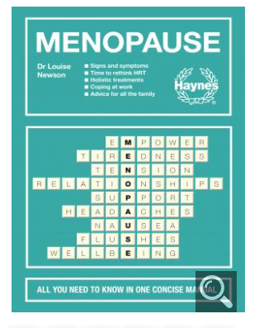
Cracking the Menopause: While Keeping Yourself Together  By Mariella Frostrup and Alice Smellie | 
Menopausing  By Davina McCall with Dr Naomi Potter | 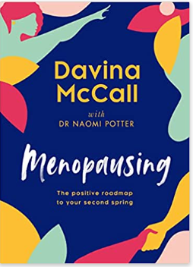
Menopause: The Change for the Better  By Deborah Garlick | 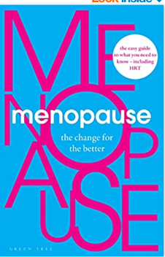
The Complete Guide to the Menopause  By Annice Mukherjee | 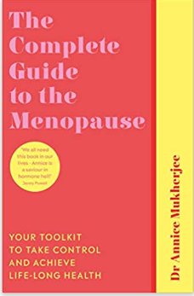
Natural Solutions to the Menopause  By Marilyn Glenville PhD | 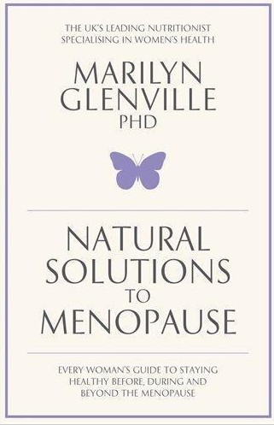
Menopause, The One Stop Guide  By Kathy Abernethy | 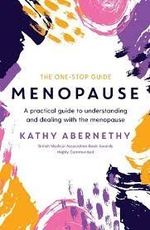
The Good Menopause Guide  By Liz Earle | 
Managing hot flushes and night sweats: a cognitive behavioural self help guide to the  Menopause  By Myra Hunter | 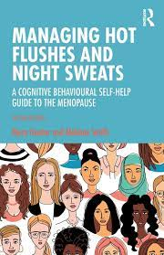
Understanding BRCA, living with the breast cancer gene  By Clarissa Foster | 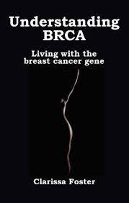

Articles in the media
The Guardian, 12/1/2023, “Not just hot flushes: how menopause can destroy mental health”

Women championing conversations on the menopause in the media

Mariella Frostrup & Alice Smellie (BBC - The truth about the menopause) (See also Menopause Mandate)
Louise Minchin (BBC and ITN Business Menopause: Continuing the Conversation)
Davina McCall (Channel 4 - Sex, Mind and the Menopause, and Sex, Myths and the Menopause)
Dr Shirin
Kate Thornton
Kirsty Wark (BBC - The Menopause and Me)
Lisa Snowdon
Carol Vorderman (ITV)
Penny Lancaster
Michelle Griffith Robinson
ITV: This Morning, Loose Women

