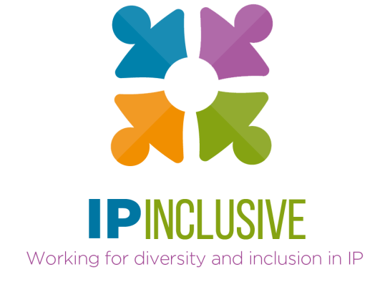

IP Inclusive
Annual meeting 18.4.23

Agenda

Venue: Zoom
Timing: 10 am – midday
1000-1005 Chair’s introduction
Andrea Brewster, IP Inclusive Lead Executive Officer
1005-1100 2022 review (see below for contributors)
Updates on IP Inclusive’s work last year (see also our 2022 Annual Report):
- Careers in Ideas
- The EDI Charter, including the regional networks
- Networking and support communities (IP & ME, IP Ability,
IP Futures, the IP Non-traditional Family Network, IP Out and Women in IP)
- Mental wellbeing
- The senior leaders’ diversity think tank
- IPIM and the Advisory Board
- Other 2022 events and activities
1100-1110 Formal matters (chaired by Michael Silverleaf KC, IPIM Chair)
IPIM business, including approval of 2022 Annual Report and Financial Report, appointment of new members and election of officers
1110-1140 Breakout sessions: objectives for 2023-24
Group discussions on IP Inclusive’s plans and priorities for the next 12 months
1140-1155 Plenary: collating and agreeing outcomes
Breakout room rapporteurs share their groups’ ideas
1155-1200 Chair’s summing up

Contributors to the 2022 review

Careers in Ideas
- Andrea Brewster and Helen Smith (IP Inclusive), Careers in Ideas task force and Summer of IP working group
- Carol Nyahasha (Elkington & Fife), project lead for the Careers in Ideas Mentoring Hub

The regional networks
- Midlands: Jennifer Unsworth (HGF), committee co-lead
- North of England: TBC
- Scotland: Rachel Gillan (CMS Cameron McKenna Nabarro Olswang), committee co-lead
- South West: Megan Jefferies (Thrings), committee co-lead

The communities
- IP & ME: TBC
- IP Ability: Marianne Privett (AA Thornton), committee co-lead
- IP Futures: Mehreen Sattar (HGF), committee member
- IP Non-traditional Family Network: Janine Swarbrick (HGF), committee co-lead
- IP Out: Tom Leonard (Kilburn & Strode), committee co-chair
- Women in IP: Susi Fish (Boult Wade Tennant), committee co-lead

Other networks and working groups
- Mental health first aiders, men’s mental wellbeing and collaborations with Jonathan’s Voice: Andrea Brewster
- Menopause support: Jane Wainwright (Potter Clarkson), working group co-founder
- Senior leaders’ diversity think tank: Gwilym Roberts (Kilburn & Strode), think tank co-lead

IP Inclusive Management (IPIM)
- Michael Silverleaf KC (11 South Square), chair

The IP Inclusive Advisory Board
- Ben Buchanan (IPO), 2022 chair

