Liv Buckingham
Don’t be afraid to reach out to current trainees over LinkedIn! I can almost guarantee most will be happy to have an informal chat

is a TRAINEE PATENT ATTORNEY
at REDDIE & GROSE
https://www.linkedin.com/in/olivia-buckingham-a20733112/
Likes: | Travel, cooking and napping far too much
Dislikes: | Bugs and scary movies!
Previously worked:
2021-present |  | Reddie & Grose
Previously studied: |  |  |  | ATTENDEE NOTES:  - Please use this space to write questions in advance of the session, or notes during the session.
Physics MSci, University of Nottingham

How they found out about the profession:
I was fortunate enough to find out about the profession through Nottingham’s career services

I then spent 5 weeks as an intern at an IP firm in Leeds and never looked back!

What does an average day look like?
I spend most of my time writing letters to the EPO/IPO

When I’m not doing that, I might be meeting inventors, writing blogs or getting involved in general business development

Top tips for job applications and interviews?
Make sure you know what the day-to-day role actually looks like! Employers want to know that you understand this is primarily a desk job and that you won’t necessarily be out and about and chatting to inventors 24/7.

Anything else? Any other advice?
Don’t be afraid to reach out to current trainees over LinkedIn! I can almost guarantee most will be happy to have an informal chat to give you a better idea of what training as a patent attorney looks like!

Eilidh Smith  Be honest – if this job hasn’t been your dream role since you were 5, that’s ok, explain why you are actually applying for the role now.  is an Associate  at Pinsent Masons LLP  https://www.linkedin.com/in/eilidh-smith-9460598a/ |  |  |  | 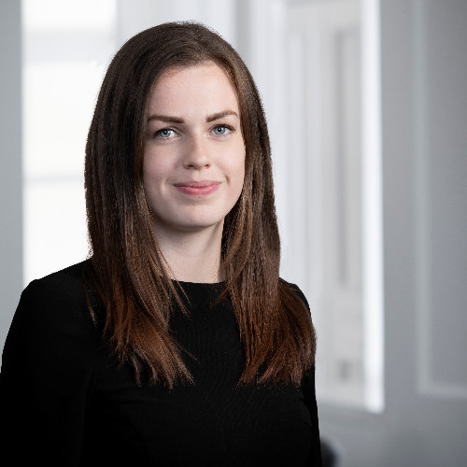
Likes: | Food, travel
Previously worked:
2021 – 2023 |  | Pinsent Masons LLP
2019 – 2021 |  | Brodies LLP |  | ATTENDEE NOTES:  - Please use this space to write questions in advance of the session, or notes during the session.
2017 - 2021 |  | Trainee solicitor – Brodies LLP
Previously studied:
In what I suspect may be the most boring education history of any of the speakers today – I studied Scots Law (LLB) at undergraduate before going on to do the Diploma in Professional Legal Practice, both at the University of Glasgow.

However, for the avoidance of doubt, the route to qualification as a solicitor can be a little more varied than mine was! Many do a joint undergraduate degree (often Law with a language or Law and Politics); and lots start their LLB as a second degree (which can be done as a ‘fast track’ two year course, instead of four years).
How they found out about the profession:
I stumbled my way into law really. I didn’t know what I wanted to do at university as I was approaching the end of school. Someone suggested law and I spent a week shadowing a criminal defence solicitor. I found that interesting so applied to study law at university. Once I was at university, I began to learn about all the different areas of law and different careers a law degree could lead to. Once I had my degree and diploma, I trained at a full service commercial firm so, again, was exposed to many different types of practice areas as my traineeship was structured to spend time in different departments. Throughout university and my traineeship, however, I was sure I wanted to be a litigator. Once I qualified as a solicitor into a litigation team, I started to specialise further into IP litigation.
What does an average day look like?
Not to be cliché, but every day is different!
- Most start at my desk but some start with an early morning commute to the Court of Session, in Edinburgh, or one of the Sheriff Courts throughout Scotland for an evidential hearing or a legal debate. I may be appearing in the courts personally or instructing advocates to do so. As my firm works across the UK (and beyond), I may also be instructing barristers to appear in the English courts or attending one of our English offices to meet with clients;
- If I don’t have to commute to a court, it might be because I have a hearing taking place by video conference instead (this is a new phenomenon post covid – it does save you from too many long train journeys but you miss out on the true experience of being in a court room!;
- Most days, however, I won’t be in a hearing but rather advising clients, this often means meeting with clients to discuss a potential new dispute, a concern they have that might become a dispute, or a piece of correspondence of court papers that have been received. This involves speaking with clients to explain the legal principles while also distilling a fair amount of technical information that they might provide;
- However – I do get help with the technical information! I often work with patent attorneys who provide their expert advice in the form of reports. Some days will be spent reviewing expert reports and translating that into letters setting out claims before court proceedings are raised or into court pleadings themselves;
- Finally, not everything ends up in a full dispute! I spend a lot of my time advising clients at an early stage and negotiating settlement, whether that be through a formal mediation or simply in correspondence.
Top tips for job applications and interviews?
- Be honest – if this job hasn’t been your dream role since you were 5, that’s ok, explain why you are actually applying for the role now.
- Know what the role actually involves – speak to people in the role, it can seem daunting to approach people but people are always happy to help. If you don’t have a family member in the field, that’s ok – reach out to people you meet at events or through LinkedIn.

Noelia SAINZ PASTOR  Work hard and never hesitate to ask for help when you need it. This profession is full of really lovely professionals.  is a Patent Attorney, Director IP  at Autolus Therapeutics  https://www.linkedin.com/in/noeliasainz/ |  |  |  | 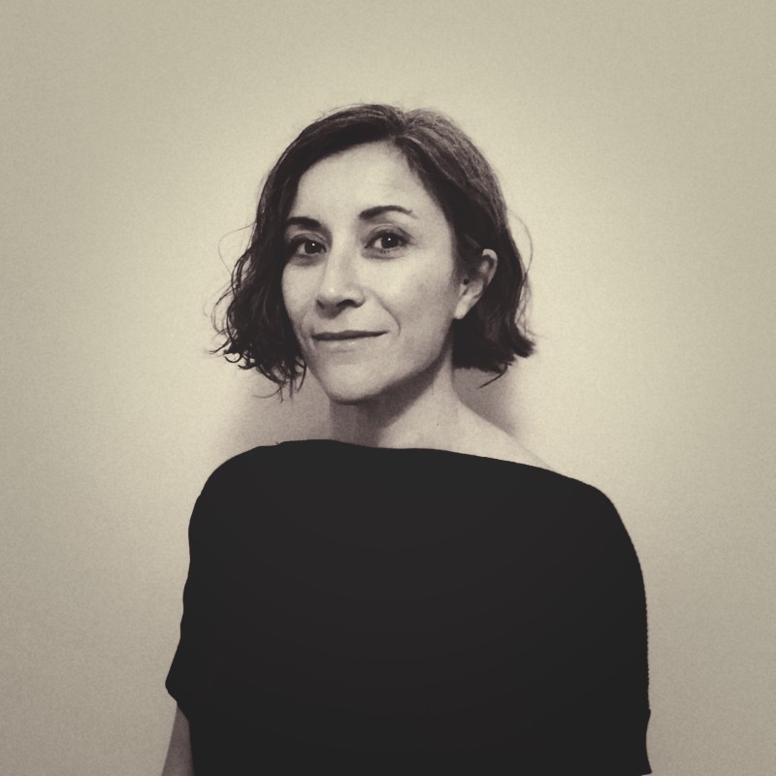
Likes: | Gigs, travelling, theatre, film, walking and hiking, London.
Dislikes: | Extreme temperatures.
Previously worked:
2015-2018 |  | Patent Attorney at Proteome Sciences (UK) – In-house
2011-2015 |  | ABG IP (Spain) – Private practice |  | ATTENDEE NOTES:  - Please use this space to write questions in advance of the session, or notes during the session.
2008-2011 |  | Research Fellow at Hospital Universitario Puerta de Hierro; LeadArtis (Spain)
2007-2008 |  | Postdoc at UCL Cancer Institute (UK)
Previously studied:
- MSc in Biochemistry at Universidad Complutense de Madrid (Spain), including an Erasmus exchange at University of Greenwich.
- PhD Molecular Biology at UCL.
- CEIPI PGCert Basic Training in European Patent Law, at Spanish Patent and Trademark Office.
- PGCert in Intellectual Property at Queen Mary University of London
How they found out about the profession:
The first time was during a seminar on alternative careers to Academia while finishing my PhD, although I didn’t find it very appealing – the patent attorneys in suits made it sound very boring!

Back in Spain a couple of years later, my research results were the basis of two patent applications. The preparatory work on the patent draft with our patent attorney triggered my curiosity. Through online research, I realised that this is an intellectually stimulating career and that some personal traits (e.g., attention to detail) could be beneficial. I enrolled on the CEIPI PGCert Basic Training in European Patent Law postgrad certificate (2 years, part-time), which I began while still working as a full-time researcher, and this course opened the door to interviews for patent attorney trainee positions.

What does an average day look like?
I’m going to describe briefly my average week instead:
- Check emails and tasks – priorities can change very quickly!
- Patent focused work: for example, drafting patent applications, patent prosecution (e.g. working on arguments for responding to patent examiner’s objections), monitoring third party activity.
- Meetings (1:1 or group meetings):
  - IP Team
  - Other functions (e.g., R&D, Business Development)
- Reviewing plans for disclosures (e.g., papers, conference abstracts).
- Developing IP training and IP-related company policies.
- Admin.
- Own professional development.
Top tips for job applications and interviews?
Job applications:
- Structure your CV neatly in 2 pages.
- In each past employment entry, include the competencies developed that may be useful for a trainee patent attorney role.
Job interviews:
- Take your time to prepare and structure your answer.
- It’s OK to admit that you don’t know the answer to a question, but then try to provide a reasoned guess.
- Familiarise yourself with the structure of a patent document and the language used in the claims.
- If given written questions, read carefully the question in full.
- Have an answer ready to the question ‘why do you want to become a patent attorney?’.
- Be yourself and be honest.
- Dress smart and be punctual.

Anything else? Any other advice?
- This is a great professional career but beginnings can be tough and studying for the exams can feel isolating. Talk to other patent attorneys to understand what it takes to obtain the qualifications.
- Work hard and never hesitate to ask for help when you need it. This profession is full of really lovely professionals.
- Network with other colleagues – it is important to feel supported.

Anne Barrett  is a Patent Policy Advisor  at the UK Intellectual Property Office (UKIPO) |  |  | Enthusiasm is very helpful, particularly where you don’t have experience in an area but are keen to learn.
Likes: | Hiking, parkrun, watching rugby
Dislikes: | Gratuitous horror films
Previously worked:
2022 - Present |  | Patent policy advisor at the UKIPO
2019 - 2022 |  | Patent examiner at the UKIPO |  | ATTENDEE NOTES:  - Please use this space to write questions in advance of the session, or notes during the session.
Previously studied:
- Postgraduate Certificate in Law and Intellectual Property from the University of South Wales (completed at the IPO)
- PhD in Biochemistry
- Masters in Biochemistry
How they found out about the profession:
My sister works next door (we share a site with the Office for National Statistics) and heard the IPO were recruiting. I was told the IPO was a really interesting but relaxed place to work.

I joined the IPO as I wanted to use my science but after my PhD didn’t want to work in research anymore.

What does an average day look like?
When examining:
- Check my case list to find the highest priority case (you will usually have a subject matter area to focus on out this can change over time – I worked in biotechnology)
- Work on the case (searching for prior art/ writing up reports/ responding to agent letters) – referring to case law and setting out legal arguments as necessary.
In my policy role:
- Check emails and my task list (priorities can quickly change!)
- Work on the most urgent task – could be writing briefings, drafting letters for ministers, researching bits of patent law (to understand the legal basis of what we do and why we do it), sending legal queries to government lawyers, researching practical impacts of different aspects of the patent system
Attend meetings – with other IPO teams or other government departments (such as the Cabinet Office or the Ministry of Defence).
Top tips for job applications and interviews?
Enthusiasm is very helpful, particularly where you don’t have experience in an area but are keen to learn.

Say things confidently even if you don’t feel confident! I had to give a presentation in an interview and didn’t really know what I was talking about but said it really confidently and assertively and got really good feedback.
Other notes from the session

