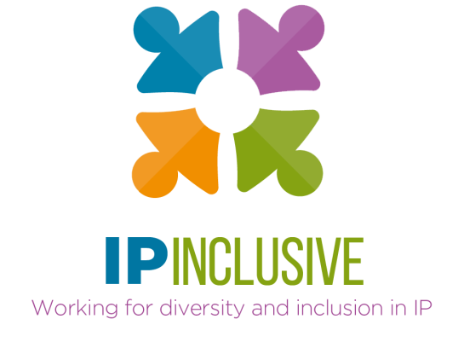

Diversity & inclusion with the IP offices (IP Inclusive event 6.12.23)
Additional resources

The following additional links and resources have been kindly supplied by speakers at our 6 December 2023 event “Diversity & inclusion with the IP offices: a holistic approach”. They include several programmes that could be of value to IP professionals’ clients; please help to publicise them if you can.
You can access a recording of the event, and a pdf of the speakers’ slides, from our website event post at https://ipinclusive.org.uk/events/diversity-inclusion-with-the-ip-offices-a-holistic-approach/.

From Lisa Jorgenson (WIPO):

- WIPO's IP and Gender Action Plan (IPGAP): WIPO launched its first IP and Gender Action Plan, an initiative aiming to promote the understanding of how intellectual property (IP) benefits women, their communities, and economies. Explore the details of IPGAP here.
- WIPO’s entry page on IP, Gender, and Diversity: https://www.wipo.int/women-and-ip/en/
- WIPO's Report on Women's Participation in International Patent Applications (1999-2020): The Global Gender Gap in Innovation and Creativity: An International Comparison of the Gender Gap in Global Patenting over Two Decades (wipo.int).
- WIPO World Gender Name Dictionary: A resource for gathering gender-related information in IP. Learn how to use it effectively at Innovation Gender Gap: The Challenges of Measuring Gender Inequality in Innovation (wipo.int).
- WIPO Guidelines for Producing Gender Analysis from Innovation and IP Data: Summarizes best practices for generating gender indicators in innovation and IP. Access the guidelines at Guidelines for producing gender analysis from innovation and IP data (wipo.int).
- WIPO and Invent Together Regional Seminars on Diversity in IP: Collaborative virtual seminars exploring IP and diversity globally. Evaluate and discuss policies addressing the gender gap. Seminars include high-level policy panels and IP economists panels for different regions.
High-level policy panels
  - African and Arab regions seminar
  - Americas seminar
  - Europe seminar
  - Asia-Pacific seminar
IP economists panels
  - African and Arab regions seminar
  - Americas seminar
  - Europe seminar
  - Asia-Pacific seminar
- WIPO’s IP for Business resources page
- WIPO Inventor Assistance Program – participating countries: Chile, Colombia, Ecuador, Kenya, Morocco, Peru, the Philippines, Singapore, South Africa.

From Valencia Martin Wallace (USPTO):

- Inventor and entrepreneur resources
- Inclusive innovation at the USPTO

