Guidance for requesting reasonable adjustments for the European Qualifying Examination

Date 26/03/2025

1. Purpose of this guidance

This guidance outlines the guidance for requesting reasonable adjustments for the European Qualifying Examination (EQE) and is to ensure candidates with disabilities, medical conditions, or specific needs have fair information to the examination process. Please note that this is guidance only and we recommend you continue to check with the EQE for the latest updates on their guidance and policies.

2. Implementing Regulations

The Implementing regulations are as follows:

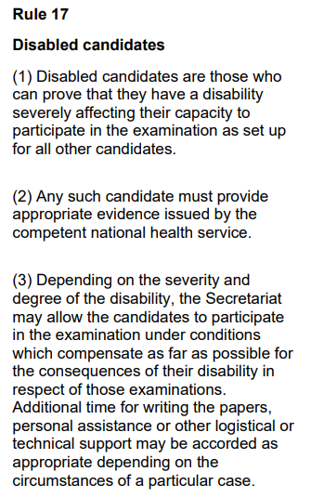

IPAbility tried to seek guidance from the Exam Secretariat about this wording, since there are a range of health conditions that could impair performance in an exam but are not necessarily considered by the candidate to be a formal “disability”.

Given that requesting reasonable adjustments can take time, if you believe you require adjustments, apply for these immediately after registering for the exams to allow maximum time to exchange correspondence.

The application process simply requires an email to the Exam Secretariat with your request and the supporting evidence.

3. Evidence

We received the following information from the Exam Secretariat:

A request under Rule 17 IPREE must be substantiated by appropriate evidence of the disability/permanent condition as issued by the competent national health service. A medical certificate from a general practitioner is usually not sufficient as evidence.

Please also specify how your condition affects your daily (working) life and specifically which compensatory measures are foreseen, i.e. at your work place (if any). This information gives us a better picture of your condition/disability and which compensatory measure would help you best.

Important points here:
- The letter must be on NHS letterheaded paper or otherwise obvious that it has come from an NHS practitioner
- A GP letter is generally insufficient
- The letter needs to be detailed

Although not stated in Rule 17, it seems to be important that the letter is recent.

If you can, provide evidence to the exam secretariat that you have also received the same adjustments in the recent past, that may also help (e.g., from the PEB or Queen Mary or from your employer).

Please note that, at the time of writing, the Exam Secretariat generally does not allow additional time for dyslexia.

